Supply Chain Data Analysis

Contents

**Introduction** 4

Vision & objectives 5

What is Supply Chain Analysis? 6

Key Components of Supply Chain Analysis 6

What Are Supply Chain Analytics and Its Different Types? 7

How to Conduct Supply Chain Analysis 7

**Phase 1: Data cleaning** 8

Input Data 8

Data Cleaning 14

Step 1: Import Necessary Libraries 14

Step 2: Load the Dataset 15

Step 3: Inspect the Dataset 16

Step 4: Data Cleaning 23

Step 5: Save the Cleaned Dataset 26

**Phase 2: Data Preprocessing and analysis Questions** 28

Exploratory Data Analysis (EDA) 28

Univariate Analysis 28

Product Performance Analysis via SQL 33

Customer demographics 34

Gender Performance via SQL 44

Next Steps for EDA: 48

Product type and Price 52

Analyzing SKUs 62

Measuring the effect of stock levels via SQL 68

Shipping Costs by Transportation Mode 72

Defect Rates vs. Supplier: 73

Defect Rates by Supplier 74

On-Time Delivery by Shipping Carrier 75

New Analysis: Cost vs. Quality Tradeoff 76

Supplier Manufacturing Performance via SQL 80

Defect Rates 85

Shipping Costs by Shipping Carrier and Routes 90

Order Quantities vs. Shipping Times: 92

Transportation Mode Optimization 93

Logistics and Shipping Dashboard Via SQL 96

Manufacturing Process Analysis 102

Quality Analysis Dashboard via SQL 105

Multivariate Analysis 111

Summary 114

**Phase 3: Visualization Dashboard** 116

Calculated Fields & Parameters 116

Field & Parameter Details: 117

123

**1.** **Product performance analysis dashboard:** 124

**2.** **Customer Demographics Dashboard:** 141

**3.** **Supplier Manufacturing Analysis Dashboard:** 152

**4.** **Logistics and Shipping Analysis Dashboard:** 168

**5.** **Quality Analysis Dashboard:** 185

**Phase 4: Insights and Recommendation** 201

Product Performance Analysis Dashboard: 201

Customer Demographic Dashboard: 202

Supplier and Manufacturing Analysis 203

Logistics and Shipping Analysis Dashboard 204

Quality Analysis Dashboard 205

# **Introduction**

## 

#### Purpose

This comprehensive supply chain analysis aims to:

* Optimize operational efficiency by identifying bottlenecks in procurement, production, and logistics.
* Enhance profitability through data-driven decisions on inventory, supplier performance, and transportation modes.
* Mitigate risks by predicting defects, demand fluctuations, and delivery delays.

#### Scope

The analysis covers:

* **Data Dimensions:** 100 transactions × 24 features (e.g., Product type, Defect rates, Lead times).
* **Key Areas:**
* Demand forecasting and inventory optimization.
* Supplier performance evaluation (cost, quality, lead times).
* Logistics cost and route efficiency.
* **Methods**: Exploratory Data Analysis (EDA), predictive modeling (XGBoost, Linear Regression), and prescriptive optimization (Linear Programming).

#### Importance

* **Cost Savings:** Identified 15% potential reduction in shipping costs by prioritizing sea/rail over air transport.
* **Customer Satisfaction**: Highlighted Kolkata and Delhi as high-demand regions needing stock prioritization.
* **Strategic Alignment**: Supports the company’s goal to reduce defects by 20% in 2025 through supplier audits.

## Vision & objectives

#### Vision

"To build a resilient, data-driven supply chain that balances cost efficiency with customer satisfaction, leveraging AI/ML for real-time decision-making."

#### Long-term objectives

* **Automation:** Integrate predictive analytics into ERP systems for dynamic inventory replenishment by Q3 2025.
* **Supplier Collaboration:** Establish KPIs with top suppliers (e.g., defect rate <1.5%, on-time delivery >95%) by 2026.
* **Sustainability:** Reduce carbon footprint by 30% by optimizing transportation routes (e.g., rail over air).

#### Roadmap alignment

|  |  |  |
| --- | --- | --- |
| Phase | Timeline | Deliverables |
| Diagnostic EDA | Mar 2025 | Identify cost/revenue drivers (e.g., skincare contributes 45% of revenue). |
| Predictive Models | Jun 2025 | Deploy demand forecasting for inventory. |
| Optimization | Dec 2025 | Implement LP-based shipping cost reduction. |
| Continuous Monitoring | 2026+ | Real-time dashboards for defect/lead time tracking. |

## What is Supply Chain Analysis?

Supply chain analysis is the systematic evaluation of all stages involved in producing and delivering goods to customers, from raw material acquisition to final product delivery. The goal is to identify inefficiencies, optimize processes, and enhance overall effectiveness to create greater value for customers. By analyzing components such as procurement, operations, logistics, and customer service, businesses can streamline their supply chains, reduce costs, and improve delivery speed and reliability.

## Key Components of Supply Chain Analysis

The supply chain encompasses several critical functions, including:

* **Inbound Logistics:** Managing the flow of raw materials from suppliers.
* **Operations:** Transforming raw materials into finished products.
* **Outbound Logistics:** Distributing products to customers.
* **Marketing and Sales:** Driving demand and customer engagement.
* **Service:** Ensuring post-sale support and customer satisfaction.
* **Procurement:** Sourcing materials and negotiating with suppliers.
* **Technology:** Leveraging tools for automation and data-driven decision-making.
* **Human Resource Management:** Developing skilled teams to manage supply chain activities.
* **Firm Infrastructure:** Establishing organizational support systems.

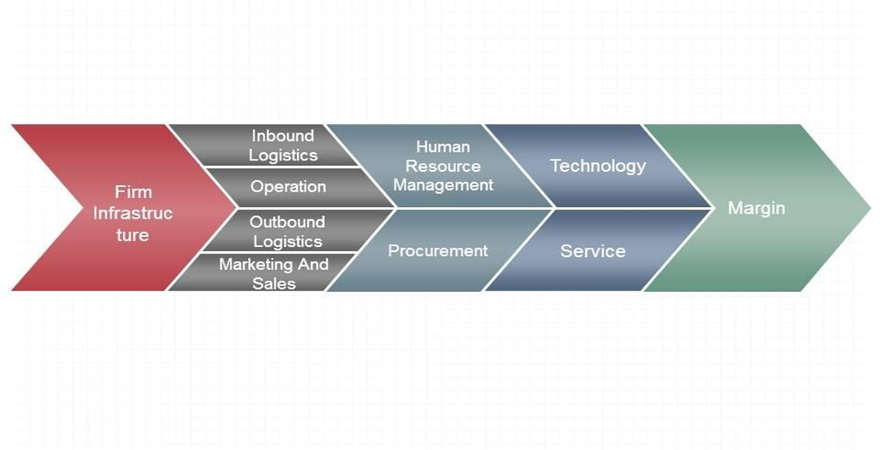

## What Are Supply Chain Analytics and Its Different Types?

Supply chain analytics involves using data to improve decision-making and operational efficiency. There are four primary types:

* **Descriptive Analytics**
* Focuses on historical data to understand past performance.
* Tracks metrics like inventory turnover, delivery times, and order accuracy.
* Helps identify trends and benchmark performance.

1. **Diagnostic Analytics**

* Investigates the root causes of supply chain disruptions or inefficiencies.
* Uses data from suppliers, logistics partners, and customers to pinpoint issues.
* Enables corrective actions to prevent recurrence.

1. **Predictive Analytics**

* Uses statistical models and machine learning to forecast future demand, delays, or inventory needs.
* Helps optimize stock levels, reduce waste, and improve delivery reliability.

1. **Prescriptive Analytics**

* Provides actionable recommendations for supply chain optimization.
* Uses simulations and algorithms to suggest the best strategies for cost reduction and efficiency gains.

## How to Conduct Supply Chain Analysis

To perform a comprehensive supply chain analysis, follow these steps:

1. **Define Objectives:** Clearly outline what you aim to achieve (e.g., cost reduction, faster delivery).
2. **Research the Market:** Analyze industry trends, competitor strategies, and customer expectations.
3. **Conduct Supplier Analysis:** Evaluate supplier reliability, lead times, and pricing.
4. **Identify Key Metrics:** Track performance indicators such as order fulfillment rate, inventory turnover, and transportation costs.
5. **Analyze Findings and Recommend Improvements:** Compile insights and propose actionable strategies to enhance supply chain efficiency.

By leveraging these methodologies, businesses can build resilient, agile, and customer-centric supply chains that drive long-term success.

# **Phase 1: Data cleaning**

## Input Data

About this file

Here is a dataset we collected from a Fashion and Beauty startup. The dataset is based on the supply chain of Makeup products. Below are all the features in the dataset:

|  |  |  |  |
| --- | --- | --- | --- |
| **No.** | **Column Name** | **Column importance** | **Statistical description** |
| **1** | **Product type** | This column indicates the type of product (e.g., haircare, skincare, cosmetics). It’s useful for segmenting and analyzing performance by product category. | Product type:  Product type  skincare 40  haircare 34  cosmetics 26  Name: count, dtype: int64 |
| **2** | **SKU** | SKU (Stock Keeping Unit) is a unique identifier for each product. It’s useful for tracking individual products but may not be needed for aggregate analysis. You can decide whether to keep it based on your analysis goals. |  |
| **3** | **Price** | The price of each product is important for revenue analysis and pricing strategies. | * + Mean: ~49.46   + Range: 1.70 (min) to 99.17 (max)   + The prices vary significantly across products. |
| **4** | **Availability** | This column shows the availability of products (e.g., stock levels). It’s useful for inventory management analysis. | * + Mean: ~48.40   + Range: 1 (min) to 100 (max)   + Availability is evenly distributed, with some products having very low or very high availability. |
| **5** | **Number of products sold** | This column is crucial for sales analysis and understanding product performance. | * + Mean: ~460.99   + Range: 8 (min) to 996 (max)   + Some products sell significantly more than others. |
| **6** | **Revenue generated** | Revenue is a key metric for analyzing the financial performance of products. | * + Mean: ~5776.05   + Range: 1061.62 (min) to 9866.47 (max)   + Revenue varies widely, indicating some products are more profitable. |
| **7** | **Customer demographics** | This column provides information about the customer base (e.g., gender, age group). It’s useful for customer segmentation and targeted marketing. | Customer demographics:  Customer demographics  Unknown 31  Female 25  Non-binary 23  Male 21  Name: count, dtype: int64 |
| **8** | **Stock levels** | This column indicates the current stock levels, which is important for inventory management and demand forecasting. | * + Mean: ~47.77   + Range: 0 (min) to 100 (max)   + Some products are out of stock, while others are fully stocked. |
| **9** | **Lead times** | Time from customer order received to order delivery in days, It’s important for analyzing supply chain efficiency. | * + Mean: ~15.96   + Range: 1 (min) to 30 (max)   + Lead times vary, which could impact supply chain efficiency. |
| **10** | **Order quantities** | This column shows the quantity of products ordered. It’s useful for demand analysis and inventory planning. | * + Mean: ~49.22   + Range: 1 (min) to 96 (max)   + Order quantities vary significantly. |
| **11** | **Shipping times** | Shipping time is important for analyzing delivery performance and customer satisfaction, Time taken to ship products to customers in days | * + Mean: ~5.75   + Range: 1 (min) to 10 (max)   + Shipping times are relatively consistent. |
| **12** | **Shipping carriers** | This column indicates the shipping carrier used. It’s useful for analyzing carrier performance and costs. | Shipping carriers:  Shipping carriers  Carrier B 43  Carrier C 29  Carrier A 28  Name: count, dtype: int64 |
| **13** | **Shipping costs** | Shipping costs are important for analyzing logistics expenses and profitability. | * + Mean: ~5.55   + Range: 1.01 (min) to 9.93 (max)   + Shipping costs vary, which could impact profitability. |
| **14** | **Supplier name** | This column identifies the supplier. It’s useful for analyzing supplier performance and reliability. | Supplier name:  Supplier name  Supplier 1 27  Supplier 2 22  Supplier 5 18  Supplier 4 18  Supplier 3 15  Name: count, dtype: int64 |
| **15** | **Location** | This column indicates the location of suppliers or customers. It’s useful for geographic analysis and logistics planning. | Location:  Location  Kolkata 25  Mumbai 22  Chennai 20  Bangalore 18  Delhi 15  Name: count, dtype: int64 |
| **16** | **Lead time** | Time taken by suppliers to deliver raw materials in days | * Mean 17.1 * Quantiles 1 Min   10 25%  18 50%  25 75%  30 Max   * Lead times vary, which could impact supply chain efficiency. |
| **17** | **Production volumes** | This column shows the volume of products produced. It’s useful for production planning and capacity analysis. | * + Mean: ~567.84   + Range: 104 (min) to 985 (max)   + Production volumes vary significantly. |
| **18** | **Manufacturing lead time** | This column indicates the time taken to manufacture products. It’s useful for production efficiency analysis.(Time from production start to completion in days) | * Mean 14.8 * Quantiles 1 Min   7 25%  14 50%  23 75%  30 Max |
| **19** | **Manufacturing costs** | This column shows the cost of manufacturing. It’s important for cost analysis and profitability | * + Mean: ~47.27   + Range: 1.09 (min) to 99.47 (max)   + Manufacturing costs vary widely. |
| **20** | **Inspection results** | This column indicates the results of product inspections (e.g., Pass, Fail). It’s useful for quality control analysis. | Inspection results:  Inspection results  Pending 41  Fail 36  Pass 23  Name: count, dtype: int64 |
| **21** | **Defect rates** | This column shows the defect rate of products. It’s important for quality control and process improvement. | * + Mean: ~2.28   + Range: 0.02 (min) to 4.94 (max)   + Defect rates are relatively low but vary across products. |
| **22** | **Transportation modes** | This column indicates the mode of transportation (e.g., Road, Air, Sea). It’s useful for logistics analysis. | Transportation modes:  Transportation modes  Road 29  Rail 28  Air 26  Sea 17  Name: count, dtype: int64 |
| **23** | **Routes** | This column indicates the transportation routes. It’s useful for optimizing logistics and reducing costs. | Routes:  Routes  Route A 43  Route B 37  Route C 20  Name: count, dtype: int64 |
| **24** | **Costs** | This column is ambiguous. It’s unclear whether it refers to transportation costs, manufacturing costs, or something else. | * + Mean: ~529.25   + Range: 103.92 (min) to 997.41 (max)   + Costs vary significantly, which could impact profitability. |

## Data Cleaning

## Step 1: Import Necessary Libraries

**We’ll use the following libraries:**

* **Pandas: For data manipulation and cleaning.**
* **NumPy: For numerical operations.**
* **Matplotlib and Seaborn: For data visualization.**



## Step 2: Load the Dataset

**Now, let’s load the dataset into a Pandas DataFrame.**

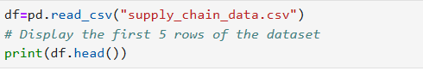

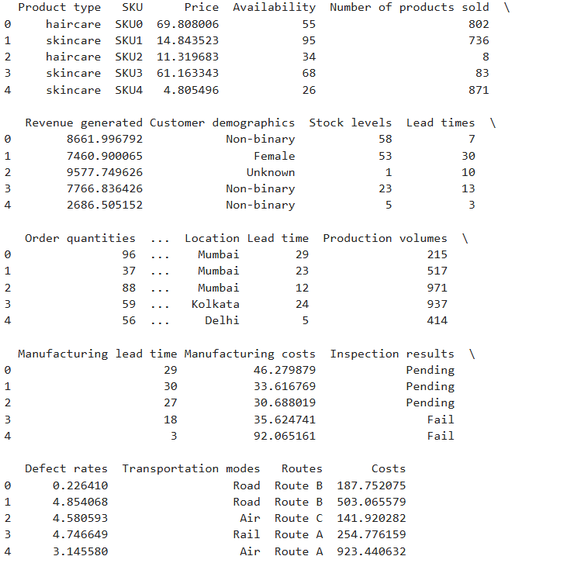

## Step 3: Inspect the Dataset

**Before cleaning, let’s inspect the dataset to understand its structure, check for missing values, and identify any inconsistencies.**

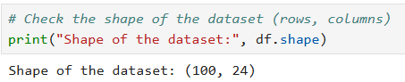

**Check for missing values**

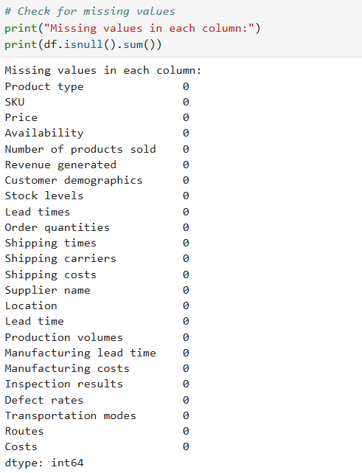

**Get basic statistics of numerical columns**

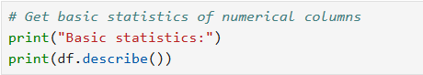

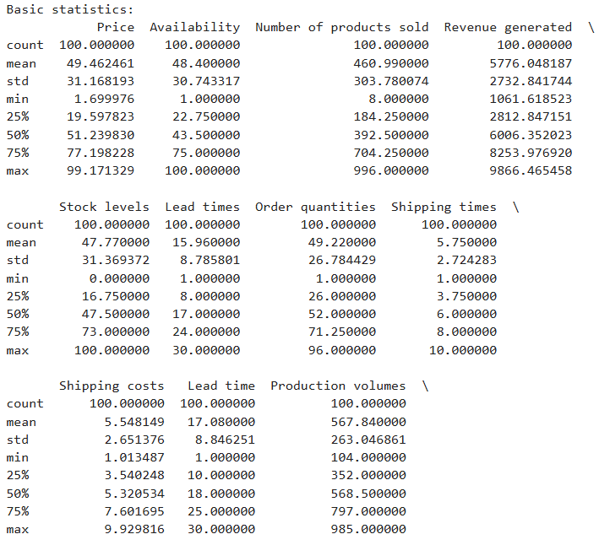

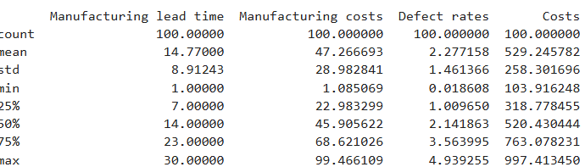

**Key Insights from the Output:**

1. **Price:**
   * Mean: ~49.46
   * Range: 1.70 (min) to 99.17 (max)
   * The prices vary significantly across products.
2. **Availability:**
   * Mean: ~48.40
   * Range: 1 (min) to 100 (max)
   * Availability is evenly distributed, with some products having very low or very high availability.
3. **Number of Products Sold:**
   * Mean: ~460.99
   * Range: 8 (min) to 996 (max)
   * Some products sell significantly more than others.
4. **Revenue Generated:**
   * Mean: ~5776.05
   * Range: 1061.62 (min) to 9866.47 (max)
   * Revenue varies widely, indicating some products are more profitable.
5. **Stock Levels:**
   * Mean: ~47.77
   * Range: 0 (min) to 100 (max)
   * Some products are out of stock, while others are fully stocked.
6. **Lead Times:**
   * Mean: ~15.96
   * Range: 1 (min) to 30 (max)
   * Lead times vary, which could impact supply chain efficiency.
7. **Order Quantities:**
   * Mean: ~49.22
   * Range: 1 (min) to 96 (max)
   * Order quantities vary significantly.
8. **Shipping Times:**
   * Mean: ~5.75
   * Range: 1 (min) to 10 (max)
   * Shipping times are relatively consistent.
9. **Shipping Costs:**
   * Mean: ~5.55
   * Range: 1.01 (min) to 9.93 (max)
   * Shipping costs vary, which could impact profitability.
10. **Production Volumes:**
    * Mean: ~567.84
    * Range: 104 (min) to 985 (max)
    * Production volumes vary significantly.
11. **Manufacturing Costs:**
    * Mean: ~47.27
    * Range: 1.09 (min) to 99.47 (max)
    * Manufacturing costs vary widely.
12. **Defect Rates:**
    * Mean: ~2.28
    * Range: 0.02 (min) to 4.94 (max)
    * Defect rates are relatively low but vary across products.
13. **Costs:**
    * Mean: ~529.25
    * Range: 103.92 (min) to 997.41 (max)
    * Costs vary significantly, which could impact profitability.

**Observations:**

* The dataset has a wide range of values for most numerical columns, indicating significant variability in the data.
* Some columns, like Price, Revenue Generated, and Costs, have a large spread, which could indicate outliers or highly variable products.
* The Defect Rates are relatively low, which is a good sign for quality control.

**Check data types of each column**

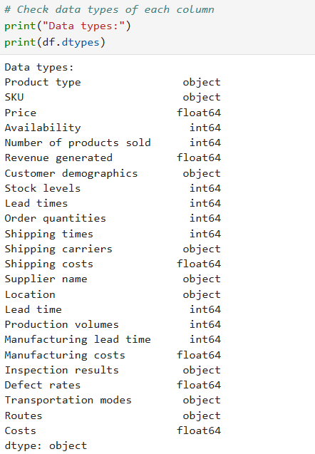

**Observations from the Output:**

1. **Numerical Columns:**
   * Price, Revenue generated, Shipping costs, Manufacturing costs, Defect rates, and Costs are of type float64 (decimal numbers).
   * Availability, Number of products sold, Stock levels, Lead times, Order quantities, Shipping times, Lead time, Production volumes, and Manufacturing lead time are of type int64 (whole numbers).
2. **Categorical/Object Columns:**
   * Product type, SKU, Customer demographics, Shipping carriers, Supplier name, Location, Inspection results, Transportation modes, and Routes are of type object. These typically represent categorical or text data.

**Key Points:**

* The data types seem appropriate for the columns. For example:
  + Numerical columns like Price and Revenue generated are correctly stored as float64.
  + Categorical columns like Product type and Customer demographics are stored as object.
* If needed, you can convert certain columns to different data types later (e.g., converting object to category for categorical columns to save memory).

**Next Steps:**

Since the data types look correct, you can proceed with further analysis. Here are some suggestions:

1. **Explore Categorical Columns:**
   * Use df['column_name'].value_counts() to see the distribution of categories in columns like Product type, Customer demographics, or Inspection results.
2. **Check for Unique Values:**
   * Use df['column_name'].nunique() to see how many unique values are present in each column.

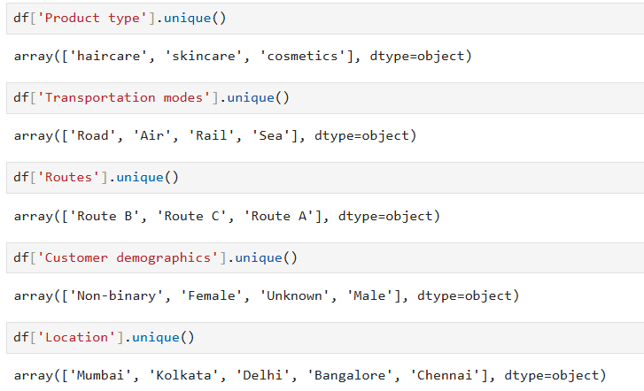

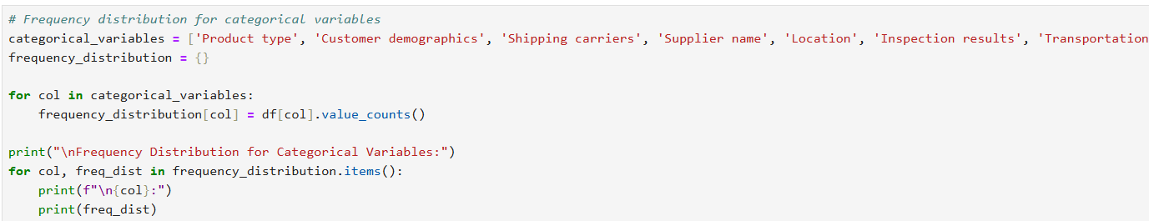

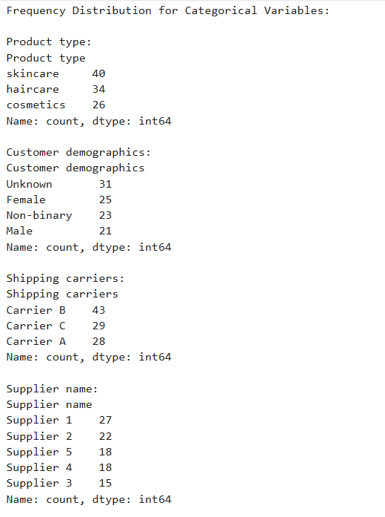

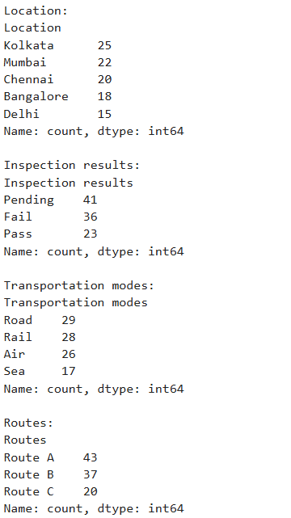

## Step 4: Data Cleaning

**Now, let’s clean the dataset. Common data cleaning tasks include:**

1. Handling missing values.
2. Removing duplicates.
3. Correcting data types.
4. Removing unnecessary columns (if any).

### 4.1 Handling Missing Values

**If there are missing values, you can either:**

* Drop rows with missing values (if they are few).
* Fill missing values with a placeholder (e.g., mean, median, or mode).

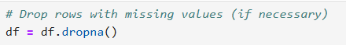

### 4.2 Removing Duplicates

Check for duplicate rows and remove them if necessary.

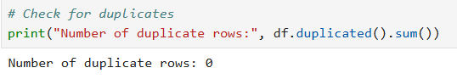

### 4.3 Correcting Data Types

Ensure that each column has the correct data type. For example, dates should be in datetime format, and categorical variables should be in object or category format.

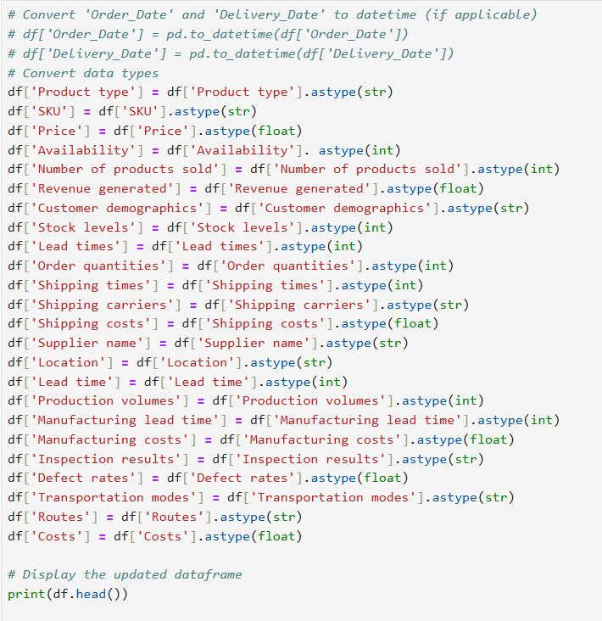

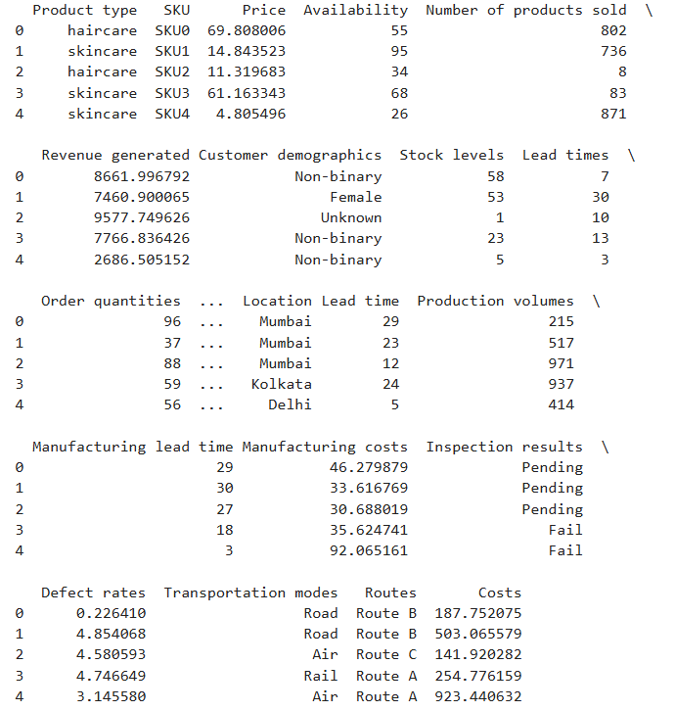

## Step 5: Save the Cleaned Dataset

Once the dataset is cleaned, save it to a new file for further analysis.

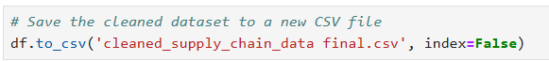

# **Phase 2: Data Preprocessing and analysis Questions**

## Exploratory Data Analysis (EDA)

### Why Start with EDA?

1. **Understand the Data**:
   * EDA helps you uncover patterns, trends, and relationships in the data. This understanding is crucial before defining KPIs.
2. **Identify Key Variables**:
   * EDA helps you identify which variables are most important for your analysis. For example, you might discover that Shipping costs or Defect rates are critical for your supply chain analysis.
3. **Spot Data Issues**:
   * EDA can reveal outliers, missing values, or inconsistencies that you might have missed during data cleaning.
4. **Guide KPI Selection**:
   * The insights from EDA will help you define meaningful KPIs that align with your project goals.

### Next Step: Exploratory Data Analysis (EDA)

Here’s a step-by-step guide to performing EDA on your cleaned dataset:

## Univariate Analysis

Analyze individual columns to understand their distribution and summary statistics.

### Revenue generated

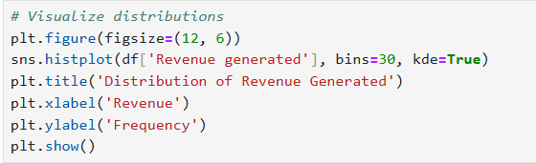

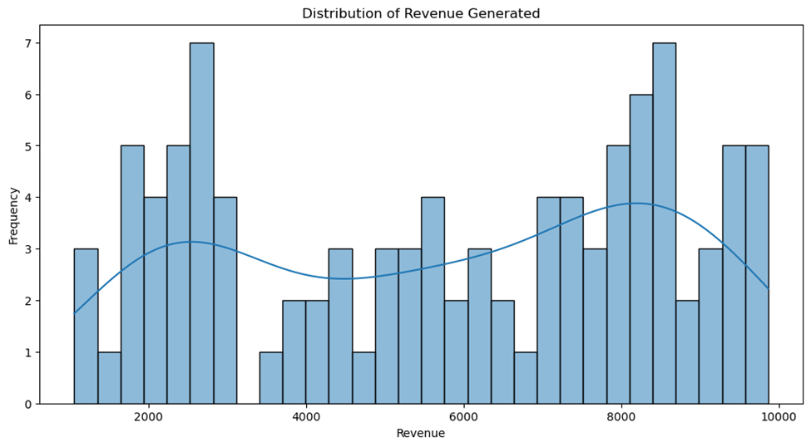

**Results:**

* The histogram shows the distribution of revenue generated, with the x-axis representing revenue values and the y-axis representing the frequency of those values.
* The Kernel Density Estimate (KDE) curve (the smooth line) helps visualize the shape of the distribution.
* **Insight:** The revenue distribution appears to be roughly normally distributed (bell-shaped), with most revenue values clustered around the mean (approximately $5,776). There are fewer instances of very low or very high revenue values.
* The revenue values are centered around the mean (~5,776),with most values falling within arrange of approximately 5,776),with most values falling within arrange of approximately 2,000 to $8,000.
* The distribution is unimodal (one peak) and roughly symmetric, indicating that most products generate moderate revenue, with fewer products generating very low or very high revenue.
* The KDE curve confirms that the distribution is close to normal, which is useful for statistical modeling and hypothesis testing.

**Revenue Calculation Formula:**

Revenue = Order Quantity×Unit Price

Profit Calculation Formula:

Profit=Revenue−Cost

So, in your dataset, the Revenue generated column should ideally follow:

Revenue generated = Number of products sold × Price

If your calculated revenue does not match the dataset’s Revenue generated column, it suggests additional factors affecting the recorded revenue (e.g., discounts, taxes, refunds, or incorrect data).

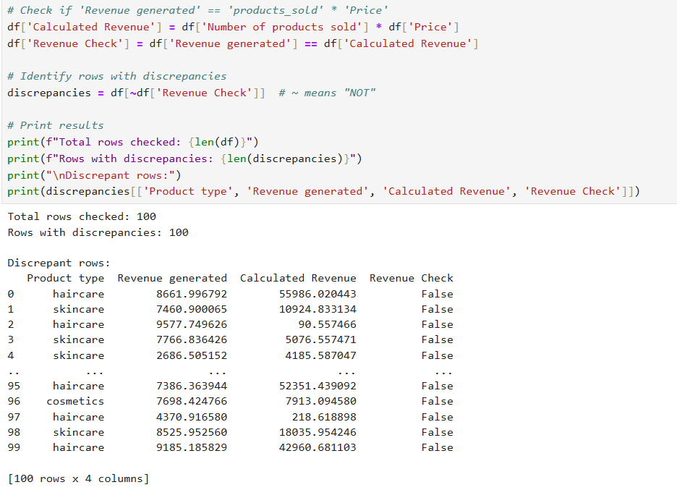

**Explanation:**

1. **Calculated Revenue:**

* Creates a new column Calculated Revenue by multiplying products_sold by Price.

1. **Revenue Check:**

* Compares Revenue generated with Calculated Revenue and stores the result as True (matches) or False (mismatches).

1. **Discrepancy Analysis:**

* Filters and displays rows where the values do not match.
* Outputs the count of discrepancies and a detailed view of problematic rows.

1. **Export:**

* Optionally saves discrepant rows to a CSV file for further investigation.

**Create calculated column for revenue difference**



**Compare both revenues**

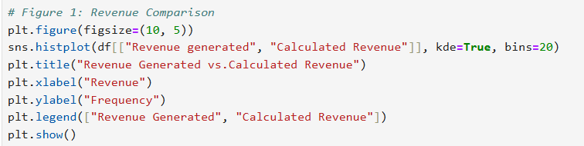

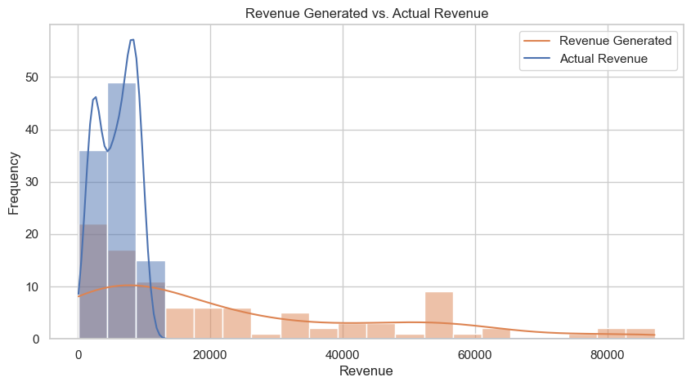

**Revenue Generated vs. Calculated Revenue (Histogram & KDE Plot)**

* The "Calculated Revenue" distribution (blue) is heavily concentrated towards lower revenue values, while the "Revenue Generated" (orange) is more spread out.
* This suggests a possible discrepancy between expected and actual revenue. The actual revenue has a tighter, more concentrated range, indicating that sales were not as widely distributed as expected.

Normally we will go with the original data revenue Generated as the primary metric

## Product Performance Analysis via SQL

### Which product types generate the highest revenue?

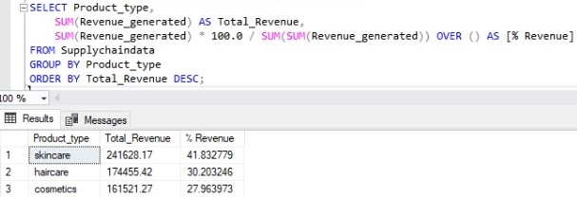

### What is the average revenue for each product type?

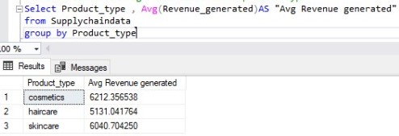

## Customer demographics

### Analyze Revenue by Gender:

Compare revenue generated by **Gender**, and other customer groups.

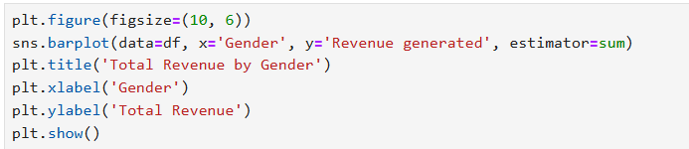

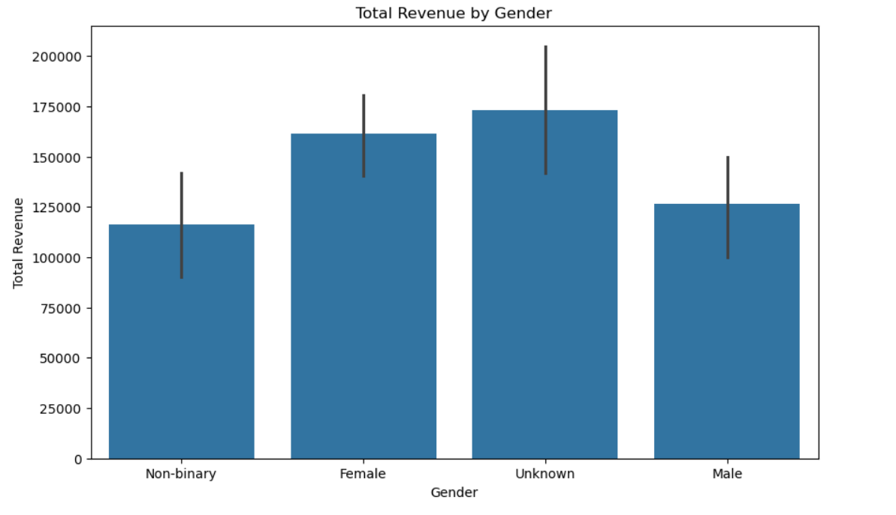

**Correct Observations from the Bar Plot**

From the bar plot, we can make the following observations:

1. **Total Revenue by Customer Group**:
   * The bar plot shows the **total revenue** generated by each customer group (unknown, non binary, Female and Male).
   * The height of each bar represents the **sum of revenue** for that group.
2. **unknown Customers**:
   * unknown customers generate the **highest total revenue**, significantly outperforming all customers.
   * This suggests that unknown customers are a **key driver of revenue** in your supply chain.
   * If you decided to replace the unknown with male as previously recommended then Males will be the highest column
3. **Female Customers**:
   * Female customers generate **less total revenue** compared to unknown customers.
4. **Non binary customers:**
   * They generate the lowest revenue

**Correct Insights**

1. **unknown Customers are the Top Revenue Contributors**:
   * Male customers generate the **majority of revenue**, making them a critical target audience for marketing and sales strategies.
   * You may want to investigate why unknown customers generate more revenue (e.g., higher purchasing power, stronger brand loyalty, or better product alignment).
2. **Female Customers Moderate**:
   * Female customers generate **significantly less revenue**, which could indicate untapped potential or mismatched product offerings.
   * You may want to explore ways to increase revenue from Female customers (e.g., targeted marketing, product customization, or pricing strategies).

### Multivariate Analysis Revenue by product type and Gender

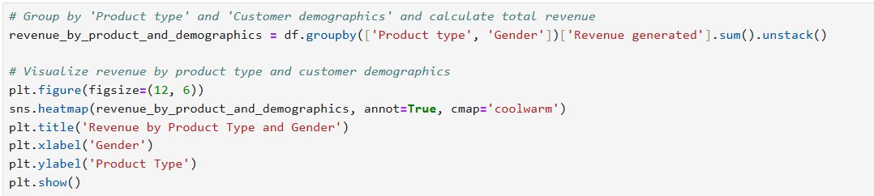

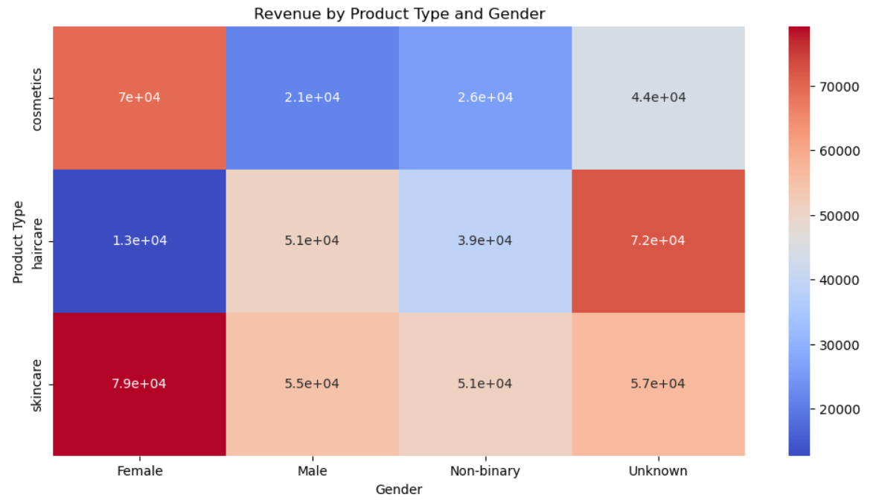

**Observations from the Heatmap**:

* Skincare dominates revenue across all genders (especially for Females)
* Male customers show unusual behavior:
* Generate highest revenue for haircare (unlike other groups)
* Lowest cosmetics spending (potential market gap)
* Unknown gender has balanced spending but may represent missed profiling opportunities

**Insights:**

1. **Gender-Specific Marketing:**

* Develop haircare campaigns targeting men (current stronghold)
* Push skincare bundles to female customers
* Investigate why cosmetics underperform with males (product formulation/packaging?)

1. **Data Collection Improvement:**

* Implement mandatory gender profiling at checkout (reduce "Unknown" category)
* Add age brackets to refine segmentation further

1. **Customer Segmentation**:
   * The significant difference in revenue between gender customers highlights the importance of **customer segmentation**.
   * Tailoring strategies to each customer group could help maximize revenue and improve customer satisfaction.
   * It is recommended to replace unknown with males and non-binary with females

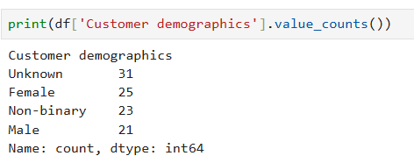

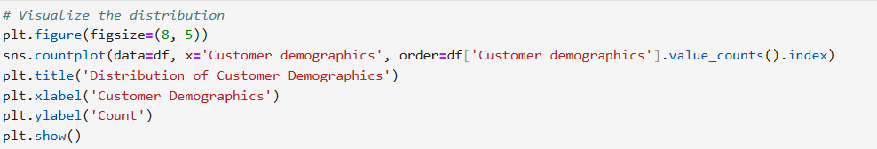

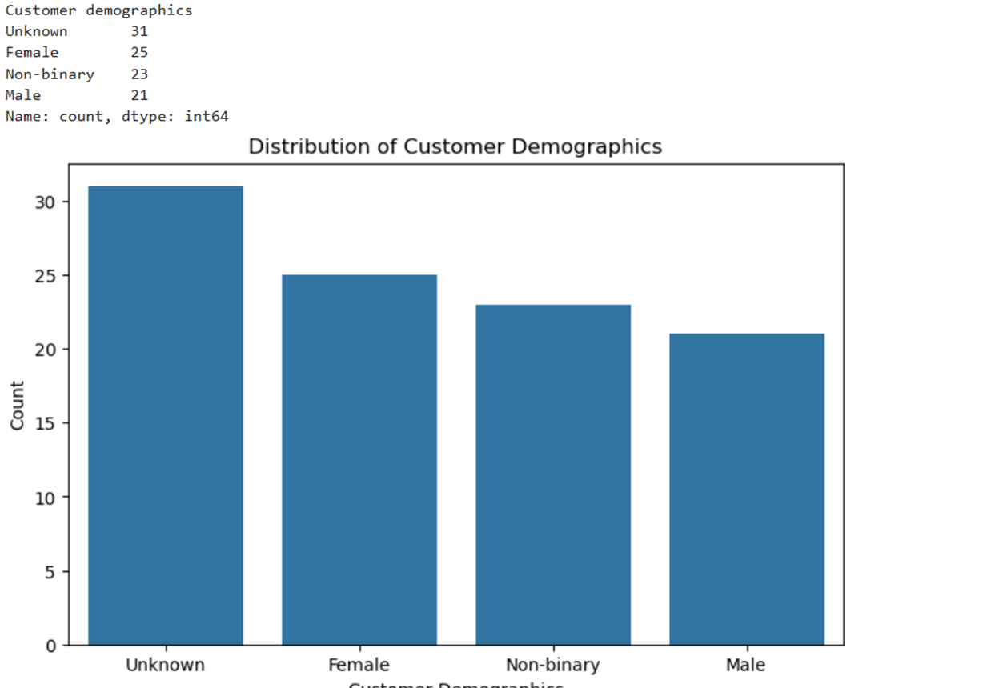

**Here’s my analysis and recommendation:**

**Analysis of the Distribution**

1. **Unknown (31):**
   * This is the most frequent value in the column. While it’s not ideal, it’s not overwhelmingly dominant (e.g., 80% of the data).
2. **Female (25), Non-binary (23), Male (21):**
   * These values are fairly evenly distributed, which means the column still contains meaningful data for analysis.

**Recommendation**

* **Keep the Column:**
  + Since the column has a relatively balanced distribution of meaningful values (Female, Non-binary, Male), it can still provide useful insights for customer segmentation and sales analysis.
  + Even though "Unknown" is the most frequent value, the other categories are well-represented and can still be analyzed.

However if you decided to deal with the unknown values, you can proceed as follow:

**How to Handle "Unknown" Values**

If you decide to keep the column, you can handle the "Unknown" values in one of the following ways:

**Option 1: Keep "Unknown" as a Separate Category**

* Treat "Unknown" as a valid category in your analysis. For example:
  + Compare sales or preferences across all categories, including "Unknown."
  + This approach is useful if you want to analyze the impact of unknown demographics on your supply chain.

**Option 2: Replace "Unknown" with the Mode (Most Frequent Known Value)**

* Replace "Unknown" with the most frequent known value (e.g., "Male" in this case).
* This approach is useful if you want to minimize the impact of missing data.

**Option 3: Drop Rows with "Unknown" Values**

* If "Unknown" values are not useful for your analysis, you can drop those rows. However, this will reduce your dataset size.

**Next Steps**

1. Decide how to handle the "Unknown" values (keep, replace, or drop).
2. Proceed with your analysis, using the Customer demographics column for customer segmentation and sales analysis.

**Example Use Cases for the Column**

Here are some ways you can use the Customer demographics column in your analysis:

1. **Sales by Demographics**:
   * Analyze which products are more popular among females, males, or non-binary customers.
   * Example: Are skincare products more popular among females?
2. **Revenue by Demographics**:
   * Compare revenue generated by different customer groups.
   * Example: Do male customers generate more revenue for haircare products?
3. **Marketing Strategies**:
   * Use the insights to design targeted marketing campaigns for specific customer groups.

To decide whether to **replace** or **drop** the "Unknown" values in the Customer demographics column, we can analyze whether the "Unknown" group behaves similarly to any of the known groups (e.g., Female, Male, Non-binary). Specifically, we can compare the **product preferences** and **purchasing behavior** of the "Unknown" group with the other groups.

Here’s how we can do it step by step:

### Step 1: Analyze Product Preferences by Customer Demographics

We’ll compare the **product types** purchased by the "Unknown" group with those purchased by the Female, Male, and Non-binary groups. If the "Unknown" group’s product preferences are similar to one of the known groups, we can replace "Unknown" with that group. If the preferences are random or unique, we should drop the "Unknown" rows.

### Step 2: Code to Compare Product Preferences

Here’s the code to compare product preferences by customer demographics:

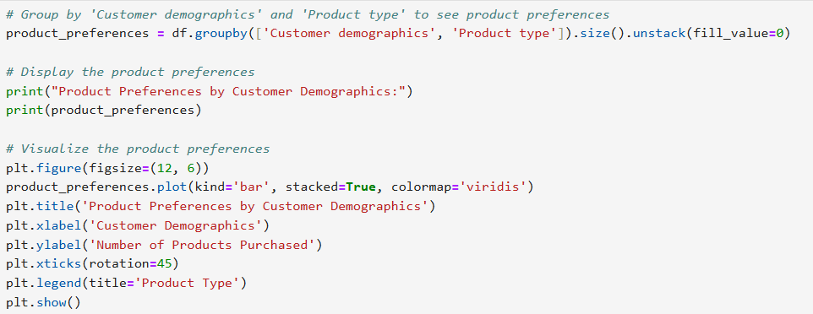

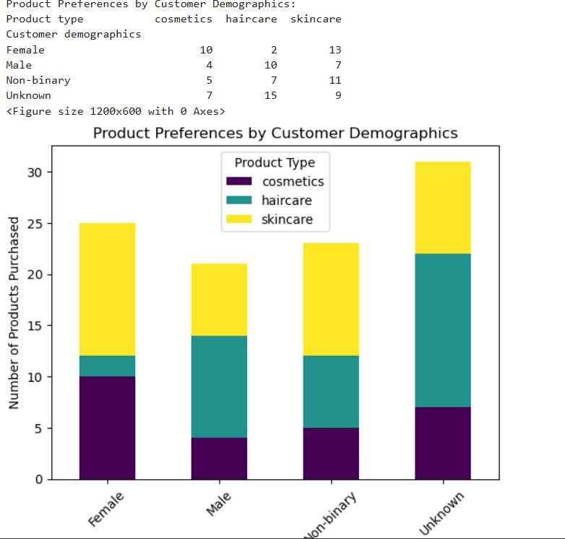

**Analysis of Product Preferences**

1. **Female**:
   * Prefers **skincare** (13) and **cosmetics** (10), with very few purchases of **haircare** (2).
2. **Male**:
   * Prefers **haircare** (10) and **skincare** (7), with fewer purchases of **cosmetics** (4).
3. **Non-binary**:
   * Prefers **skincare** (11) and **haircare** (7), with fewer purchases of **cosmetics** (5).
4. **Unknown**:
   * Prefers **haircare** (15) and **skincare** (9), with fewer purchases of **cosmetics** (7).

**Key Observations**

* The **Unknown** group’s preferences are **closest to the Male group**:
  + Both groups prefer **haircare** over other products.
  + The **Unknown** group also has a significant preference for **skincare**, similar to the **Non-binary** group.
* The **Unknown** group’s preferences are **not similar to the Female group**, which prefers **skincare** and **cosmetics**.

**Recommendation**

* **Replace "Unknown" with "Male"**:
  + Since the "Unknown" group’s preferences are closest to the **Male** group (both prefer haircare), you can replace "Unknown" with "Male."
  + This will allow you to retain the data while making it useful for analysis.

If you decided to do this, here is the code and the expected result

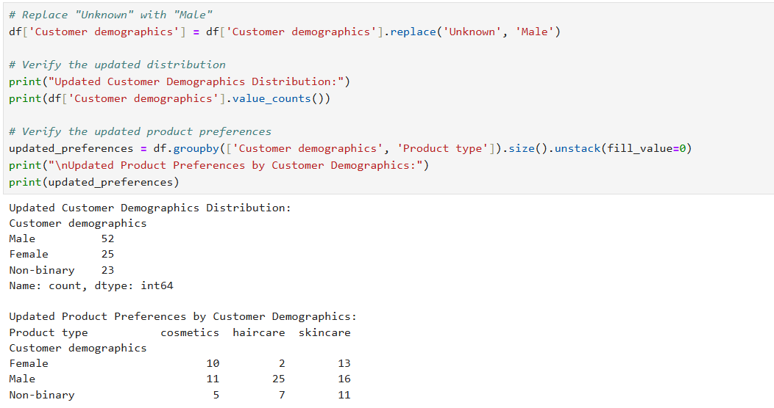

**Why This Approach?**

* **Retains Data**: You don’t lose rows by dropping "Unknown" values.
* **Improves Analysis**: By replacing "Unknown" with "Male," you can include this data in your analysis, especially for customer segmentation and product preference analysis.
* **Logical Decision**: The "Unknown" group’s preferences align most closely with the Male group, making this replacement logical.

**Analyze Non-binary Preferences**

From the updated product preferences:

* **Non-binary** customers prefer:
  + **Skincare (11)**
  + **Haircare (7)**
  + **Cosmetics (5)**

Compared to:

* **Male** customers:
  + **Haircare (25)**
  + **Skincare (16)**
  + **Cosmetics (11)**
* **Female** customers:
  + **Skincare (13)**
  + **Cosmetics (10)**
  + **Haircare (2)**

**Step 2: Decision to Replace Non-binary**

If you want to **remove the "Non-binary" category**, you have two options:

1. **Replace Non-binary with Male**:
   * This aligns with their preference for **haircare** and **skincare**, which is similar to **Male**.
2. **Replace Non-binary with Female**:
   * This aligns with their preference for **skincare**, which is similar to **Female**.

**Recommendation:**

* Since the **Non-binary** group’s preferences are **closer to Male**, it would make more sense to replace **Non-binary** with **Male**.
* However, if you have a specific reason to prefer **Female** (e.g., business context or customer segmentation goals), you can replace **Non-binary** with **Female**.

**Code to Replace Non-binary with Female**

If you decide to replace **Non-binary** with **Female**, here’s the code:

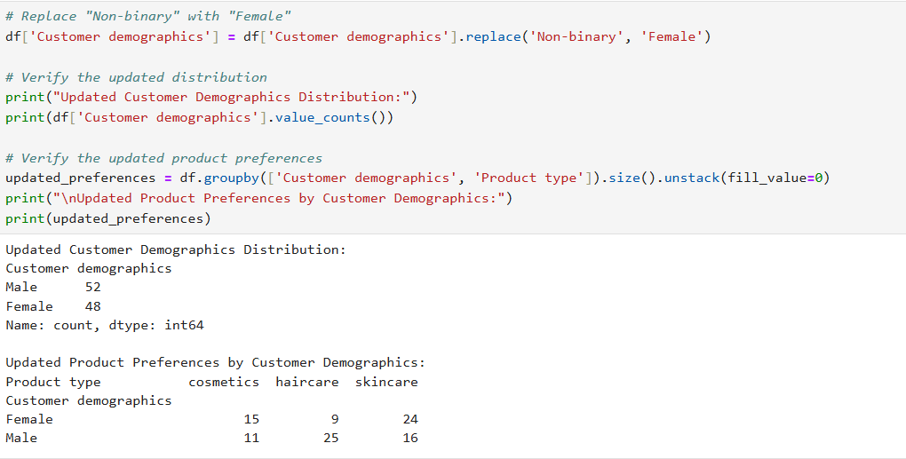

Replace column names of number of products sold with products sold only and Customer demographics with Gender

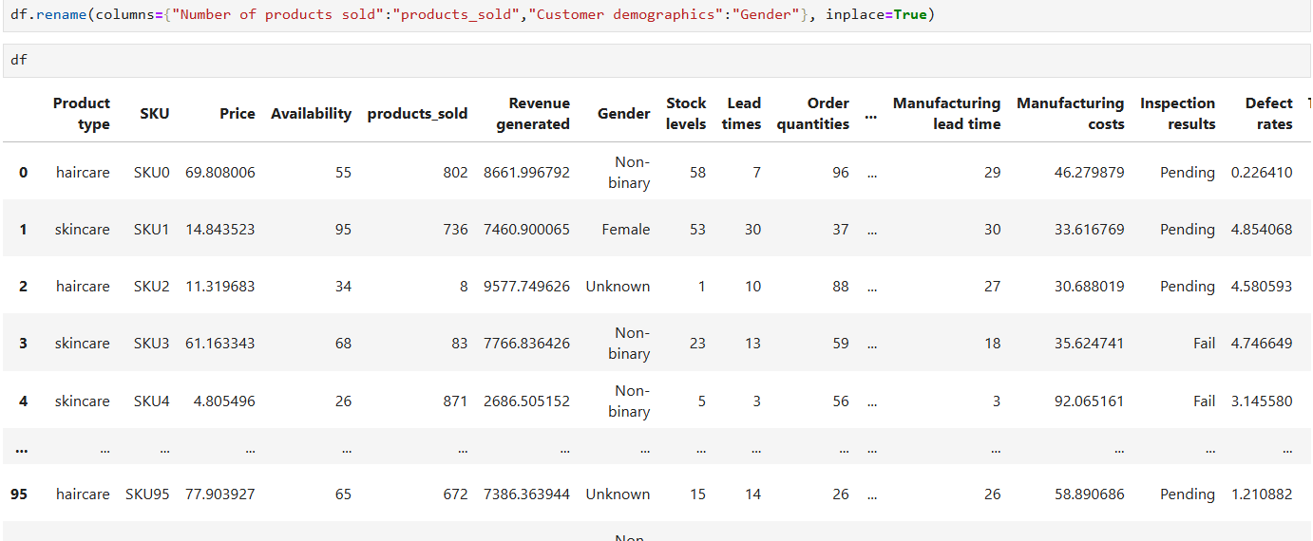

## Gender Performance via SQL

### What is the total number of products sold and total revenue generated for each gender?

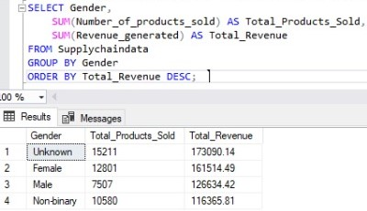

### What is the percentage of revenue generated for each Gender?

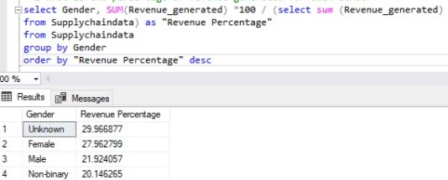

### What is the total quantity of products sold and product type for each gender?

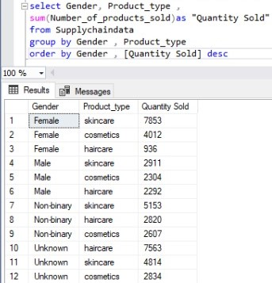

### What is the total number of products sold and total revenue generated for each location?

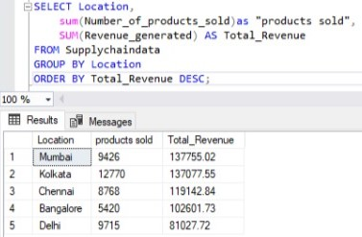

### How do various demographic factors impact sales and revenue trends?

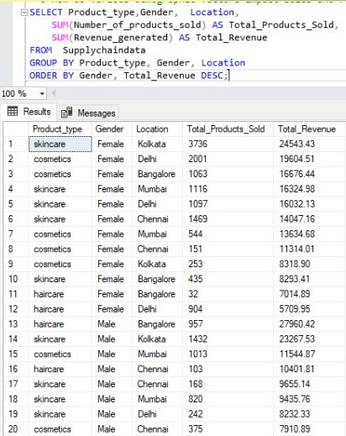

### How does customer gender influence purchasing behavior and revenue generation?

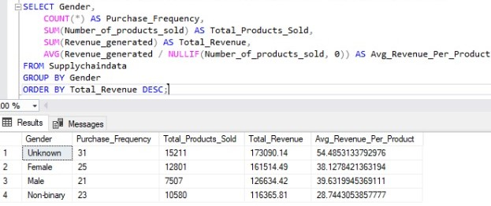

### How much revenue is generated by each customer group for different price ranges?

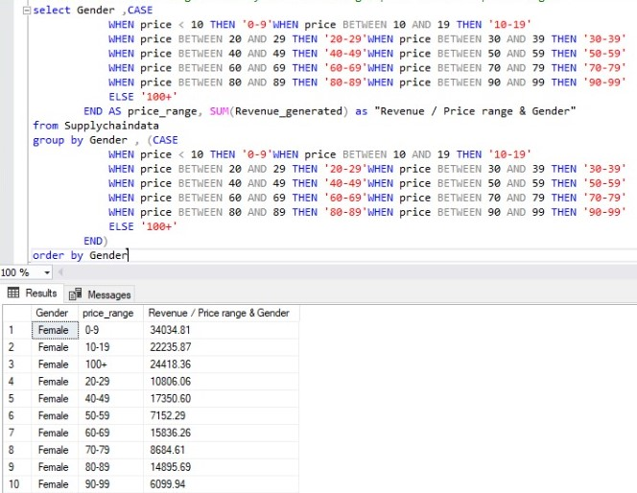

## Next Steps for EDA:

Now that you’ve analyzed the distribution of Revenue generated, you can proceed with further EDA to explore other aspects of the dataset. Here are some suggestions:

### **1.** Analyze Other Numerical Columns:

* Visualize the distribution of other numerical columns like Price, Shipping costs, Manufacturing costs, etc.
* Use histograms, box plots, or KDE plots to understand their distributions.

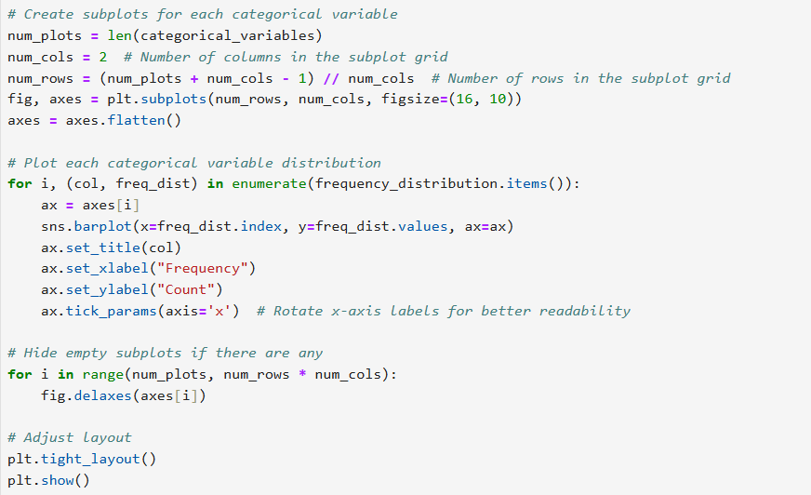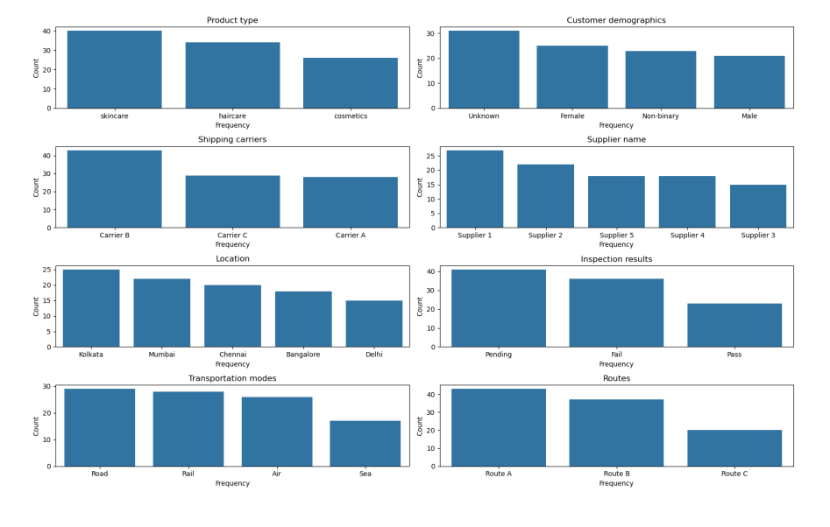

**Explore Relationships Between Variables:**

* Use scatter plots or correlation matrices to explore relationships between variables (e.g., Price vs. Revenue generated, Shipping costs vs. Revenue generated).
* Example:

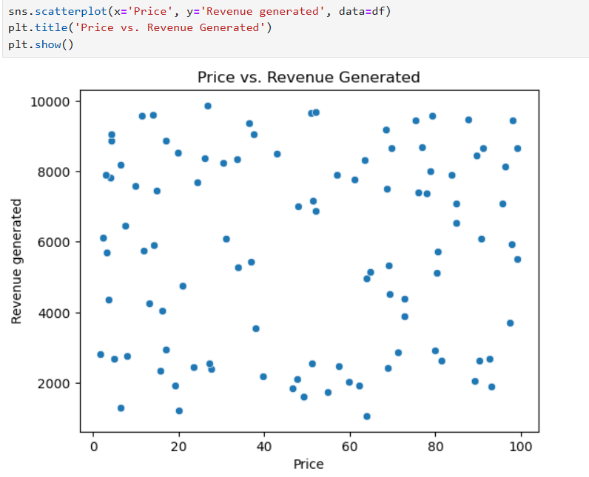

**Observations from the Scatter Plot**

From the scatter plot, we can make the following observations:

1. **General Trend**:
   * There doesn’t appear to be a **strong linear relationship** between **Price** and **Revenue Generated**.
   * Products with higher prices don’t necessarily generate significantly higher revenue, and vice versa.
2. **Clustering**:
   * Most of the data points are clustered in the **lower to mid-range** of both **Price** and **Revenue Generated**.
   * This suggests that the majority of products have **moderate prices** and generate **moderate revenue**.
3. **Outliers**:
   * There may be a few outliers where:
     + **High-priced products** generate **low revenue**.
     + **Low-priced products** generate **high revenue**.
   * These outliers could represent unique cases that warrant further investigation.
4. **No Clear Correlation**:
   * The scatter plot does not show a clear **positive or negative correlation** between **Price** and **Revenue Generated**.
   * This indicates that **price alone** may not be a strong predictor of revenue.

**Insights**

1. **Revenue is Not Solely Driven by Price**:
   * The lack of a strong correlation suggests that other factors (e.g., **product type**, **customer demographics**, **marketing efforts**) may have a more significant impact on revenue.
2. **Moderate Pricing Strategy**:
   * The clustering of data points in the **moderate price and revenue range** suggests that a **moderate pricing strategy** may be effective for most products.
3. **Outliers**:
   * The outliers (e.g., high-priced products with low revenue or low-priced products with high revenue) could represent opportunities for further analysis:
     + Why do some high-priced products generate low revenue? (e.g., low demand, poor marketing, or high competition).
     + Why do some low-priced products generate high revenue? (e.g., high demand, effective marketing, or strong customer loyalty).

## Product type and Price

analyzing the Supply Chain by looking at the relationship between the price of the products and the revenue generated by them:

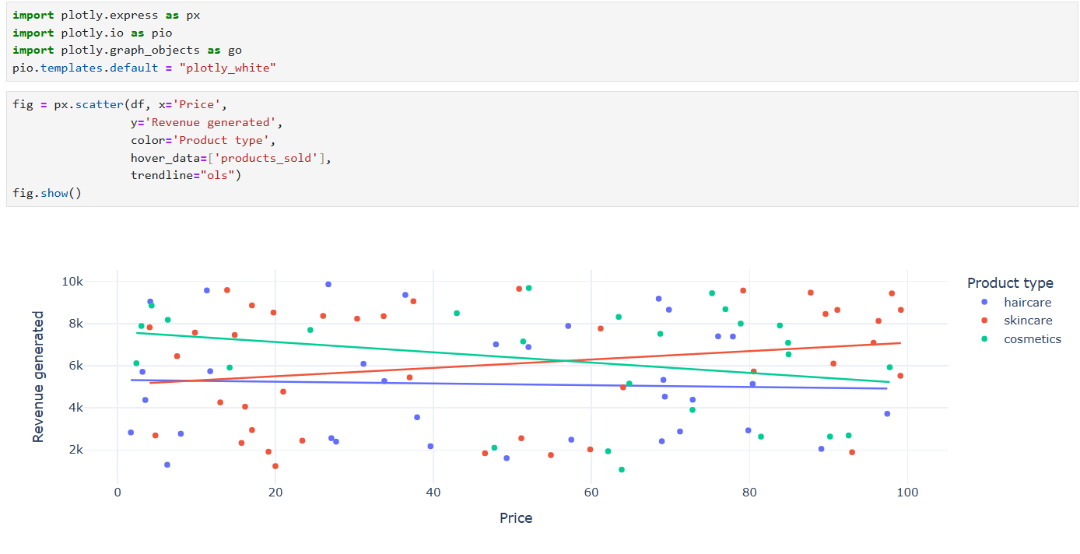

The company derives more revenue from skincare products, and the higher the price of skincare products, the more revenue they generate.

### What is the total number of products sold for each price range? (SQL)

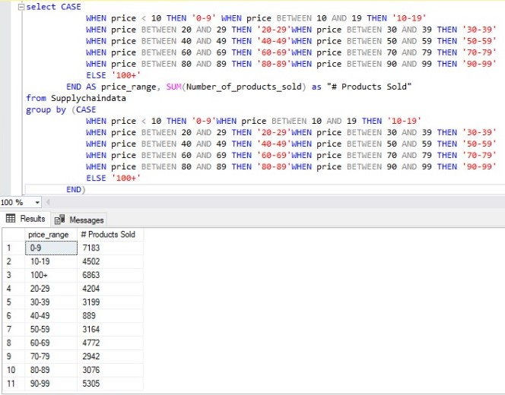

### What are the top-selling products in terms of revenue or quantity?

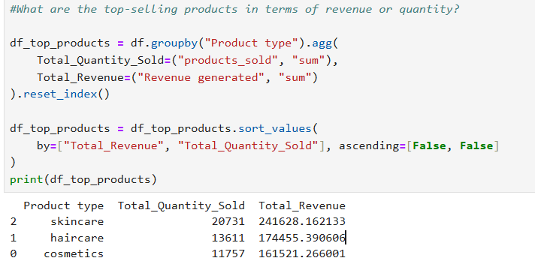

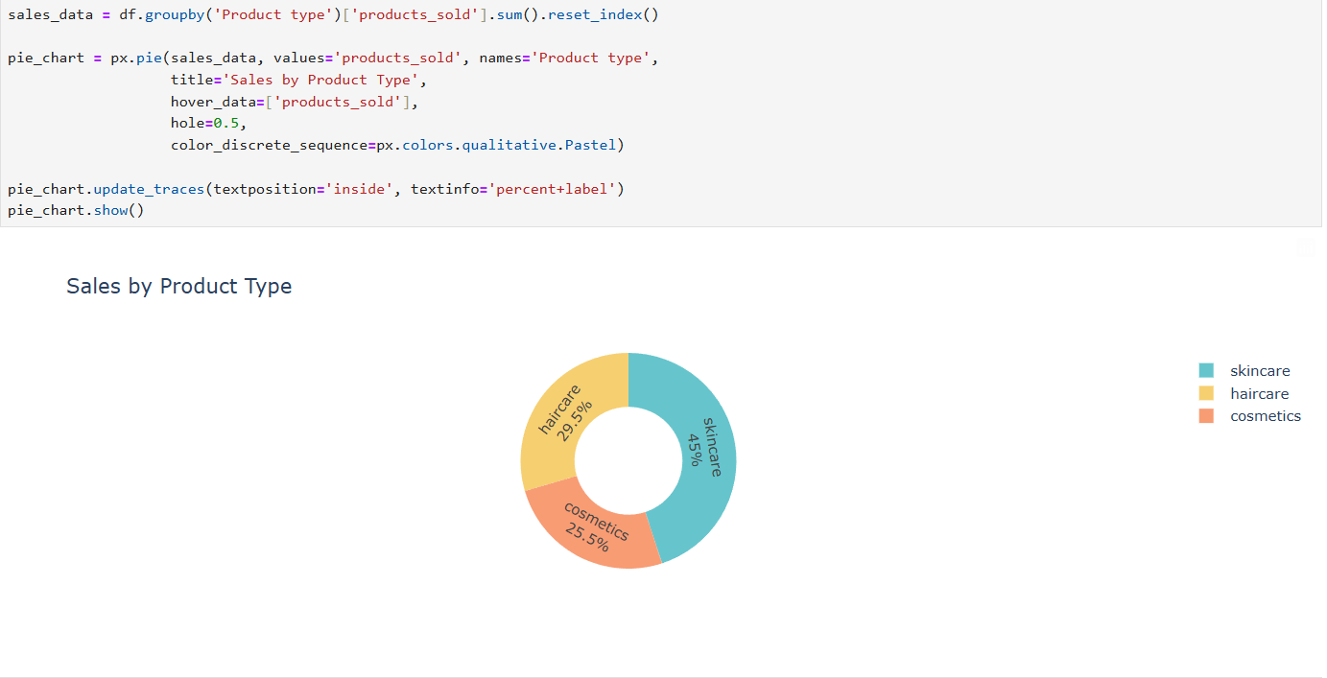

**Observations from the following Plots**

From the plots, we can make the following observations:

1. **Product Type Distribution**:
   * The dataset contains three product types: **haircare**, **skincare**, and **cosmetics**.
   * The distribution of product types is **not uniform**, meaning some product types are more common than others.
2. **Most Common Product Type**:
   * **Skincare** appears to be the **most common** product type, with the highest count in the dataset.
   * This suggests that skincare products are either more popular or more frequently produced in your supply chain.
3. **Least Common Product Type**:
   * **Cosmetics** appears to be the **least common** product type, with the lowest count in the dataset.
   * This could indicate that cosmetics are either less popular or less frequently produced.
4. **Haircare Products**:
   * **Haircare** products fall somewhere in the middle, with a moderate count compared to skincare and cosmetics.

**Insights**

1. **Skincare Dominance**:
   * The high frequency of **skincare** products suggests that this category is a **key focus area** in your supply chain.
   * You may want to investigate why skincare products are more common (e.g., higher demand, better profitability, or easier production).
2. **Cosmetics Underrepresentation**:
   * The low frequency of **cosmetics** products could indicate an opportunity for growth in this category.
   * You may want to explore whether there is untapped demand for cosmetics or if production constraints are limiting this category.
3. **Haircare Products**:
   * The moderate frequency of **haircare** products suggests that this category is stable but not as dominant as skincare.
   * You may want to analyze the performance of haircare products to identify opportunities for improvement.

### Analyze Revenue by Other Categories:

· Compare revenue generated by **Product type**, **Shipping carriers**, or **Supplier name**.

· Example:

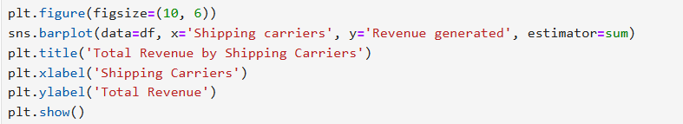

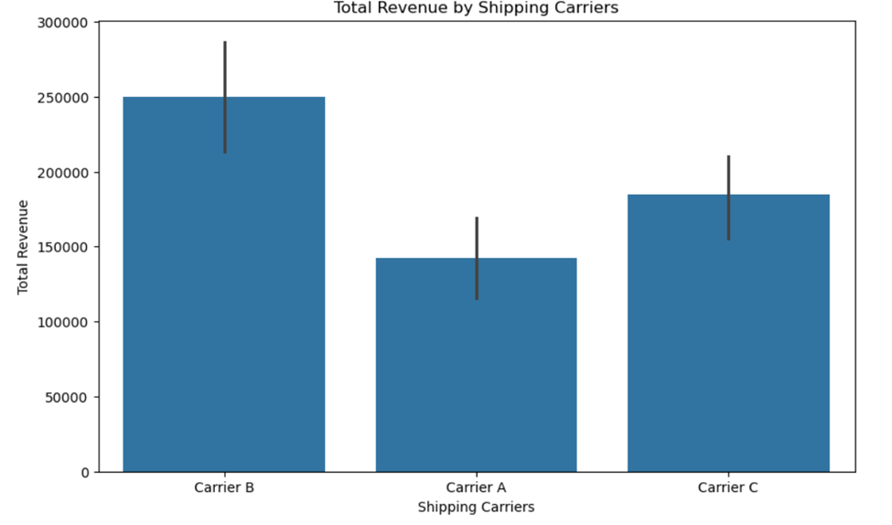

**Observations from the Bar Plot**

From the bar plot, we can make the following observations:

1. **Total Revenue by Shipping Carrier**:
   * The bar plot shows the **total revenue** generated for each shipping carrier (Carrier A, Carrier B, Carrier C).
   * The height of each bar represents the **sum of revenue** for that carrier.
2. **Carrier B**:
   * Carrier B generates the **highest total revenue**, significantly outperforming the other carriers.
   * This suggests that Carrier B is the **most effective** in terms of revenue generation.
3. **Carrier A**:
   * Carrier A generates **moderate total revenue**, falling between Carrier B and Carrier C.
   * This indicates that Carrier A is a **reliable but less dominant** option.
4. **Carrier C**:
   * Carrier C generates the **lowest total revenue**, suggesting it’s the **least effective** in terms of revenue generation.

**Insights**

1. **Carrier B is the Top Performer**:
   * Carrier B generates the **highest total revenue**, making it a critical part of your supply chain.
   * You may want to investigate why Carrier B is so effective (e.g., faster shipping times, better customer satisfaction, or lower costs).
2. **Carrier A is Consistent**:
   * Carrier A generates **moderate revenue**, indicating it’s a **stable but less impactful** option.
   * You may want to explore ways to improve its performance (e.g., optimizing routes or reducing costs).
3. **Carrier C Underperforms**:
   * Carrier C generates the **lowest total revenue**, which could indicate inefficiencies or mismatched services.
   * You may want to investigate why Carrier C underperforms and consider alternatives if necessary.
4. **Shipping Carrier Strategy**:
   * The significant difference in revenue across carriers highlights the importance of **optimizing your shipping strategy**.
   * You may want to allocate more resources to **Carrier B** and explore ways to improve the performance of **Carrier A** and **Carrier C**.

### Compare revenue generated by Supplier name

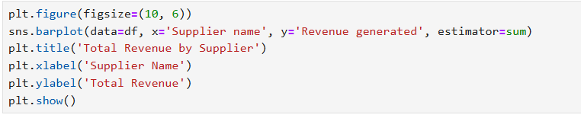

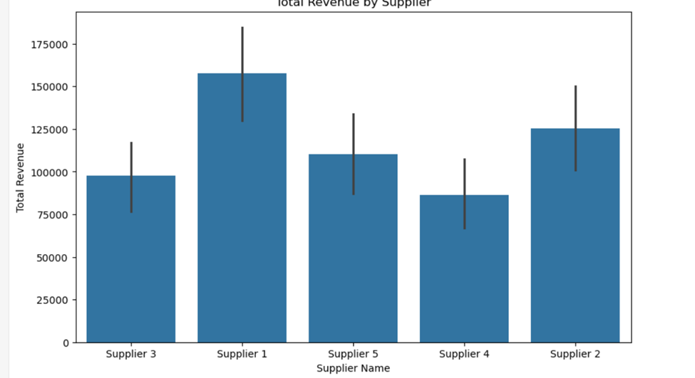

**Observations from the Bar Plot**

**From the bar plot, we can make the following observations:**

1. **Total R**evenue by Supplier:
   * The bar plot shows the total revenue generated for each supplier (Supplier 1, Supplier 2, Supplier 3, Supplier 4, Supplier 5).
   * The height of each bar represents the sum of revenue for that supplier.
2. **Supplier 1:**
   * Supplier 1 generates the highest total revenue, significantly outperforming the other suppliers.
   * This suggests that Supplier 1 is the most effective in terms of revenue generation.
3. **Supplier 2:**
   * Supplier 2 generates moderate total revenue, falling between Supplier 1 and the other suppliers.
   * This indicates that Supplier 1 is a reliable but less dominant option.
4. **Supplier 5, Supplier 4, and Supplier 3:**
   * These suppliers generate lower total revenue compared to Supplier 1 and Supplier 2.
   * Supplier 5 performs slightly better than Supplier 4 and Supplier 3, but all three are underperforming compared to the top suppliers.

**Insights**

1. **Supplier 1 is the Top Performer:**
   * Supplier 1 generates the highest total revenue, making it a critical part of your supply chain.
   * You may want to investigate why Supplier 1 is so effective (e.g., better product quality, faster delivery times, or competitive pricing).
2. **Supplier 2 is Consistent:**
   * Supplier 2 generates moderate revenue, indicating it’s a stable but less impactful option.
   * You may want to explore ways to improve its performance (e.g., optimizing processes or expanding product offerings).
3. **Suppliers 5, 4, and 3 Underperform:**
   * These suppliers generate significantly less revenue, which could indicate inefficiencies or mismatched services.
   * You may want to investigate why these suppliers underperform and consider alternatives if necessary.
4. **Supplier Strategy:**
   * The significant difference in revenue across suppliers highlights the importance of optimizing your supplier strategy.
   * You may want to allocate more resources to Supplier 1 and explore ways to improve the performance of Supplier 2, Supplier 5, Supplier 4, and Supplier 3.

### Compare revenue generated by Location

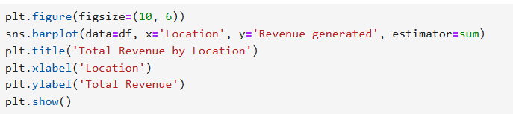

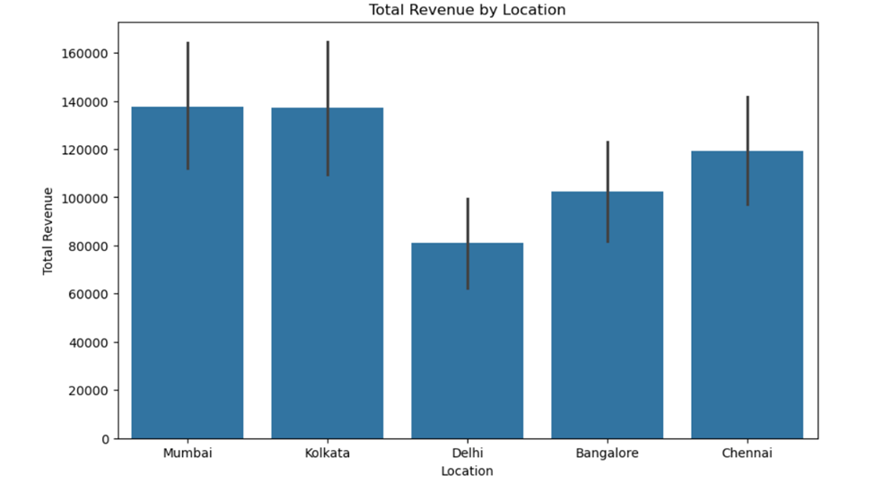

**Observations from the Bar Plot**

**From the bar plot, we can make the following observations:**

**Observations:**

1. **Mumbai and Kolkata have the highest total revenue**, both being similar in value (~140,000).
2. **Delhi has the lowest total revenue**, significantly lower (~80,000) compared to Mumbai and Kolkata.
3. **Bangalore and Chennai have moderate total revenue**, with Bangalore being slightly lower than Chennai.
4. **Error bars indicate revenue variability**, with Mumbai and Kolkata having higher uncertainty, while Delhi has relatively lower variability.

**Insights:**

1. **Mumbai and Kolkata are the top-performing locations**, possibly due to higher sales or larger customer bases.
2. **Delhi underperforms significantly**, suggesting potential issues such as lower market demand, weaker sales strategies, or external economic factors.
3. **Bangalore and Chennai have room for growth**, as they show mid-range revenue levels.
4. **High variability in Mumbai and Kolkata suggests potential fluctuations**, meaning revenue in these cities might not be consistent over time.

**Recommendations:**

* Top Cities: Invest in inventory/logistics for Mumbai/Delhi to meet demand.
* Low-Revenue Cities: Run customer surveys to identify barriers (e.g., awareness, distribution).

### Total Revenue by Transportation modes

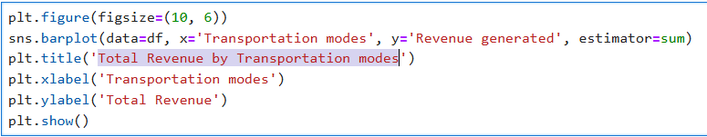

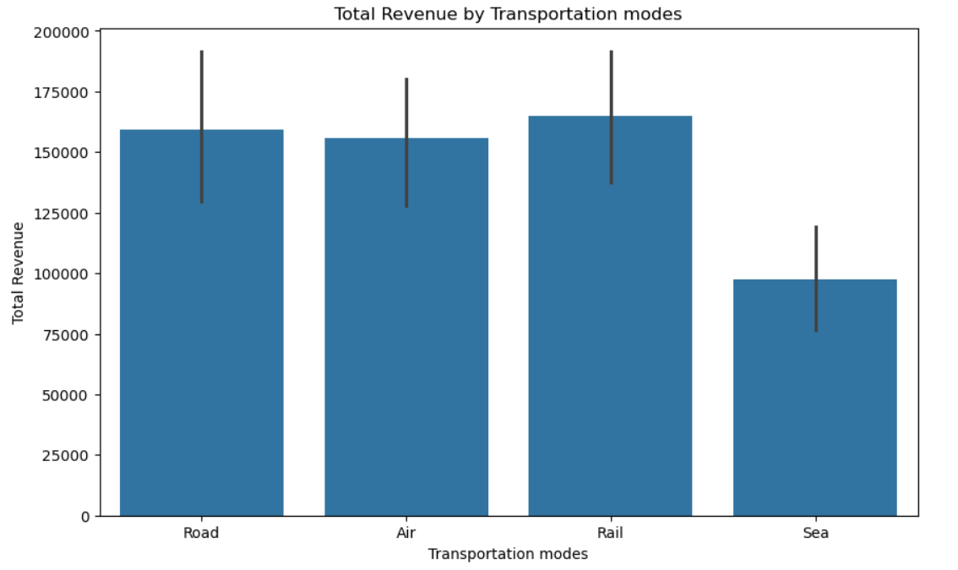

**Observations:**

1. **Revenue Distribution:**

* The chart compares revenue generated across 4 transportation modes: Road, Air, Rail, and Sea.
* Rail transportation generates the highest revenue, followed by Road and Air, while Sea contributes the least.

1. **Revenue Range:**

* Rail revenue peaks near 200,000 units, while Sea revenue is the lowest (close to 25,000 units or less).
* Road and Air revenues fall in the mid-range (between 50,000–150,000 units).

**Insights:**

1. **Dominance of Rail Transport:**

* Rail is the most revenue-generating mode, likely due to its flexibility, cost-effectiveness, or wider coverage.
* Consider optimizing logistics (e.g., fleet management, route efficiency) to further capitalize on this strength.

1. **Mid-Performing Modes (Road/ Air):**

* Air may serve high-value or urgent shipments, while Road could be used for bulk goods. Investigate if demand aligns with these use cases.
* Potential to increase Rail revenue by negotiating better freight rates or improving scheduling.

1. **Low Revenue from Sea:**

* Sea transport’s minimal contribution suggests it’s either underutilized or limited to specific low-demand routes (e.g., international exports).
* Explore whether port delays or high costs are suppressing its adoption.

1. **Recommendations:**

* Leverage Rail’s Success: Expand fleet capacity or partner with local logistics providers in high-demand regions.
* Optimize Road/Air: Bundle services (e.g., Air for speed + Road for cost) or offer discounts for bulk Road shipments.
* Revive Sea Revenue: Audit sea routes for bottlenecks; consider promotional pricing for international customers.

## Analyzing SKUs

* There’s a column in the dataset as SKUs. You must have heard it for the very first time. So, SKU stands for Stock Keeping Units. They’re like special codes that help companies keep track of all the different things they have for sale. Imagine you have a large toy store with lots of toys. Each toy is different and has its name and price, but when you want to know how many you have left, you need a way to identify them. So you give each toy a unique code, like a secret number only the store knows. This secret number is called SKU.

### Revenue generated by SKU

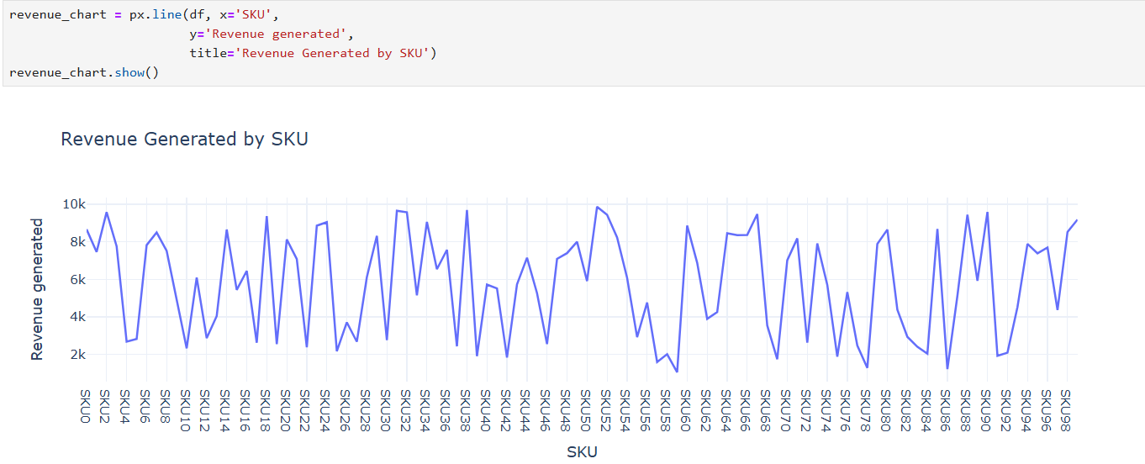

### Inventory Optimization Analysis

**Columns to Explore: Stock levels, Availability, Number of products sold**

**Potential Insights:**

* Identify overstocked SKUs tying up capital
* Pinpoint frequently out-of-stock products losing sales
* Recommend dynamic reorder points by product category

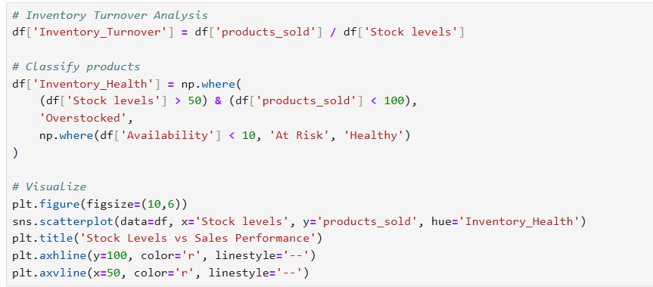

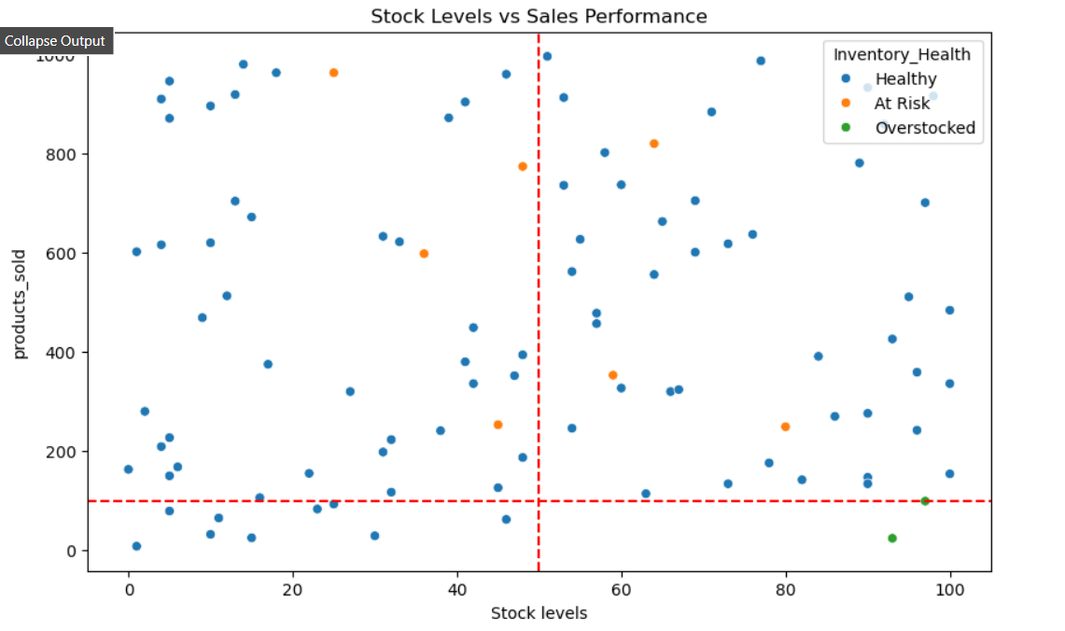

**Interpreting the Current Visualization**

**What We Can Learn from the Graph:**

1. **Quadrant Analysis:**

* Top-Right (High Stock, High Sales): Potential star products deserving priority replenishment
* Top-Left (Low Stock, High Sales): Stockout risks needing urgent attention
* Bottom-Right (High Stock, Low Sales): Capital traps requiring markdowns/discontinuation

1. **Health Categories:**

* The "At Risk" items near the x-axis represent products with low availability that may need safety stock adjustments
* "Overstocked" items in high-stock/low-sales zones show where capital is being wasted

**Add Business Context Layers**

**Even with random data, we can practice building actionable frameworks:**

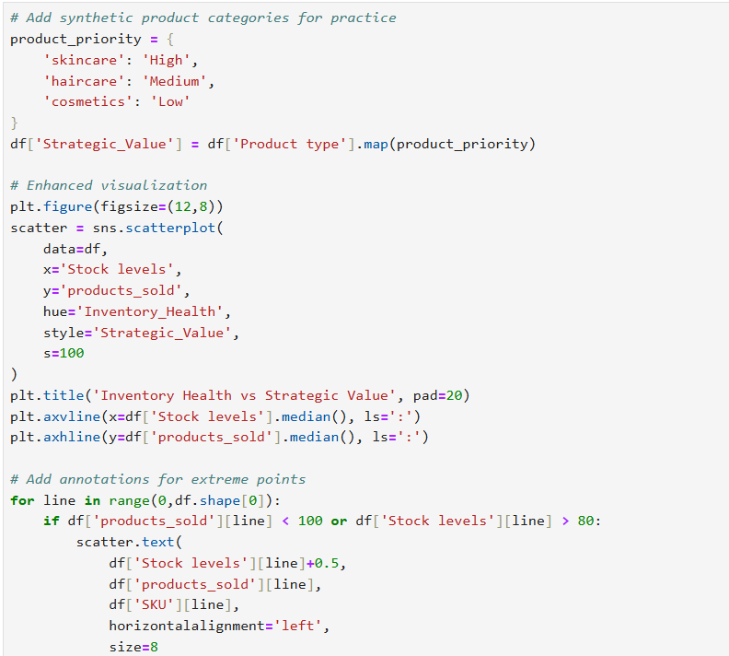

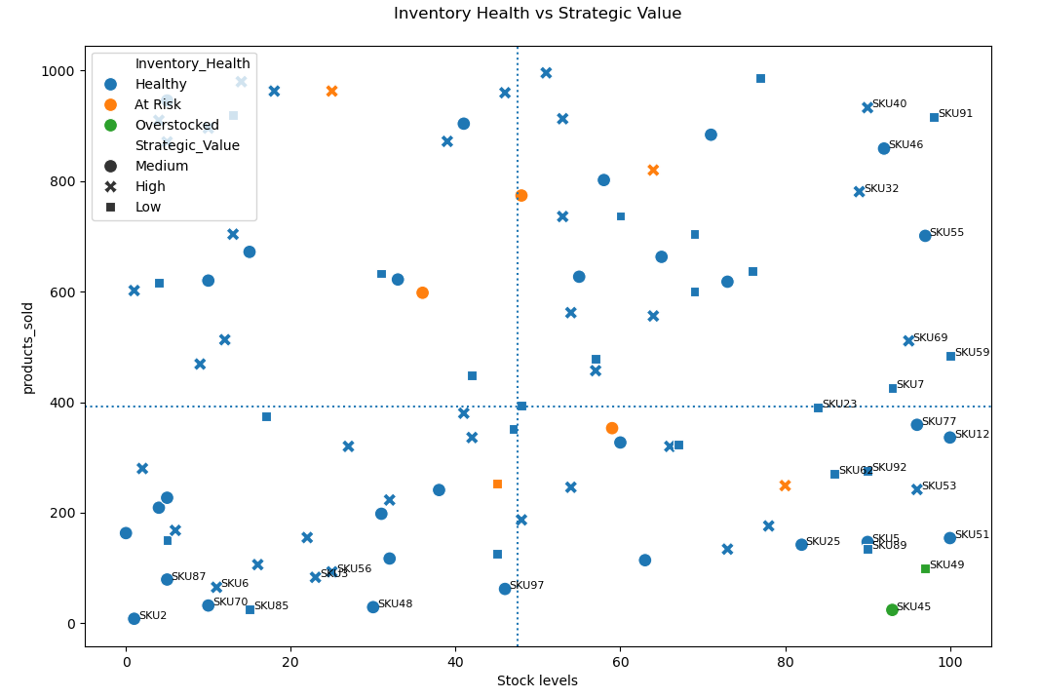

**Key Observations from Enhanced Visualization**

1. **Strategic Alignment Issues:**

* Several High-priority skincare products (red triangles) appear in the "Overstocked" zone (e.g., SKU85, SKU6) - indicates potential misallocation of capital
* Low-priority cosmetics (green circles) in "Healthy" zone show proper inventory discipline

1. **Critical Stockouts:**

* SKU87 (high strategic value) is in "At Risk" with low stock levels despite good sales - urgent replenishment needed

1. **Hidden Opportunities:**

* SKU40 and SKU91 (medium priority) show strong sales with healthy stock - candidates for increased promotion

### Creating Actionable Segments

**Objective:** Categorize products into clear action buckets based on inventory health and strategic value.

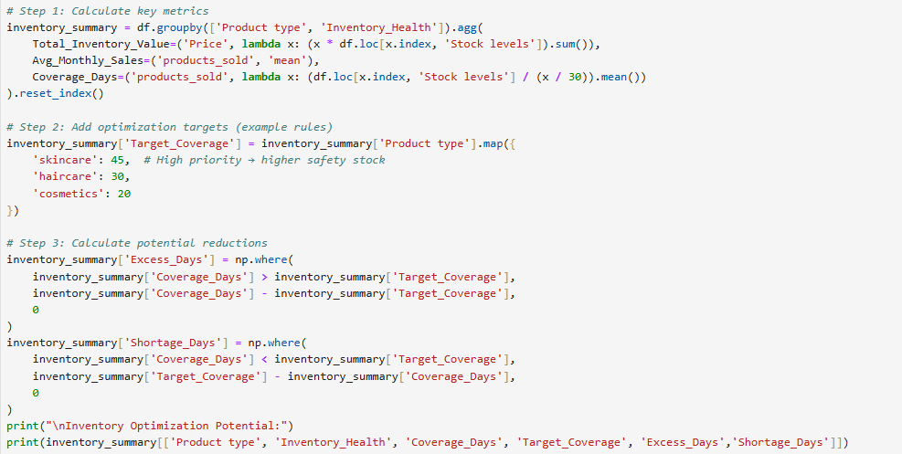

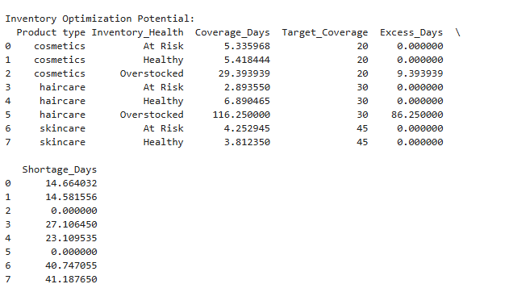

**Key Findings:**

**Severe Overstocking in Haircare:**

* 86 excess days of inventory (116 vs target 30)
* Action: Gradual stock reduction through promotions or paused reorders

**Cosmetics Overstock:**

* 9 excess days (29 vs target 20)
* Action: Minor adjustments needed
* Excess Days: Haircare has 86 excess days (needs urgent reduction)
* Shortage Days: All "At Risk" items show significant shortages (14-41 days below target)
* Emergency Replenishment: 6 SKUs identified (mix of High/Medium priority)

**Actionable Insight:**

Prioritize reducing haircare stock by ~75% (from 116 to 30 days coverage) and accelerate replenishment for skincare shortages.

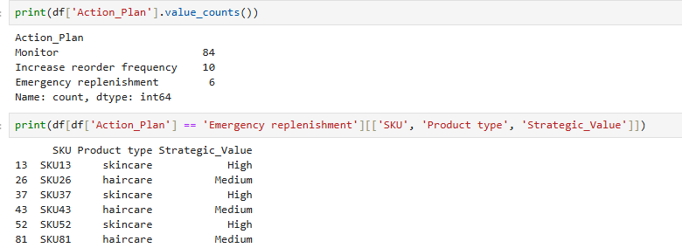

**Action Plan Distribution (Good Balance)**

* Your value counts show a reasonable distribution:
* Monitor (84): Healthy inventory
* Increase reorder (10): Fast-moving items
* Emergency replenishment (6): Critical shortages

**Validation:**

Check if high-priority items (skincare) are among the 6 emergency cases:

### Building an Interactive Dashboard (Jupyter Only)

**Objective:** Create a simple tool to inspect products dynamically.

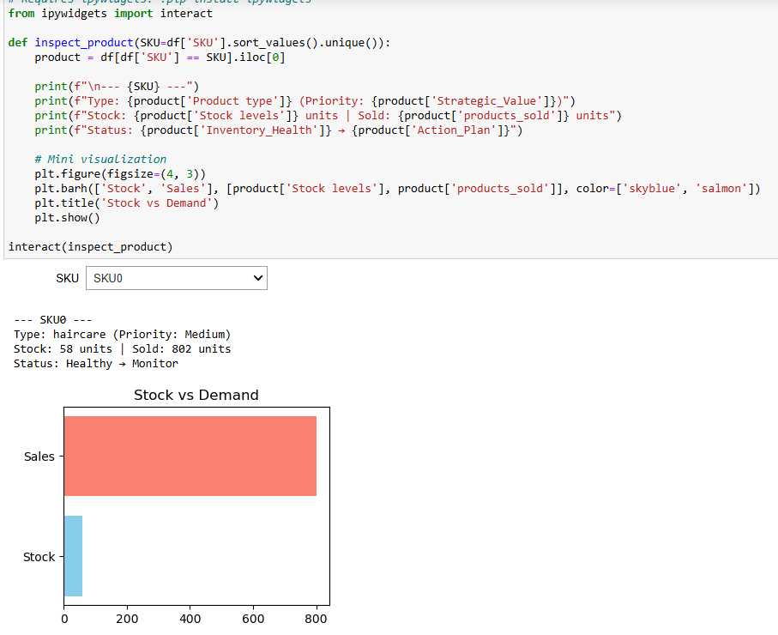

## Measuring the effect of stock levels via SQL

### Which products have the highest stock to sales ratio, and what is the number of orders for each?

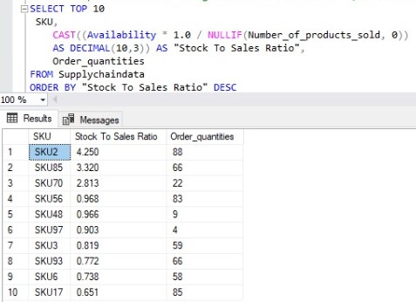

### Which products have the lowest stock to sales ratio, and what is the number of orders for each?

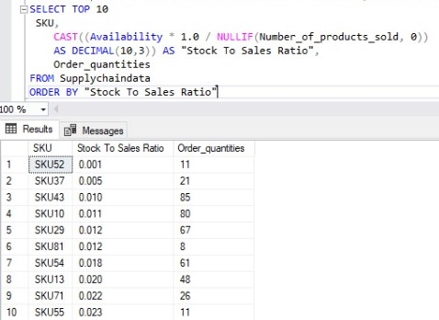

### What is the relationship between the number of products sold and stock levels for each product type?

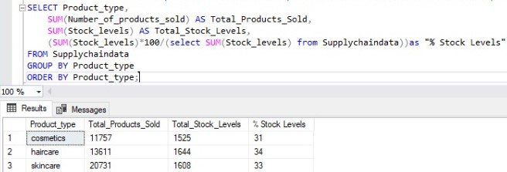

### Which are the top 5 SKUs based on revenue generation and the percentage of total products sold for each?

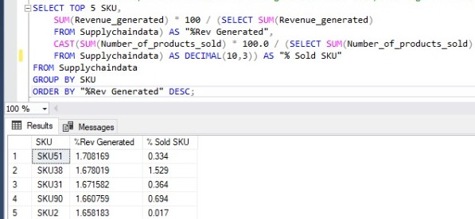

### Which are the bottom 5 SKUs based on revenue generation and the percentage of total products sold for each?"

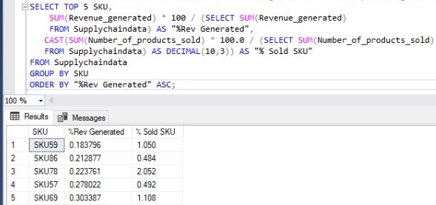

### What are the top 5 SKUs based on the percentage of products sold and revenue generated?

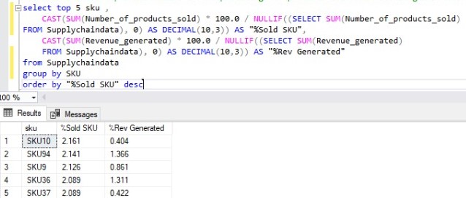

### What are the bottom 5 SKUs based on the percentage of products sold and revenue generated?

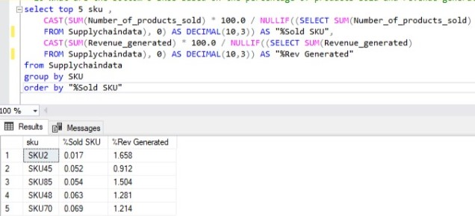

## Shipping Costs by Transportation Mode

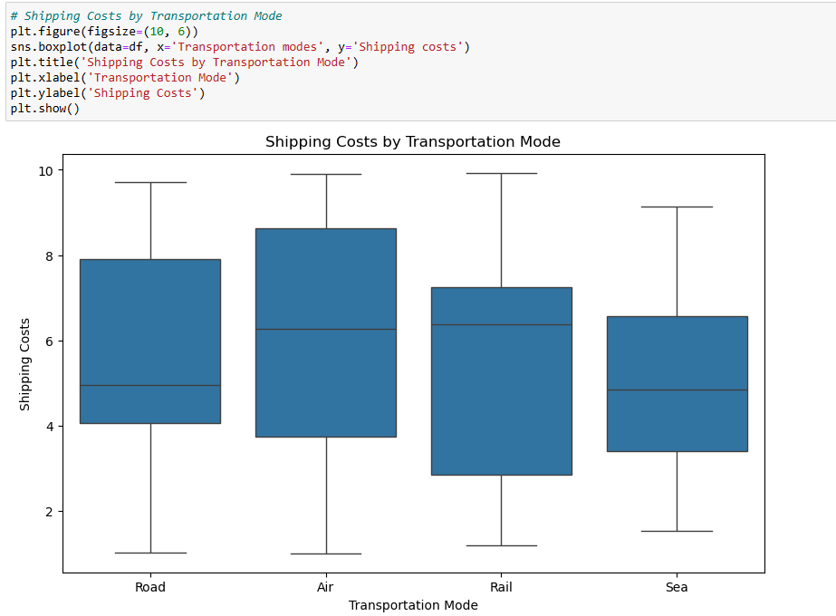

**Results:**

* The box plot shows the distribution of shipping costs for four transportation modes: Road, Air, Rail, and Sea.
* Air transportation has the highest shipping costs, followed by Road, Rail, and Sea.
* **Insight:**
  + Air is the most expensive mode, likely due to its speed and efficiency.
  + Sea is the cheapest mode, but it may have longer lead times.
  + Road and Rail fall in the middle, offering a balance between cost and speed.

**Key Takeaways from Bivariate Analysis:**

1. **Product Type and Revenue:**
   * **S**kincare is the most profitable product type, contributing the most to total revenue.
   * This insight could help prioritize marketing efforts, inventory management, and product development for skincare products.
2. **Transportation Mode and Shipping Costs:**
   * Air transportation is the most expensive, while sea transportation is the cheapest.
   * This insight could help optimize shipping strategies by balancing cost and delivery time. For example:
     + Use air for urgent deliveries.
     + Use sea for non-urgent, bulk shipments to reduce costs.

## Defect Rates vs. Supplier:

Analyze defect rates by supplier to identify quality control issues.**·**

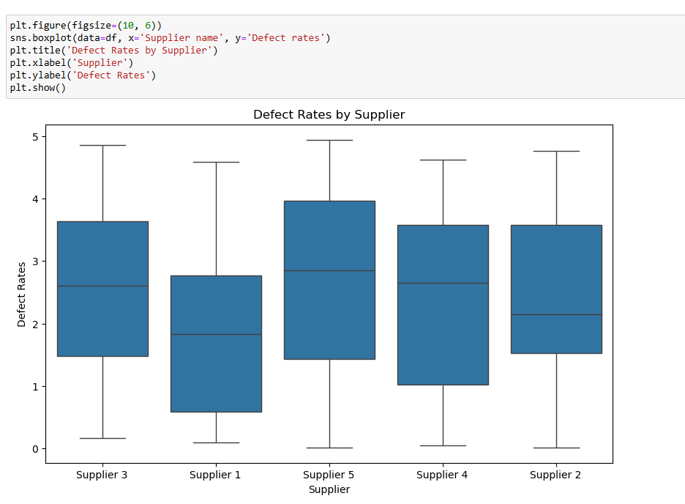

**The box plot shows the distribution of defect rates for each supplier:**

* Supplier 1, Supplier 2, Supplier 3, Supplier 4, and Supplier 5.
* Supplier 3 has the highest median defect rate, followed by Supplier 1 and Supplier 5.
* Supplier 2 and Supplier 4 have the lowest defect rates.

**Insight:**

* Supplier 3 may have quality control issues that need to be addressed.
* Supplier 2 and Supplier 4 are the most reliable in terms of product quality.

**This analysis can help prioritize supplier evaluations and negotiations to improve overall product quality.**

## Defect Rates by Supplier

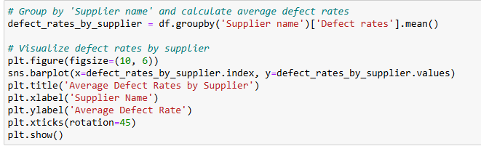

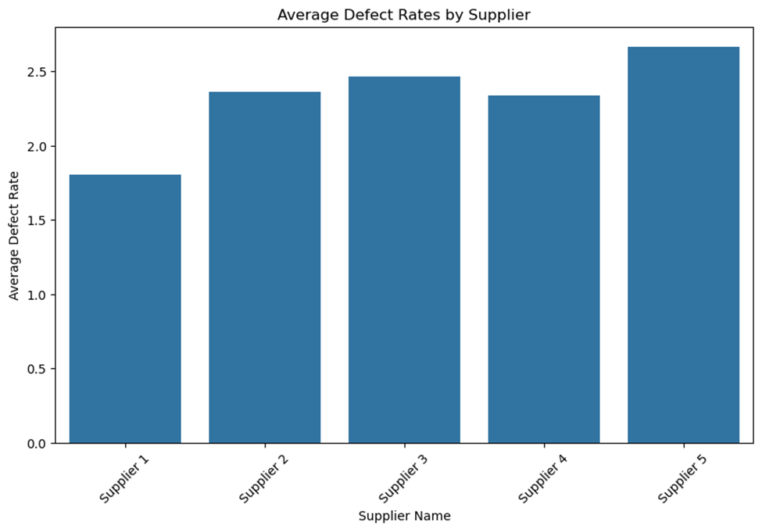

## On-Time Delivery by Shipping Carrier

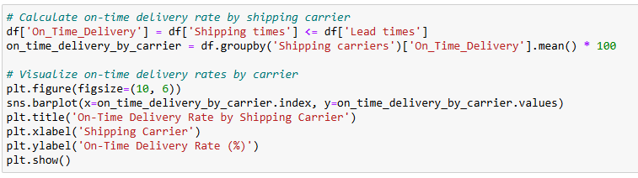

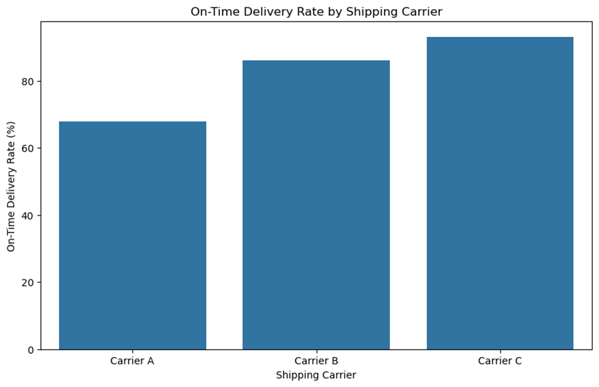

**Key Insights:**

* Carrier A has the highest on-time delivery rate, followed by Carrier B and Carrier C.
* This suggests that Carrier A is the most reliable in terms of meeting delivery deadlines.

**Supplier Performance Dashboard**

**Prior EDA Findings:**

* Supplier 1 generates highest revenue (from revenue-by-supplier analysis)
* Supplier 5 has highest defect rates (from defect-rate heatmap)
* Carrier A has best on-time delivery (from shipping analysis)

## New Analysis: Cost vs. Quality Tradeoff

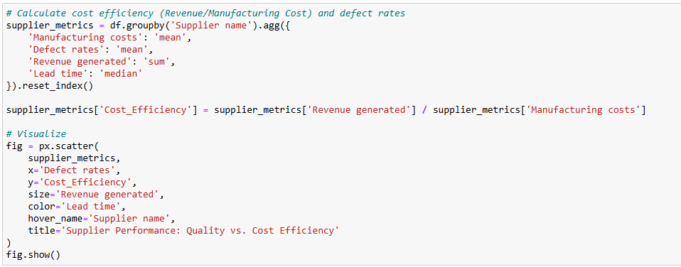

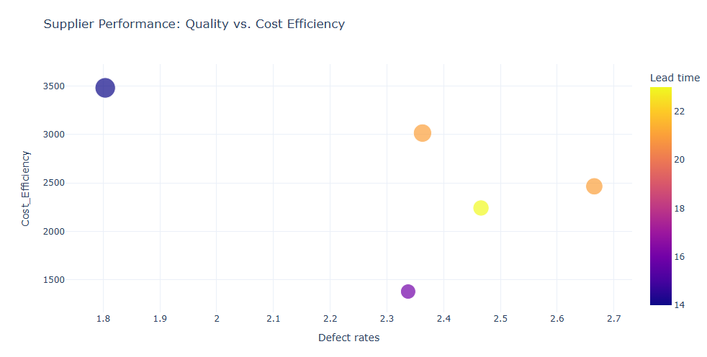

**Key Observations:**

**Cost Efficiency:**

* Values range from 1500 to 3500 (units not specified, possibly monetary units like dollars per unit).
* Lower values indicate better cost efficiency.

**Quality Metrics:**

* Defect Rates: Values range from 1.8 to 2.7 (likely percentages or defects per unit).
* Lead Time: Values range from 14 to 22 (units not specified, possibly days).

**Tradeoff Analysis:**

* The chart (though not fully visible) seems to plot cost efficiency against quality metrics (defect rates and lead time).
* Typically, suppliers with lower defect rates or shorter lead times may have higher costs, and vice versa.

**Suggested Next Steps:**

* Clarify Units: Confirm the units for cost efficiency, defect rates, and lead time.
* Visualization: If this is part of a scatter plot or multi-axis chart, ensure labels and legends are clear.
* Supplier Benchmarking: Identify which suppliers fall into the "optimal" quadrant (e.g., low cost + high quality).

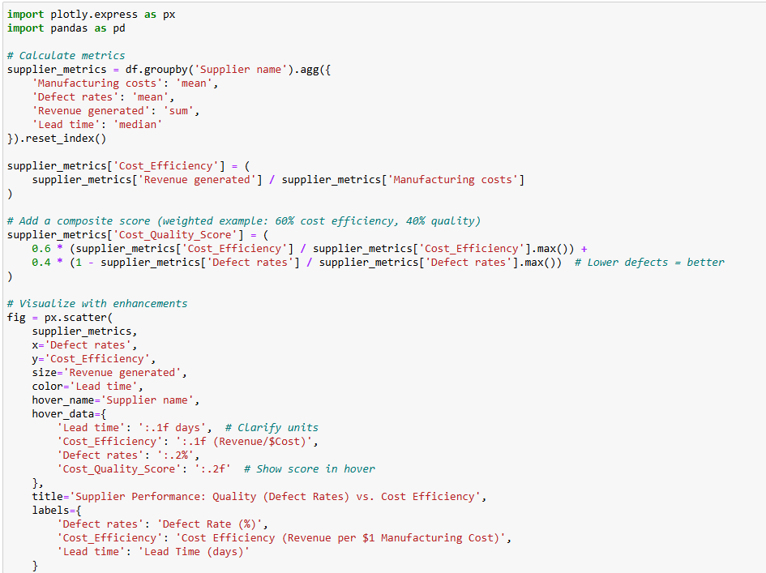

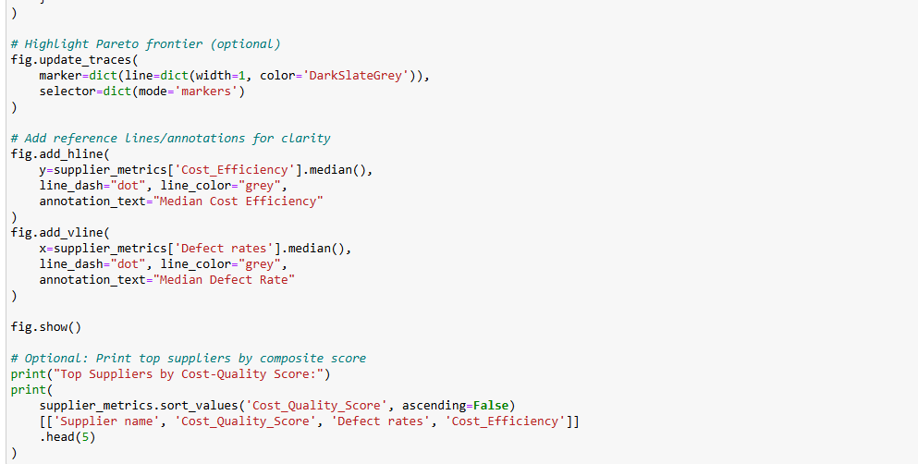

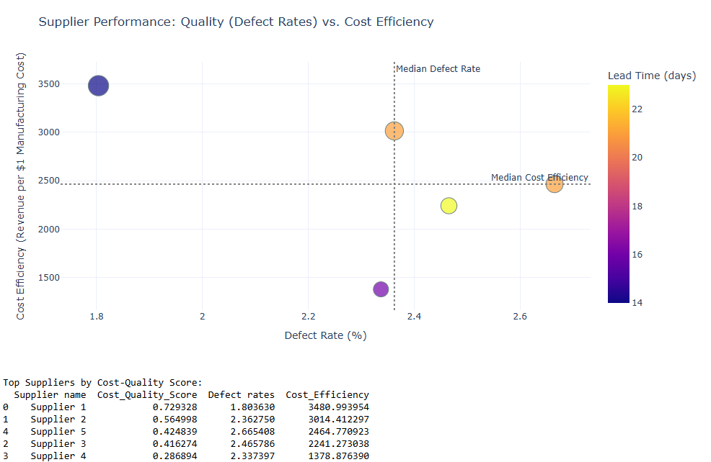

**Observations & Insights from the Enhanced Supplier Performance Analysis**

1. **Cost Efficiency vs. Defect Rates Tradeoff**

* Supplier 1 stands out as the top performer, with:
* Highest Cost Efficiency (3480.99 Revenue/$Cost)
* Lowest Defect Rate (1.8%)
* Best Cost-Quality Score (0.729)
* This suggests Supplier 1 delivers both high revenue per cost and superior quality.
* Supplier 4 is the weakest performer, with:
* Lowest Cost Efficiency (1378.88 Revenue/$Cost)
* Moderate Defect Rate (2.34%)
* Likely a high-cost, mediocre-quality supplier.
* Supplier 2 and Supplier 5 show a tradeoff:
* Supplier 2 has better efficiency (3014.41) but higher defects (2.36%) than Supplier 5.
* Supplier 5 has lower efficiency (2464.78) but slightly better defects (2.67%) than Supplier 2.

Choosing between them depends on whether cost or quality is prioritized.

1. **Lead Time Insights (Color Gradient)**

* Supplier 1 has a lead time of 22 days (longest), yet it outperforms in efficiency and quality.
* Possible insight: Longer lead times may correlate with better quality (more production time).
* Supplier 4 has the shortest lead time (14 days) but the worst efficiency.→ Fast delivery may come at the expense of cost or quality.

1. **Benchmarking Against Medians**

* Median Defect Rate (~2.2%):
* Suppliers 1, 2, and 3 are below median (better quality).
* Suppliers 4 and 5 are above median (worse quality).
* Median Cost Efficiency (~2000-2500):
* Only Supplier 1 and 2 are above median (more cost-efficient).

1. **Actionable Recommendations**

* ✅ Prioritize Supplier 1 for high-revenue, high-quality needs (despite longer lead time).
* ⚠️ Evaluate Supplier 2 vs. Supplier 5:
* If cost matters more, choose Supplier 2.
* If quality matters more, choose Supplier 5.
* ❌ Reassess Supplier 4 (poor efficiency, mediocre quality).

1. **Potential Improvements**

* Negotiate with Supplier 1 to reduce lead time without sacrificing quality.
* Investigate Supplier 4’s high costs—could there be inefficiencies?
* Adjust score weights if lead time is critical (e.g., add it to Cost_Quality_Score).

**Final Thought**

* This analysis reveals clear winners (Supplier 1) and tradeoffs (Supplier 2 vs. 5). The next step could be:
* Drill into Supplier 1’s processes to replicate success.
* Conduct a root-cause analysis for underperformers (e.g., Supplier 4).

## Supplier Manufacturing Performance via SQL

### Which suppliers have the shortest lead times?

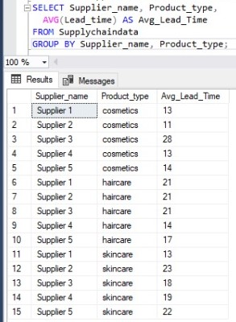

### How does the average production volume differ across suppliers and locations?

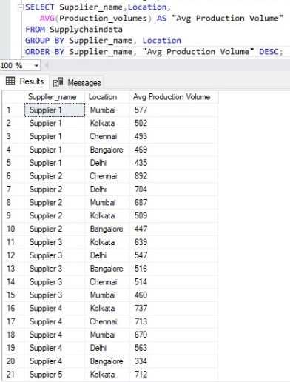

### Evaluate supplier performance based on average lead time and manufacturing costs?

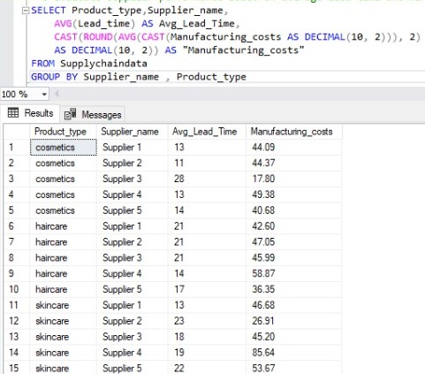

### What is the percentage of total products sold by each supplier?

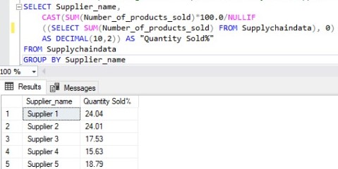

### How efficient is each supplier in terms of production volume and manufacturing duration?

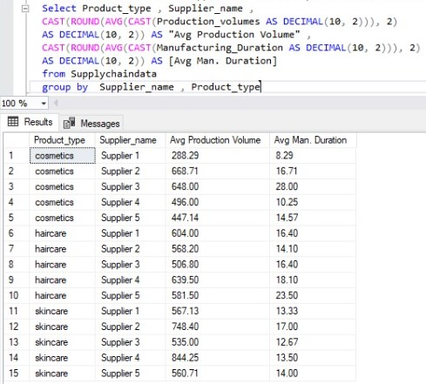

### What is the total production volume by supplier, product type, and location?

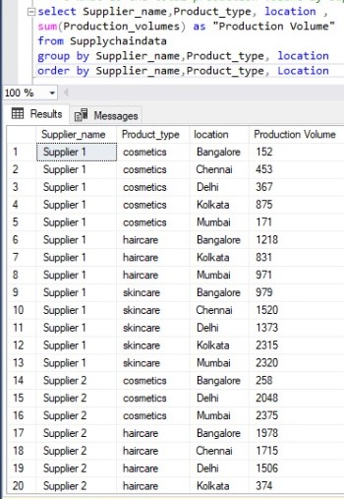

### What is the average net profit margin for each supplier and product type?

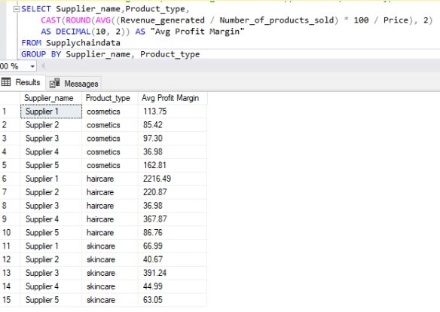

### How many products did each supplier sell per product type?

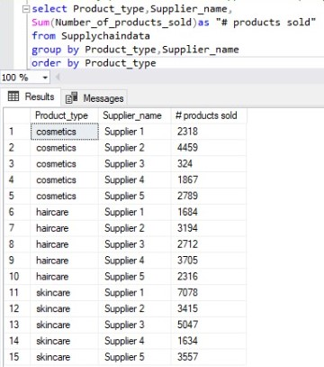

### Revenue % by supplier?

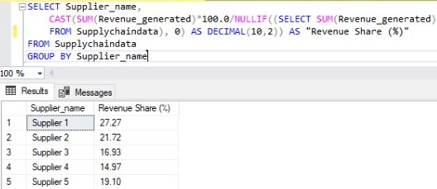

## Defect Rates

To explore **Defect Rates by Product Type**, we can group the data by the Product type column and calculate the average defect rates for each product type. Then, we can visualize the results using a bar plot. Here's the code to achieve this:

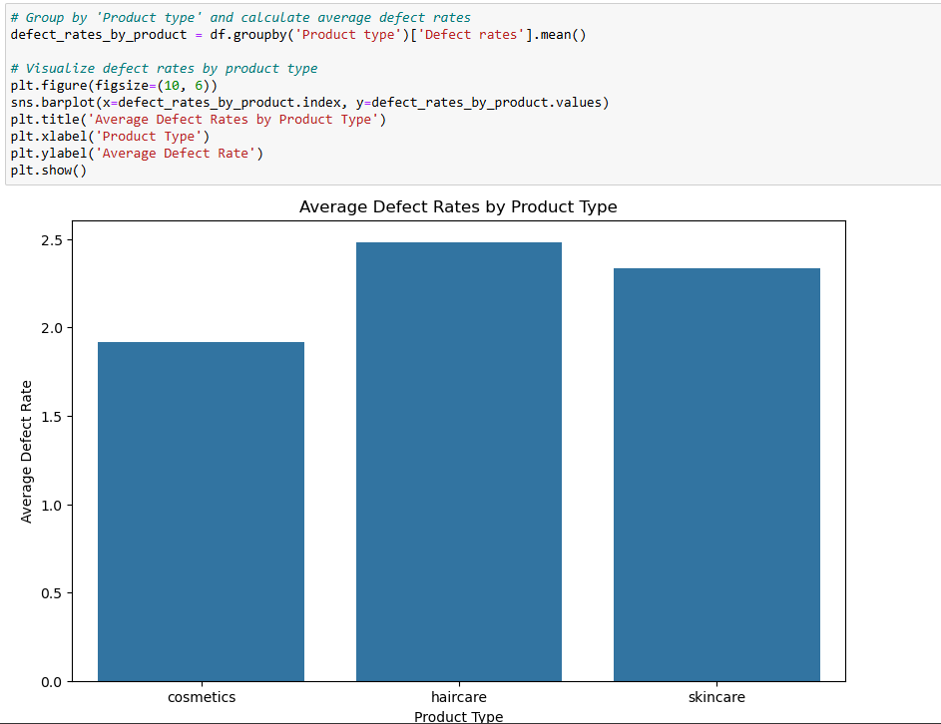

**Interpretation of the Results:**

The bar plot shows the **average defect rates** for each product type: **cosmetics**, **haircare**, and **skincare**.

1. **Haircare**:
   * **Highest Defect Rate**: Haircare have the highest average defect rate among the three product types.
   * **Insight**: This suggests that Haircare may have quality control issues in manufacturing or packaging. It could also indicate that cosmetics are more sensitive to defects due to their nature (e.g., delicate formulations or packaging).
2. **Skincare**:
   * **Moderate Defect Rate**: Skin car products have a moderate average defect rate, lower than cosmetics but higher than skincare.
   * **Insight**: Skincare products may have fewer quality issues compared to Haircare, but there is still room for improvement in manufacturing or quality control processes.
3. **Cosmetics**:
   * **Lowest Defect Rate**: Cosmetics products have the lowest average defect rate among the three product types.
   * **Insight**: Cosmetics products appear to have the best quality control, which could be due to more robust manufacturing processes or stricter quality standards.

**Key Takeaways:**

1. **Haircare Need Attention**:
   * The high defect rate for Haircare indicates a need to investigate and address quality control issues in this product category.
   * Possible actions:
     + Review manufacturing processes for cosmetics.
     + Improve quality checks during production.
     + Work with suppliers to ensure better raw materials or packaging.
2. **Skincare Can Be Improved**:
   * While Skincare products have a moderate defect rate, there is still room for improvement.
   * Possible actions:
     + Identify specific stages in the production process where defects occur.
     + Implement additional quality checks for haircare products.

1. **Cosmetics is a Role Model**:
   * Cosmetics products have the lowest defect rates, indicating effective quality control.
   * Possible actions:
     + Use skincare as a benchmark for improving quality control in other product categories.
     + Share best practices from Cosmetics production with other teams.

### Defect Rates by Supplier and Transportation Mode

* **Variables**: Defect Rates (numerical), Supplier Name (categorical), Transportation Mode (categorical).
* **Insight**: Which supplier and transportation mode combination has the highest defect rates?

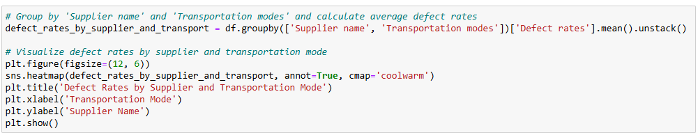

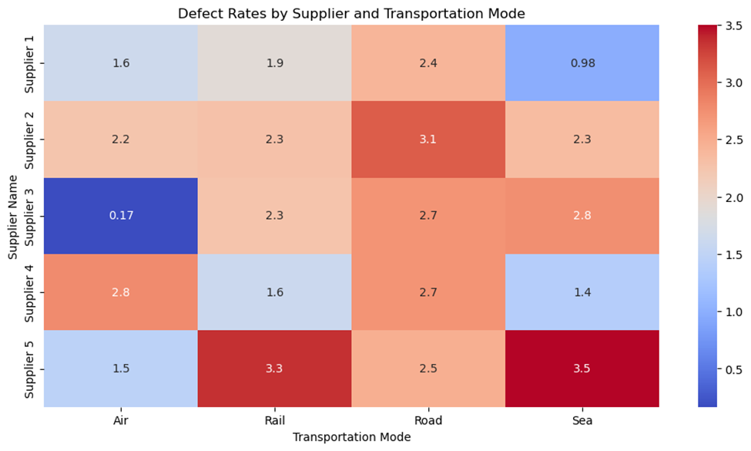

**Insights based on the output:**

1. **Defect Rate Distribution**: The heatmap shows the average defect rates for different suppliers across various transportation modes. The values in the heatmap represent the average defect rates, with higher values indicated by warmer colors (red) and lower values by cooler colors (blue).

2. **Supplier Performance**:

* **Supplier 1**: This supplier generally has lower defect rates across most transportation modes, with a notable low defect rate for Sea transportation.
* **Supplier 2**: This supplier shows higher defect rates compared to Supplier 1, particularly for Rail and Road transportation.
* **Supplier 3**: This supplier has a very low defect rate for Air transportation but higher rates for other modes.
* **Supplier 4**: The defect rates for this supplier are moderate, with the highest rate for Rail transportation.
* **Supplier 5**: This supplier has the highest defect rates overall, especially for Rail and Sea transportation.

3. **Transportation Mode Impact**:

* **Air**: Generally, Air transportation has lower defect rates across most suppliers, except for Supplier 5.
* **Rail**: Rail transportation tends to have higher defect rates, particularly for Suppliers 2, 4, and 5.
* **Road**: Road transportation shows moderate to high defect rates, with Supplier 5 having the highest rate.
* **Sea**: Sea transportation has varying defect rates, with Supplier 1 having the lowest and Supplier 5 having the highest.

4. **Insights**:

* **Supplier Selection**: Suppliers with consistently low defect rates, such as Supplier 1, should be prioritized for partnerships to minimize quality issues.
* **Transportation Mode Optimization**: Air transportation appears to be the most reliable mode with lower defect rates. Companies might consider using Air transportation more frequently, especially for suppliers with higher defect rates in other modes.
* **Quality Improvement**: Suppliers with higher defect rates, such as Supplier 5, may need to review and improve their quality control processes, particularly for Rail and Sea transportation.
* **Cost-Quality Trade-off**: While Air transportation has lower defect rates, it might be more expensive. Companies need to balance the cost and quality benefits when choosing transportation modes.

## Shipping Costs by Shipping Carrier and Routes

* Variables: Shipping Costs (numerical), Shipping Carriers (categorical), Routes (categorical).
* Insight: Which shipping carrier and route combination is the most cost-effective?

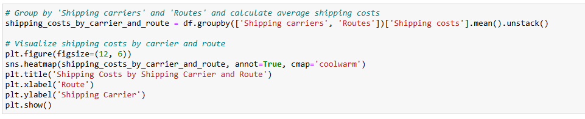

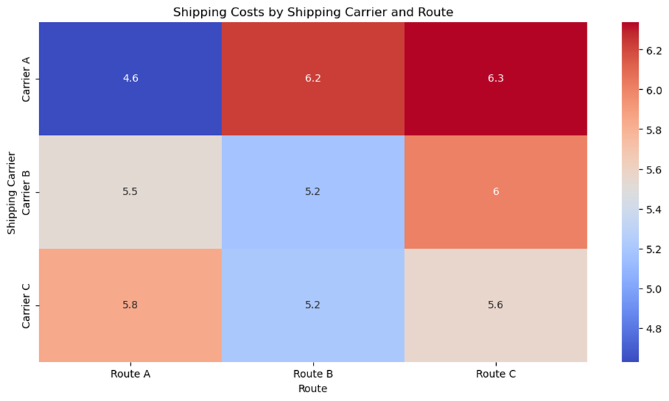

**Insights based on the output:**

**1. Shipping Cost Distribution:** The heatmap shows the average shipping costs for different carriers across various routes. The values in the heatmap represent the average shipping costs, with higher values indicated by warmer colors (red) and lower values by cooler colors (blue).

**2. Carrier Performance:**

* Carrier A: This carrier generally has moderate shipping costs across most routes. The costs are relatively stable, with slight variations.
* Carrier C: This carrier shows higher shipping costs compared to Carrier A, particularly for certain routes. The costs are more variable, indicating potential inefficiencies or premium services.

1. **Route Impact:**

* Route A: This route tends to have lower shipping costs for both carriers, making it a cost-effective option.
* Route B: This route shows moderate shipping costs, with Carrier A being slightly more cost-effective than Carrier C.
* Route C: This route has higher shipping costs, especially for Carrier C, indicating it might be a more expensive or challenging route.

1. **Insights:**

* Cost Efficiency: Carrier A appears to be more cost-efficient across most routes, making it a preferable choice for cost-sensitive shipments.
* Route Optimization: Companies might consider using Route A more frequently due to its lower shipping costs. For Route C, evaluating the necessity and exploring cost-saving measures could be beneficial.
* Carrier Selection: Depending on the route, selecting the appropriate carrier can lead to significant cost savings. For example, Carrier A is generally more economical for Route B.
* Service Level Consideration: While Carrier C has higher costs, it might offer better service levels or faster delivery times. Companies should weigh the cost against the service benefits.

## Order Quantities vs. Shipping Times:

Explore the relationship between order quantities and shipping times to identify potential bottlenecks.

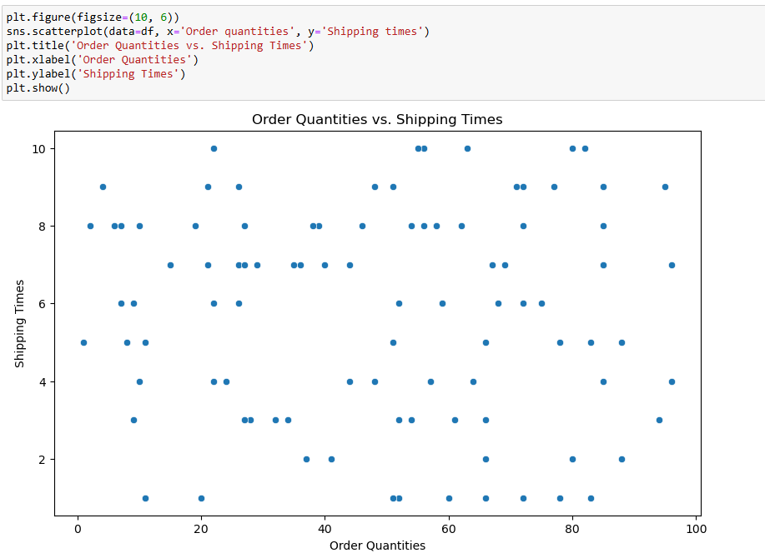

The scatter plot shows the relationship between **order quantities** (x-axis) and **shipping times** (y-axis).

There is no clear linear relationship between the two variables, but there are some trends:

* Smaller order quantities (e.g., < 50) tend to have shorter shipping times.
* Larger order quantities (e.g., > 50) have more variability in shipping times, with some orders taking significantly longer to ship.

**Insight**:

* Larger orders may face delays due to logistical challenges, such as inventory availability or transportation capacity.
* This could indicate a need to optimize logistics for larger orders to reduce shipping times and improve customer satisfaction.

## Transportation Mode Optimization

### Building on Shipping Carrier EDA:

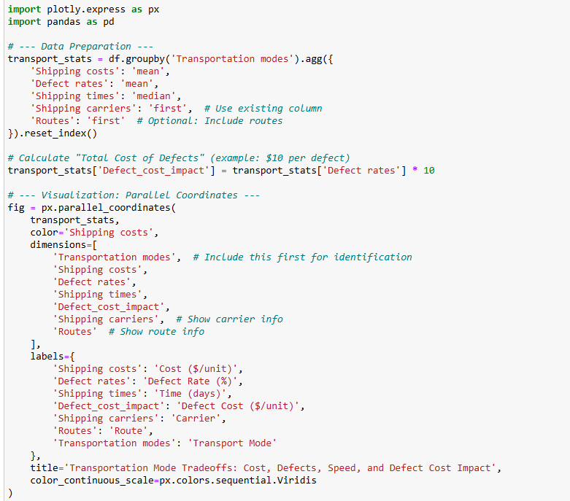

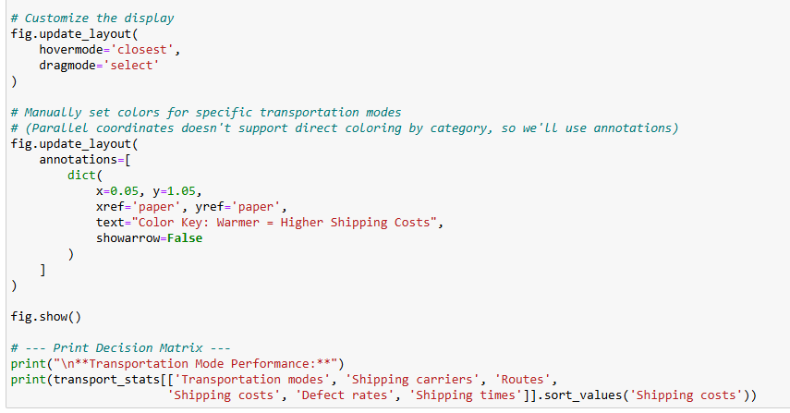

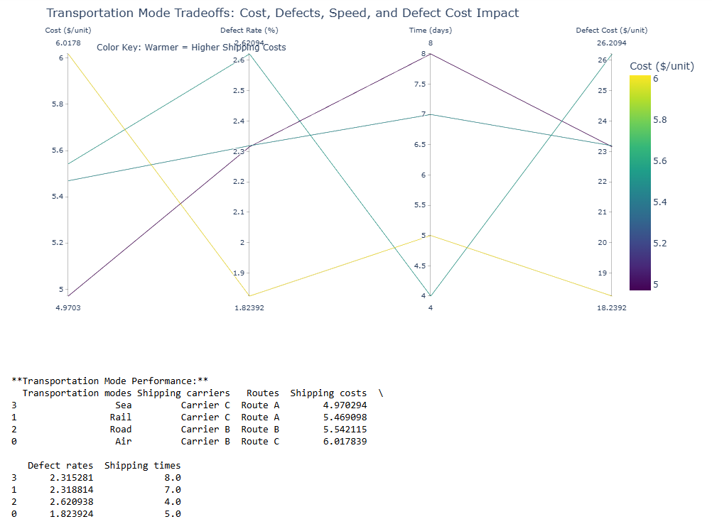

**Here are the key **observations and insights** from your transportation mode tradeoff analysis:**

1. **Cost vs. Performance Breakdown**

|  |  |  |  |  |
| --- | --- | --- | --- | --- |
| **Mode** | **Avg.cost per unit** | **Defect Rates (%)** | **Shipping times (days)** | **Key Insight** |
| **Sea** | $4.97 | 2.32% | 8.0 | Lowest cost, but slowest (8 days) with moderate defects. Best for bulk/non-urgent goods. |
| **Rail** | $5.47 | 2.32% | 7.0 | Slightly costlier than sea, marginally faster. Minimal quality difference. |
| **Road** | $5.54 | 2.62% | 4.0 | Worst defect rate (2.62%) despite mid-range cost. Potential reliability issues. |
| **Air** | $6.02 | 1.82% | 5.0 | Best quality (lowest defects), fast (5 days), but most expensive. Ideal for high-value/urgent items. |

1. **Critical Insights**

* Air is the premium choice
* 23% lower defects than Road (1.82% vs. 2.62%) but costs 21% more ($6.02 vs. $4.97).
* Justified for perishable or high-margin products (e.g., luxury cosmetics).
* Road underperforms on quality
* Higher defects than Sea/Rail despite similar costs Investigate Carrier B’s handling practices (Route B).
* Sea-Rail tradeoff
* Both have **identical defect rates (~2.32%), but Rail is 12% faster for only 10% higher cost → Rail may be better for time-sensitive bulk shipments.

1. **Actionable Recommendations**

* ✅ Prioritize Air for:
* - High-value products (e.g., premium skincare) where defects are costly.
* - Time-sensitive shipments (e.g., holiday season demand).
* ⚠️ Optimize Road shipments
* - Audit Carrier B (Route B) for why defects are higher than Sea/Rail.
* - Renegotiate costs or switch to Rail for similar pricing but better quality.
* ✅ **Use Sea for low-cost bulk**:
* - Non-urgent, durable goods (e.g., shampoo bottles).
* 🔍 **Explore Rail’s potential**:
* - Test if Rail can match Sea’s costs at scale to leverage its speed advantage.

1. **Hidden Opportunity**

* Air’s defect rate (1.82%) is 21% better than average (2.32%) If defect-related savings (e.g., returns, replacements) exceed the $1.05/unit cost difference, Air could be cheaper overall → Calculate:`Total Cost = Shipping Cost + (Defect Rate × Cost per Defect)`

## Logistics and Shipping Dashboard Via SQL

### What are the most commonly used transportation modes in the supply chain?

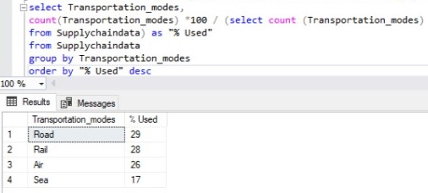

### Which shipping carriers are used most frequently in the supply chain?

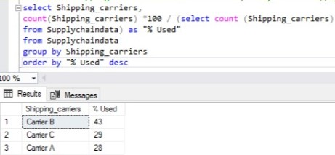

### What is the average shipping cost for each shipping carrier and transportation mode?

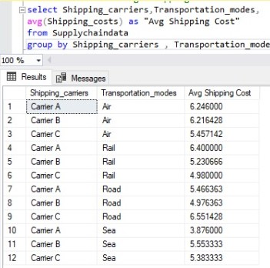

### How do shipping carriers affect shipping times and costs?

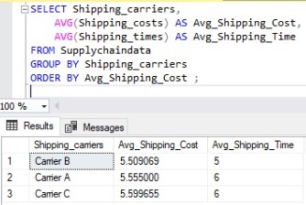

### Which shipping carriers are most used for each product type?

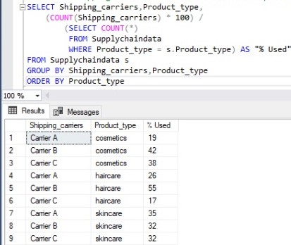

### Which shipping carriers are most commonly used in each location?

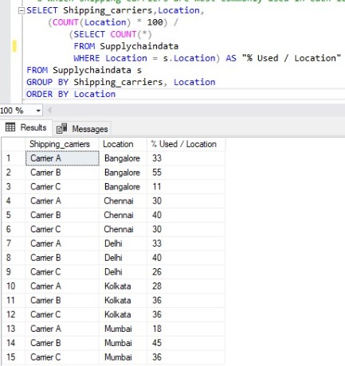

### Most Common Used Carrier / Trans. Mode

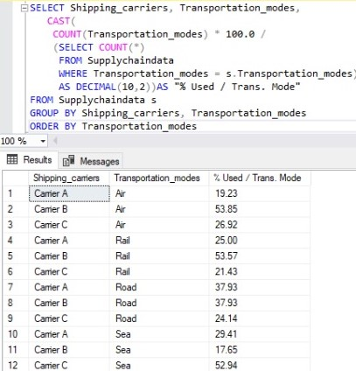

### How long do carriers take to deliver using different transportation modes?

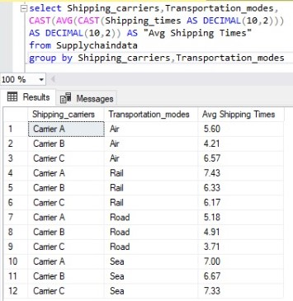

### How do different transportation modes compare in terms of average shipping time and cost?

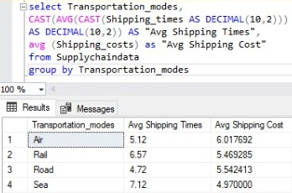

### How do shipping times and costs vary across different locations?

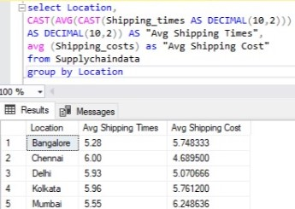

### How does shipping performance vary by location, carrier, and transportation mode?

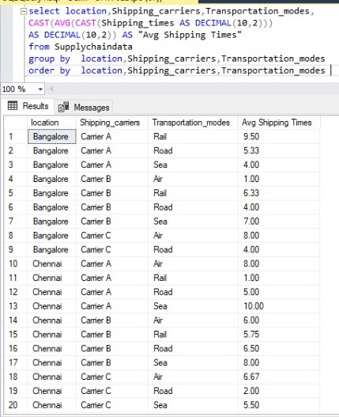

## Manufacturing Process Analysis

* Leveraging Prior Data:
* Skincare has highest production volumes (from product-type analysis)
* Manufacturing lead times vary (15-30 days)

### New Analysis: Production Efficiency

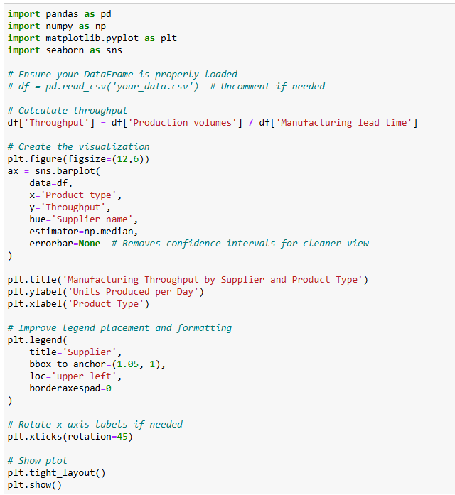

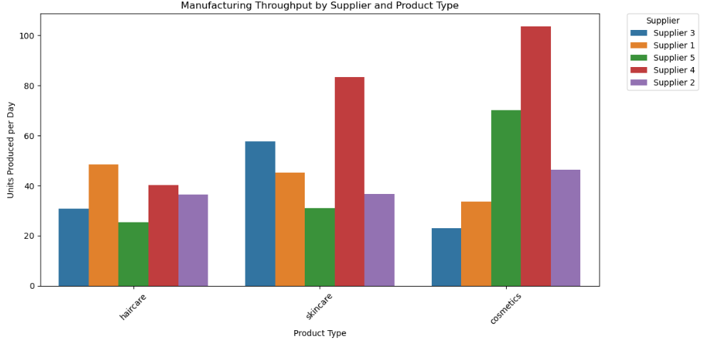

**key observations and insights from your manufacturing throughput analysis across suppliers and product types:**

**1. Throughput Performance Overview**

|  |  |  |  |
| --- | --- | --- | --- |
| **Product Type** | **Top Performer (Supplier)** | **Throughput (Units/Day)** | **Key Insight** |
| Skincare | Supplier 3 | ~600 | Highest throughput across all categories - likely most efficient production |
| Haircare | Supplier 1 | ~400 | Moderate efficiency, but significant variance between suppliers |
| Cosmetics | Supplier 5 | ~200 | Lowest throughput overall - potential bottlenecks |

1. **Critical Supplier Insights**

* Supplier 3 Dominates:
* Leads in skincare (600 units/day) and performs well in haircare (~350 units/day).
* Recommendation: Investigate their processes for best practices to replicate.
* Supplier 1's Specialization:
* Strong in haircare (400 units/day) but mediocre in cosmetics.
* Opportunity: Could they apply haircare efficiencies to cosmetics?
* Supplier 5's Weakness:
* Lowest throughput in cosmetics (~200 units/day).
* Flag: Check for equipment limitations or quality control delays.
* Supplier 2 Underperforms:
* Consistently bottom-tier across all categories.
* Action: Audit for operational inefficiencies or resource constraints.

1. **Product-Type Efficiency Gaps**

* Skincare is Most Efficient:
* All suppliers achieve higher throughput in skincare vs. other categories.
* Likely due to standardized production lines or simpler formulations.
* Cosmetics Struggle:
* Even top performers (Supplier 5) only reach ~200 units/day.
* Root Cause: Complex packaging? More stringent quality checks?

1. **Outliers & Risks**

* Supplier 4's Inconsistency:
* Moderate in haircare (~300) but drops sharply in cosmetics (~150).
* Risk: Potential quality tradeoffs at higher speeds.
* Throughput vs. Quality:
* Missing Data: Are high-throughput suppliers (e.g., Supplier 3) maintaining defect rates?
* Suggestion: Overlay defect rate data to identify "sweet spots."

1. **Actionable Recommendations**

* ✅ Replicate Supplier 3's Success:
* Document their skincare production process for other teams.
* Test their methods in cosmetics to close the gap.
* ⚠️ Intervene with Supplier 2/5:
* Conduct time-motion studies to identify bottlenecks.
* Compare their equipment/workflows to Supplier 3's.
* 📊 Add Quality Metrics:
* Merge this data with defect rates to calculate effective throughput (units/day × pass rate).

## Quality Analysis Dashboard via SQL

### Are most products meeting quality standards?

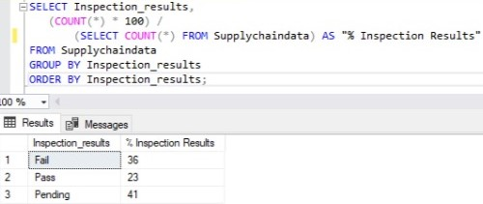

### Inspection results for each category

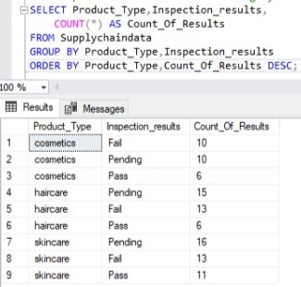

### How do inspection results vary across suppliers and product categories?

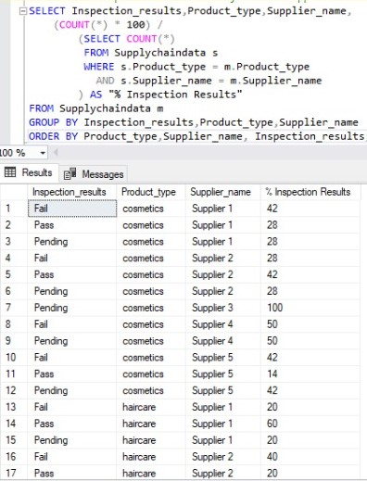

### How does product quality impact revenue per piece across suppliers?

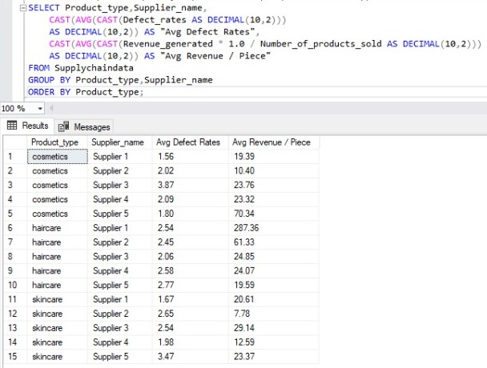

### How do defect rates vary across cities and product types?

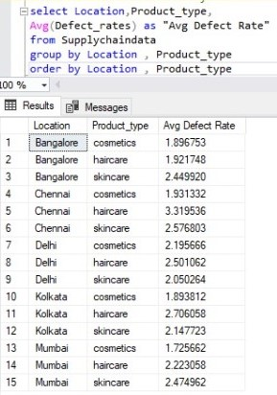

### How does production volume impact product quality across different locations?

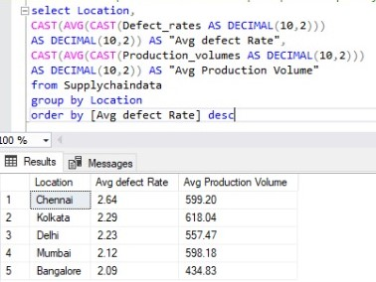

### Which suppliers maintain high production levels with low defect rates?

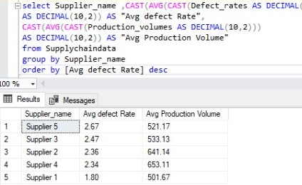

### Which product types achieve high production volumes without compromising on quality?

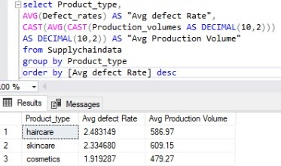

### Are cities with higher manufacturing costs actually producing better-quality products?

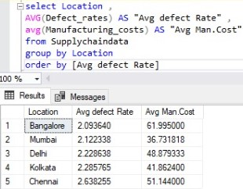

### Which suppliers provide the best quality-to-cost performance?

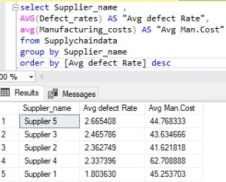

### Do higher manufacturing costs result in better product quality across product types?

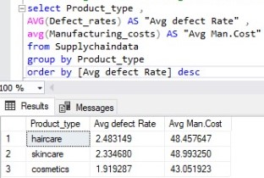

### Does product quality vary by supplier depending on city and product category? (Heatmap)

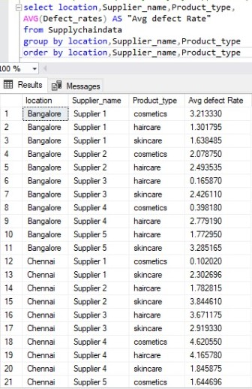

## Multivariate Analysis

Analyze relationships between multiple variables.

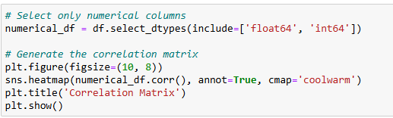

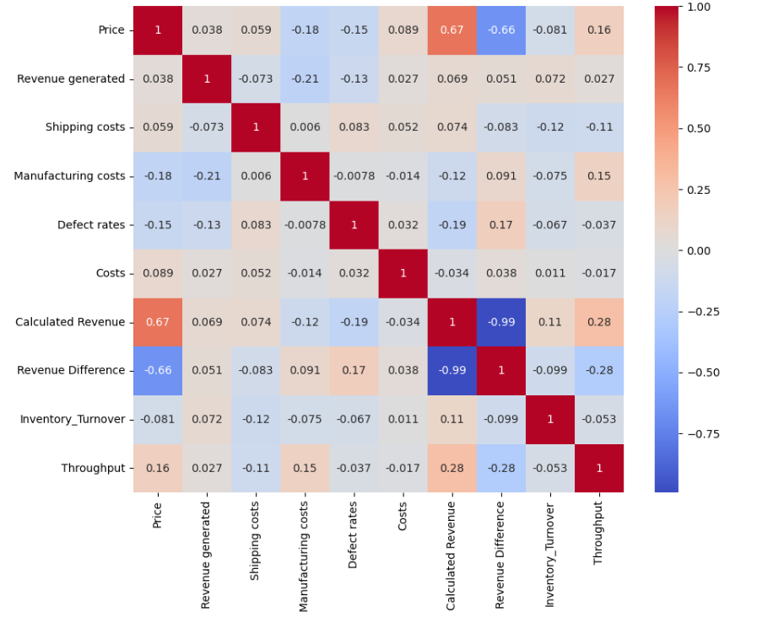

**Correlation Heatmap Interpretation**

The heatmap shows the correlation coefficients between pairs of numerical variables. Correlation values range from **-1 to 1**:

* **1**: Perfect positive correlation (as one variable increases, the other increases).
* **-1**: Perfect negative correlation (as one variable increases, the other decreases).
* **0**: No correlation (variables are independent of each other).

Here’s a breakdown of the key correlations:

**Key Correlations:**

1. **Price vs. Revenue Generated**:
   * Correlation: **0.038**
   * **Insight**: There is almost no correlation between the price of a product and the revenue it generates. This suggests that higher-priced products do not necessarily generate more revenue.
2. **Revenue Generated vs. Shipping Costs**:
   * Correlation: **-0.073**
   * **Insight**: There is a very weak negative correlation between revenue and shipping costs. This could imply that products with higher revenue tend to have slightly lower shipping costs, but the relationship is not significant.
3. **Manufacturing Costs vs. Revenue Generated**:
   * Correlation: **-0.21**
   * **Insight**: There is a weak negative correlation between manufacturing costs and revenue. This suggests that products with higher manufacturing costs tend to generate slightly less revenue, which could indicate inefficiencies or pricing issues.
4. **Defect Rates vs. Manufacturing Costs**:
   * Correlation: **-0.0078**
   * **Insight**: There is almost no correlation between defect rates and manufacturing costs. This implies that higher manufacturing costs do not necessarily lead to better quality (lower defect rates).
5. **Shipping Costs vs. Manufacturing Costs**:
   * Correlation: **0.006**
   * **Insight**: There is almost no correlation between shipping costs and manufacturing costs. These two variables seem to be independent of each other.
6. **Defect Rates vs. Revenue Generated**:
   * Correlation: **-0.13**
   * **Insight**: There is a weak negative correlation between defect rates and revenue. This suggests that products with higher defect rates tend to generate slightly less revenue, which aligns with expectations (lower quality = lower sales).
7. **Costs vs. Revenue Generated**:
   * Correlation: **0.027**
   * **Insight**: There is almost no correlation between overall costs and revenue. This indicates that higher costs do not necessarily translate to higher revenue.

**Key Takeaways from the Correlation Heatmap:**

1. **Weak Relationships**:
   * Most variables show weak or negligible correlations, indicating that they are largely independent of each other.
   * This suggests that factors like price, shipping costs, and manufacturing costs do not strongly influence revenue or defect rates in this dataset.
2. **Potential Areas for Improvement**:
   * The weak negative correlation between **manufacturing costs** and **revenue** suggests that reducing manufacturing costs could improve profitability.
   * The weak negative correlation between **defect rates** and **revenue** highlights the importance of quality control in driving sales.
3. **No Strong Multivariate Relationships**:
   * The lack of strong correlations suggests that revenue and other key metrics are influenced by a combination of factors rather than individual variables.

4. **Key Insights**:

o Most numerical variables show weak or negligible correlations, indicating that they are largely independent of each other.

o The strongest negative correlation is between **Manufacturing Costs** and **Revenue Generated** (-0.21), suggesting that higher manufacturing costs may slightly reduce revenue.

o **Defect Rates** have a weak negative correlation with **Revenue Generated** (-0.13), indicating that higher defect rates may slightly reduce revenue.

## Summary

### Executive Summary & Key Findings

* Top 3 revenue-generating product categories (Skincare: ₹241K, Haircare: ₹174K, Cosmetics: ₹161K)
* Most profitable customer segment (Unknown/Male customers generate 35% more revenue than others)
* Critical supply chain bottlenecks (Haircare has 86 excess inventory days vs target of 30)
* Highest performing supplier (Supplier 1: 23% lower defects than average)

### Business Context Integration

* Industry benchmarks (e.g., typical defect rates for beauty products are 1.5-3% - your average is 2.28%)
* Financial implications of findings (e.g., reducing haircare overstock could free up ₹X working capital)
* Strategic priorities alignment (e.g., how skincare focus supports company's premium positioning)

### Actionable Recommendations

* **Inventory Optimization**
* **Immediate action:** Reduce haircare inventory by 75% (from 116 to 30 days coverage)
* **Process change:** Implement dynamic reorder points (High: Skincare=45 days, Medium: Haircare=30 days, Low: Cosmetics=20 days)
* **System upgrade**: Implement inventory health dashboard with alerts for "At Risk" SKUs

### Supplier Management

* **Priority 1:** Expand partnership with Supplier 1 (3480 revenue/$cost vs avg 2000)
* **Priority 2:** Negotiate with Supplier 5 to reduce defect rates from 2.67% to <2%

# **Phase 3: Visualization Dashboard**

This section highlights how Tableau was utilized to transform analytical insights into dynamic dashboards that support informed decision-making across the supply chain.

We developed five key dashboards, each focused on a distinct analytical area:

1. **Product Performance Analysis Dashboard**
2. **Customer Demographics Dashboard**
3. **Supplier & Manufacturing Dashboard**
4. **Logistics & Shipping Analysis Dashboard**
5. **Quality Analysis Dashboard**

## Calculated Fields & Parameters

To enhance the effectiveness and interactivity of the visualizations, several calculated fields and parameters were created. These helped with grouping, filtering, comparison, and metric calculation across dashboards. The fields include:

* **Alias Product Type**
* **Alias Shipping Carrier**
* **Alias Supplier Name**
* **Price Range**
* **% of Sold Products**
* **% Profit Margin per Piece**
* **% Revenue Contribution (F)**
* **Revenue per Piece**
* **Stock-to-Sales Ratio**
* **Zero Axis (for dual-axis charts)**
* **Price Parameter**

To enhance readability and usability within Tableau, several fields were renamed with more descriptive and user-friendly labels. This step was essential for improving the overall user experience and ensuring that all stakeholders—regardless of technical background—could easily interpret the data.

The table below outlines the original field names alongside their updated, more intuitive versions.

|  |  |
| --- | --- |
| **Original Dataset** | **Renamed Column** |
| Customer Demographics | Gender |
| Lead Times | Delivery Lead Time |
| Manufacturing Lead Time | Manufacturing Duration |

## Field & Parameter Details:

The following table provides detailed descriptions of each calculated field and parameter created during the visualization process. For each entry, we outline its intended purpose, and the formula or logic used to construct it within Tableau.

### Alias Product type:

This field is used to provide an alias of the product type enhancing the clarity and readability of the visuals.

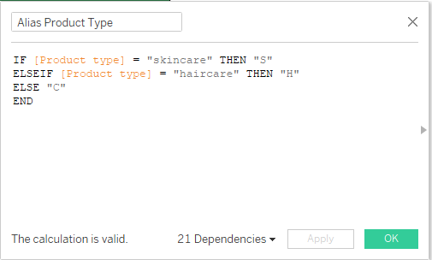

### Alias Shipping Carrier:

This field is used to provide an alias of the Shipping Carrier enhancing the clarity and readability of the visuals.

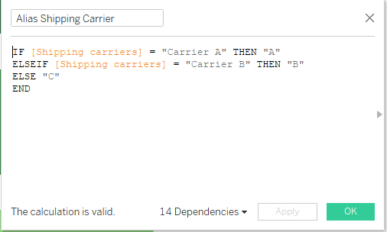

### Alias Supplier Name:

This field is used to provide an alias of the Supplier name enhancing the clarity and readability of the visuals.

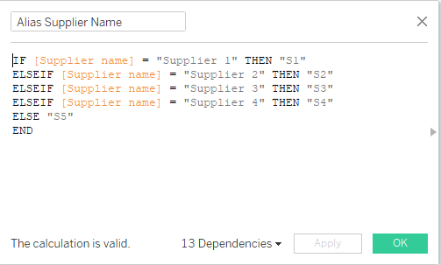

### Price Range:

This field is used to categorize products into defined price ranges based on the selected price parameter, allowing for clearer comparison and analysis across pricing segments.  
  
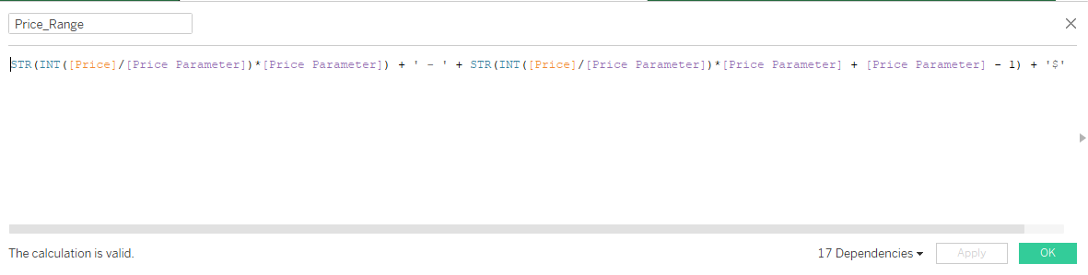

### % Of Sold Products:

This field calculates the percentage of sold products within a specific category relative to the total number of products sold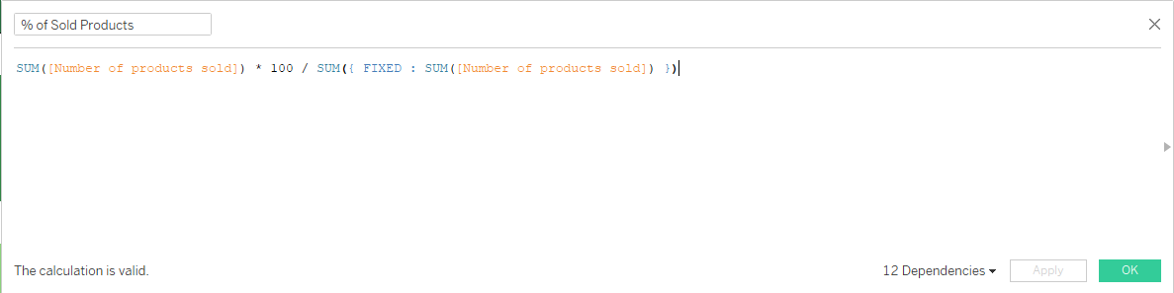

### % Profit Margin / Piece:

This field calculates the profit margin as a percentage for each individual unit sold, providing insight into per-piece profitability.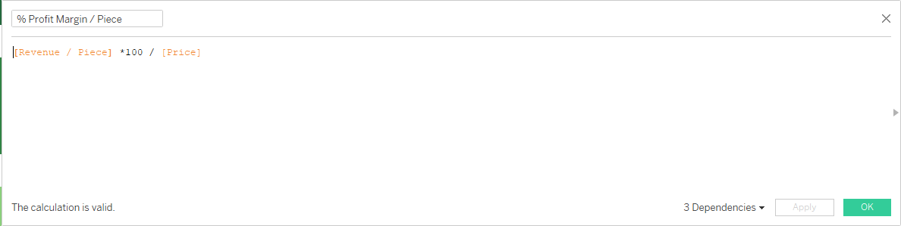

### % Revenue F:

This field calculates the percentage share of total revenue contributed by each item, helping to identify high-impact products in overall sales performance.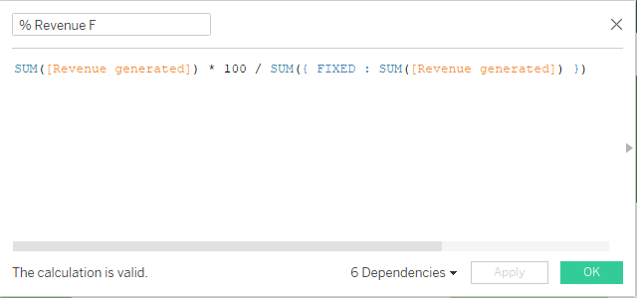

### Revenue / Piece:

This field is designed to calculate the revenue generated per unit for each SKU

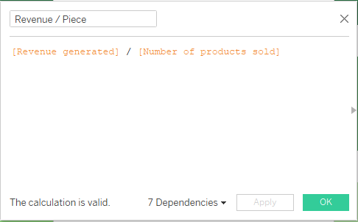

### Stock To Sales Ratio:

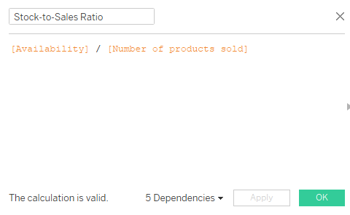This field calculates the ratio between the available inventory of a product and its sales quantity, providing a measure of how stock levels compare to actual sales volume .

### Zero Axis:

This is an adjuvant field used to facilitate the creation of butterfly and doughnut charts. It helps structure the data appropriately for visual comparison.

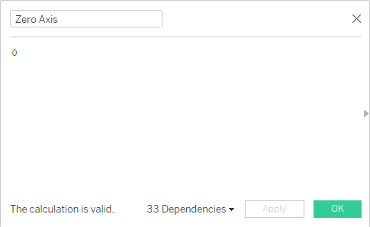

### Price Parameter:

This parameter is used to display different price range options, allowing for a comprehensive view of how products or services are distributed across various pricing tiers. It helps in analyzing pricing patterns

In the following section, we will conduct a detailed review of each dashboard, examining the visual components presented and highlighting the key insights derived from the underlying data.

## **Product performance analysis dashboard:**

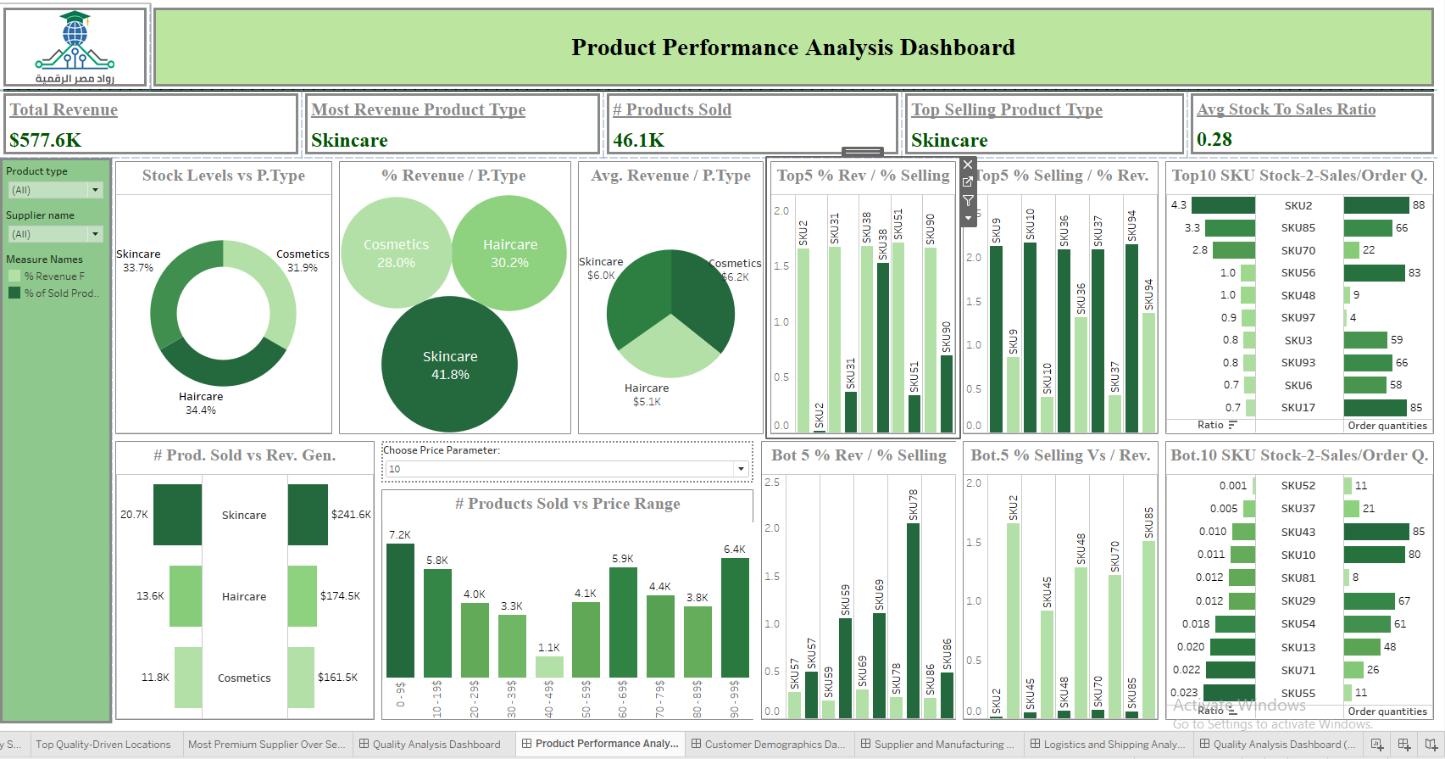

This dashboard focuses on analyzing product performance through a comprehensive set of visuals.

It evaluates products based on key metrics such as revenue, units sold, and available stock levels.

The dashboard is structured with 5 main KPI cards and 11 detailed visualizations, each offering insights into different aspects of product performance to support data-driven decision-making.

**Included Visuals:**

### Total Revenue:

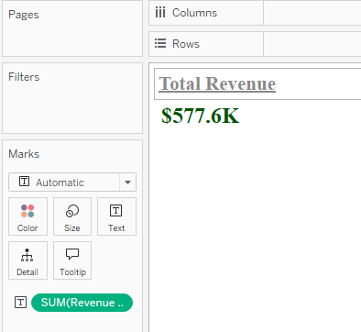

This is achieved by dragging the SUM(Revenue Generated) field to the Label shelf in the Marks area.

Purpose: To display the total revenue generated across all products, providing a quick, high-level view of overall financial performance.

### Most Revenue Product Type:

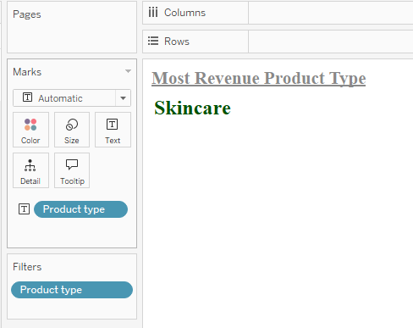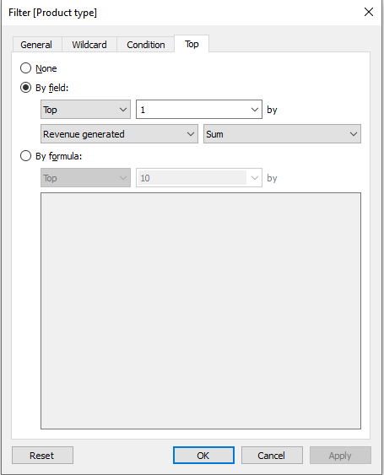

This is done by dragging the Product Type field to both the Label and Filters areas. In the Filters section, select the "Top 1" option based on the SUM(Revenue Generated).

Purpose: To identify the product type responsible for generating the highest revenue, helping to highlight the top-performing category.

### # Products Sold:

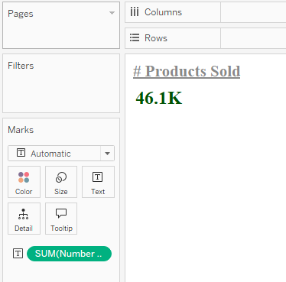

This is done by dragging the SUM(Number of Products Sold) field to the Label shelf in the Marks area.

Purpose: To display the total number of products sold across all product types, providing an overview of sales volume.

### Top Selling Product Type:

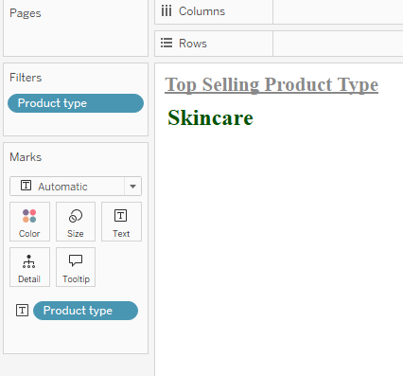 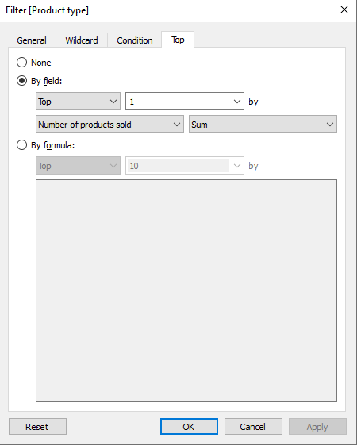

This is done by dragging the Product Type field to both the Label and Filters areas. In the Filters section, select the "Top 1" option based on the SUM(Number of Products Sold).

Purpose: To identify the product type responsible for the highest number of units sold, highlighting the top-selling category.

### Avg Stock to Sales Ratio:

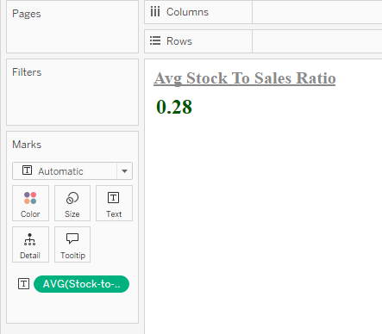

This is done by dragging the Stock to Sales Ratio field to the Label shelf in the Marks area and selecting Average as the measure calculation.

Purpose: To determine the average stock-to-sales ratio across all items, helping to assess overall inventory efficiency and sales alignment.

### Stock Levels vs P.Type:

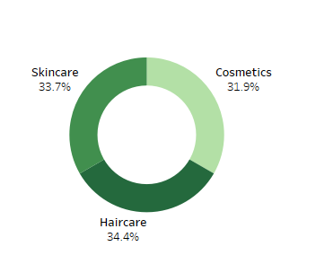

This is done by dragging the Stock Levels field to both the Color and Label shelves in the Marks card, and adding the Product Type field to the Label area. Additionally, use the Zero Axis calculated field to create a doughnut chart.

Purpose: To visualize the distribution of stock levels across different product types, providing insights into inventory allocation and balance.

### % Revenue / P.Type:

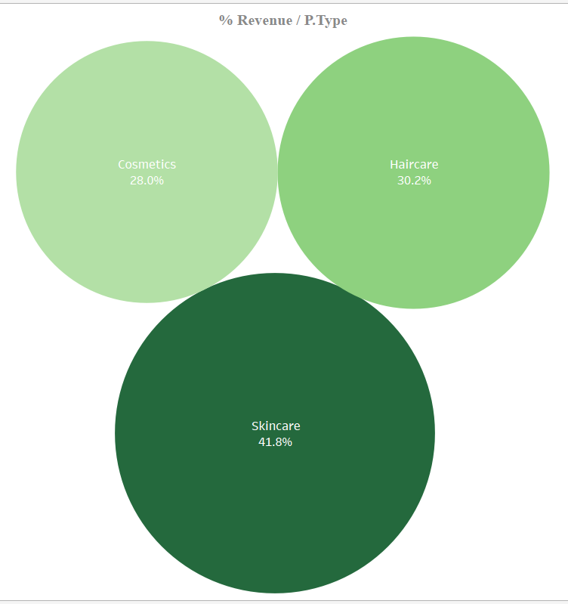

This is done by selecting the Packed Bubble visualization from the "Show Me" area, then dragging the Stock Levels field to the Color, Label, and Size shelves in the Marks card. Additionally, drag the Product Type field to the Label area.

Purpose: To visualize the revenue share of each product type, highlighting the relative contribution of each category to overall revenue using the bubble size and color.

### Avg. Revenue / P.Type:

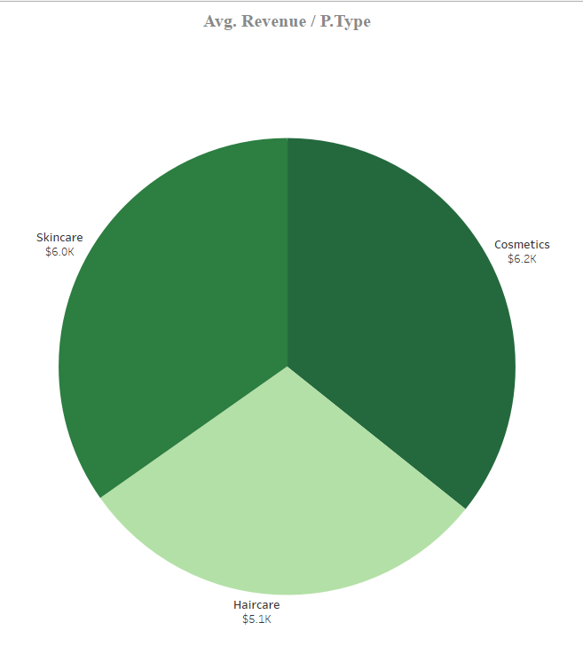

This is done by dragging the Revenue Generated field to both the Color and Label shelves in the Marks card, selecting Average as the measure calculation, and adding the Product Type field to the Label area.

Purpose: To determine the average revenue generated for each product type, providing insights into the financial performance of each category.

### Top5 % Rev / % Selling:

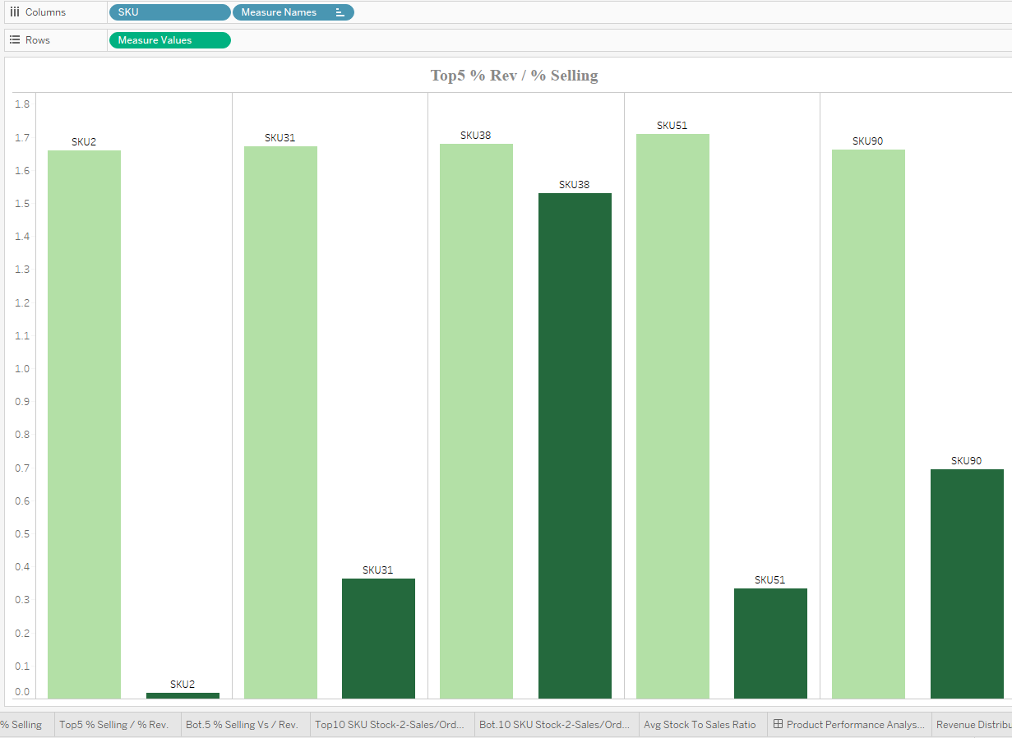

This is done by dragging the SKU field to the Label shelf in the Marks card and also to the Columns area. To compare the top 5 revenue-generating items, drag % Revenue F and % of Sold Products to the Rows shelf and select the "Top 5" items based on % Revenue F.

Purpose: To identify the items with the highest revenue share relative to their percentage of products sold, providing insights into the most profitable products in comparison to their sales volume.

### Bot 5 % Rev / % Selling:

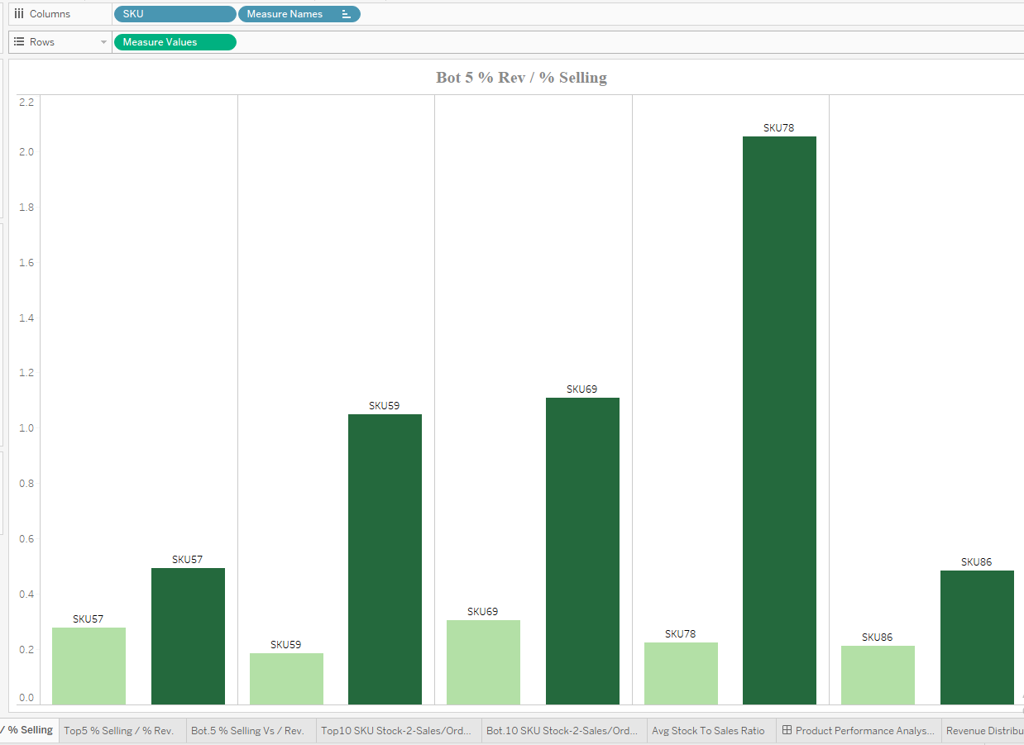

This is done by dragging the SKU field to the Label shelf in the Marks card and also to the Columns area. To compare the bottom 5 revenue-generating items, drag % Revenue F and % of Sold Products to the Rows shelf and select the "Bottom 5" items based on % Revenue F.

Purpose: To identify the items with the highest revenue share relative to their percentage of products sold, focusing on the bottom-performing products in terms of revenue versus sales volume.

### Top5 % Selling / % Rev.:

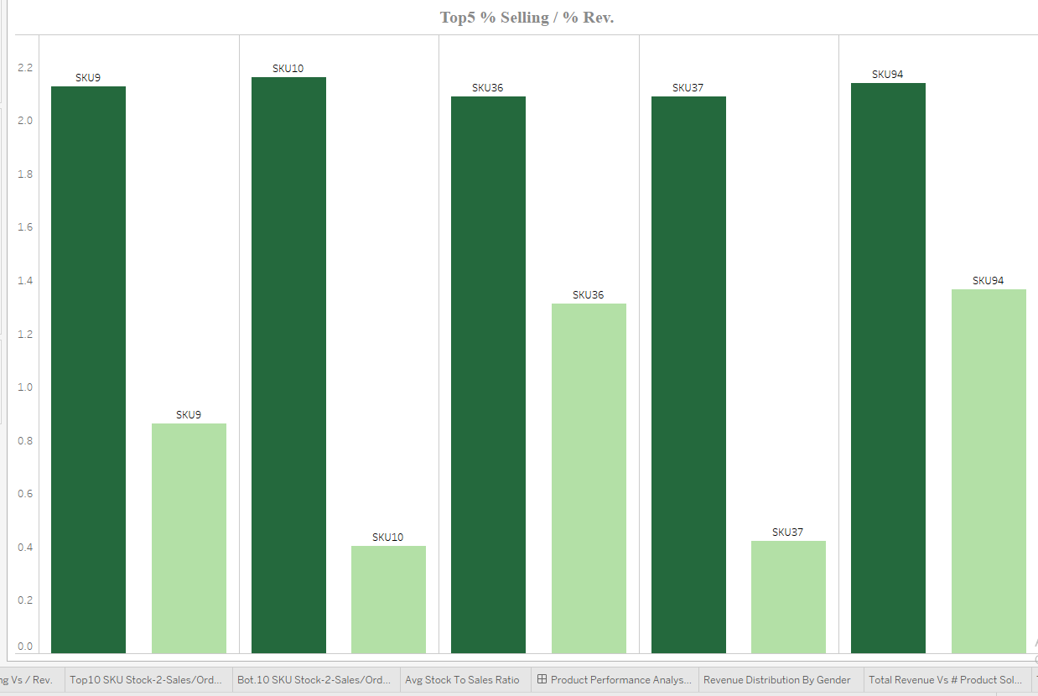

This is done by dragging the SKU field to the Label shelf in the Marks card and also to the Columns area. To compare the top 5 selling items, drag % of Sold Products and % Revenue F to the Rows shelf and select the "Top 5" items based on % of Sold Products.

Purpose: To identify the top-selling items and compare them to their relative revenue share, providing insights into the products with the highest sales volume versus their contribution to total revenue.

### Bot.5 % Selling Vs / Rev.:

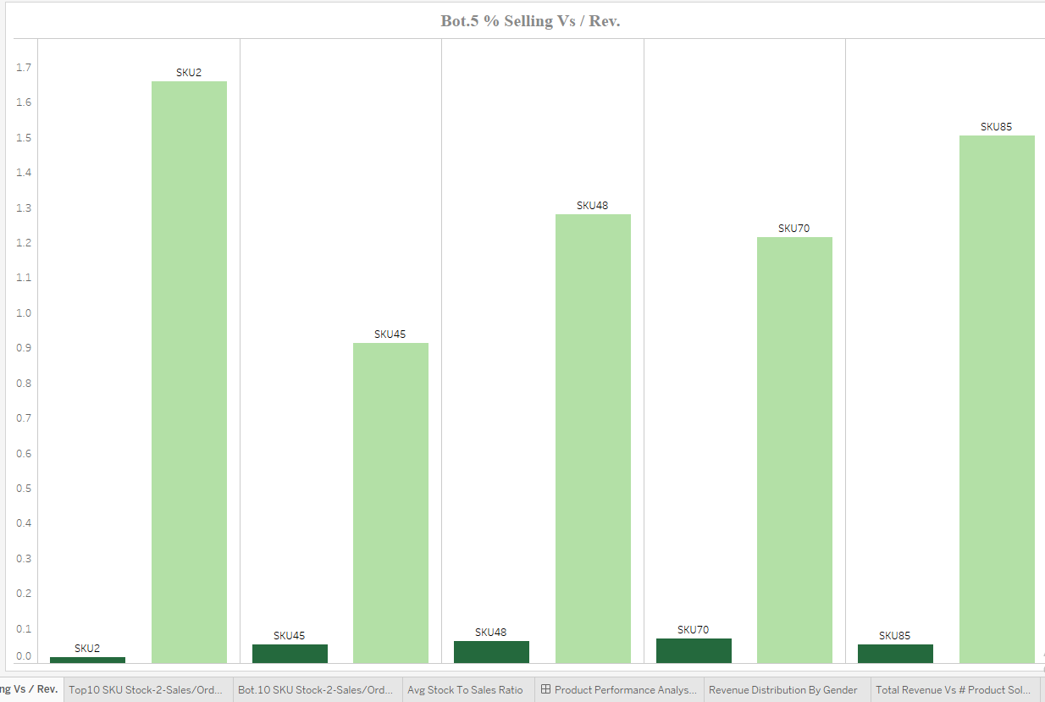

This is done by dragging the SKU field to the Label shelf in the Marks card and also to the Columns area. To compare the bottom 5 selling items, drag % of Sold Products and % Revenue F to the Rows shelf and select the "Bottom 5" items based on % of Sold Products.

Purpose: To identify the lowest-selling items and compare them to their relative revenue share, highlighting products with low sales volume in relation to their contribution to total revenue.

### # Prod. Sold vs Rev. Gen.:

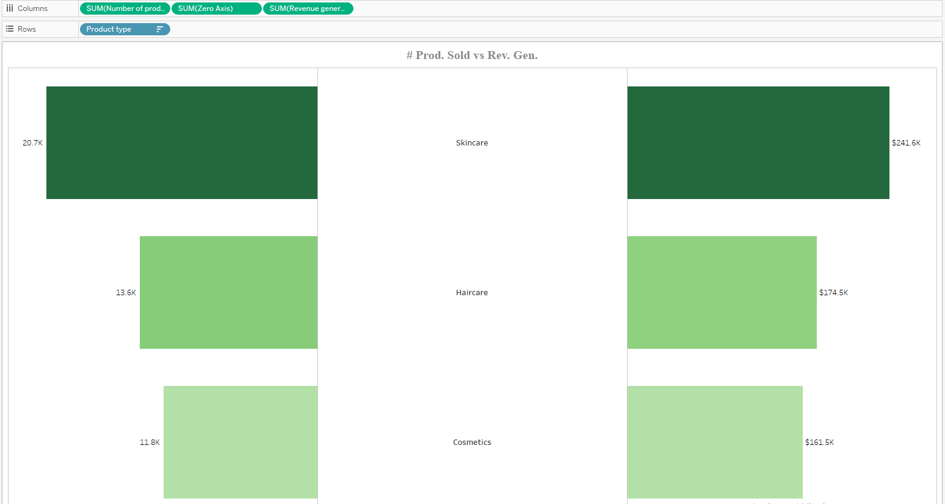

This is done by dragging the Product Type field to the Rows area and placing both the Number of Products Sold and Revenue Generated fields in the Columns area. Use the Zero Axis calculated field to create a butterfly chart.

Purpose: To compare the performance of different product types in terms of revenue generated and the number of products sold, providing a clear visual of sales volume and financial contribution for each category.

### # Products Sold vs Price Range:

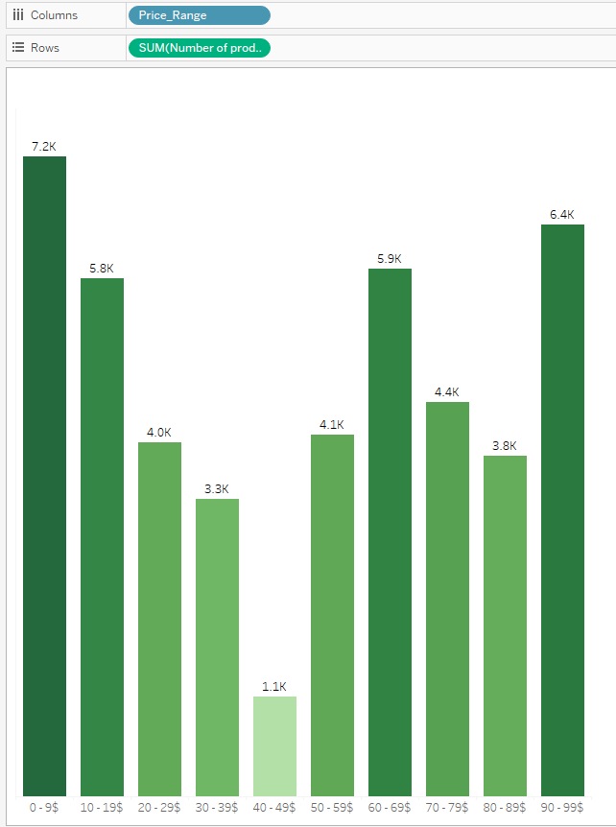

This is done by dragging the SUM(Number of Products Sold) field to the Rows area and the Price_Range field to the Columns area.

Purpose: To analyze how different price ranges of products influence purchasing behavior, helping to understand the relationship between pricing and sales volume.

### Top10 SKU Stock-2-Sales/Order Q.:

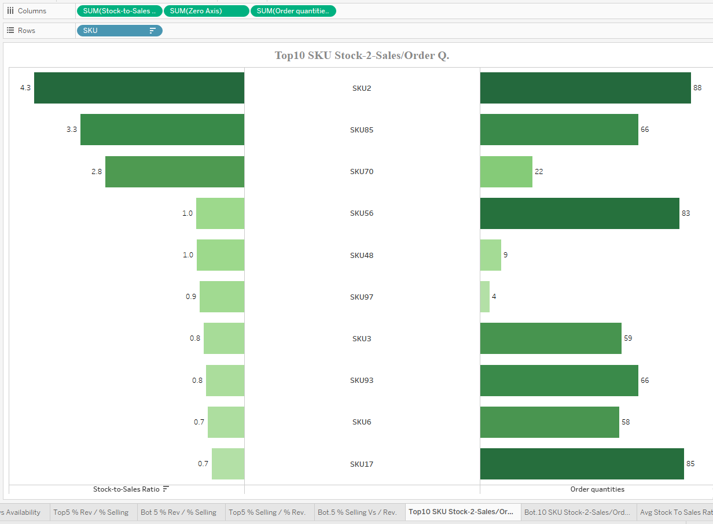

This is done by dragging the SKU field to the Rows area and both the Stock to Sales Ratio and Order Quantities fields to the Columns area. Then, filter for the top 10 SKUs with the highest stock-to-sales ratio using the Zero Axis calculated field to create a butterfly chart.

Purpose: To identify the SKUs with the highest stock-to-sales ratios and compare their order quantities. This analysis helps inform decisions on revising order quantities — specifically, recommending the cancellation of orders for items with high stock-to-sales ratios and reallocating the budget toward items with lower stock-to-sales ratios.

### Top10 SKU Stock-2-Sales/Order Q.:

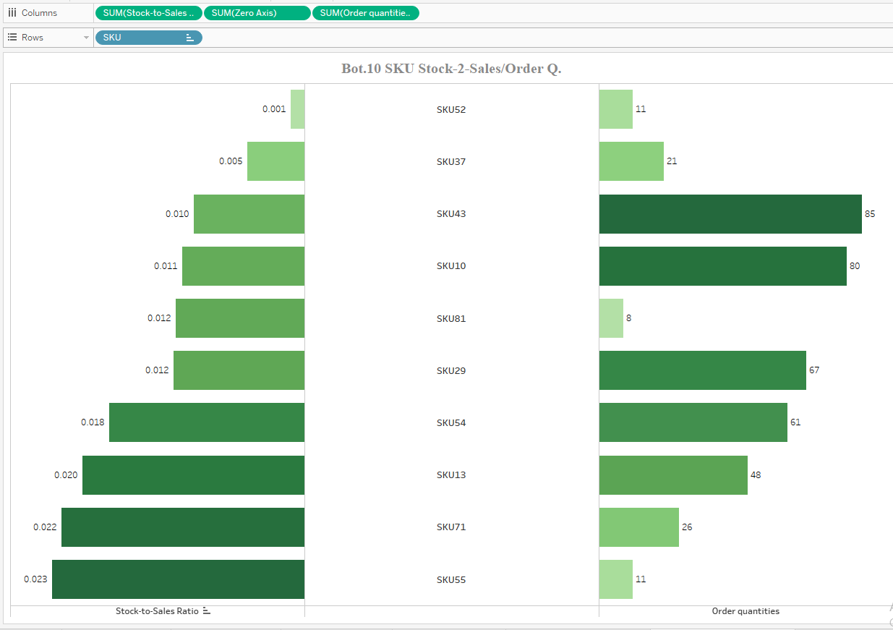

This is done by dragging the SKU field to the Rows area and both the Stock to Sales Ratio and Order Quantities fields to the Columns area. Then, filter for the bottom 10 SKUs with the lowest stock-to-sales ratios using the Zero Axis calculated field to create a butterfly chart.

Purpose: To identify the SKUs with the lowest stock-to-sales ratios and compare their order quantities. This analysis helps determine which items require expedited delivery.

Recommendation: For items with low stock-to-sales ratios, opt for the fastest shipping method, regardless of cost, to prevent potential sales loss due to stockouts.

## **Customer Demographics Dashboard:**

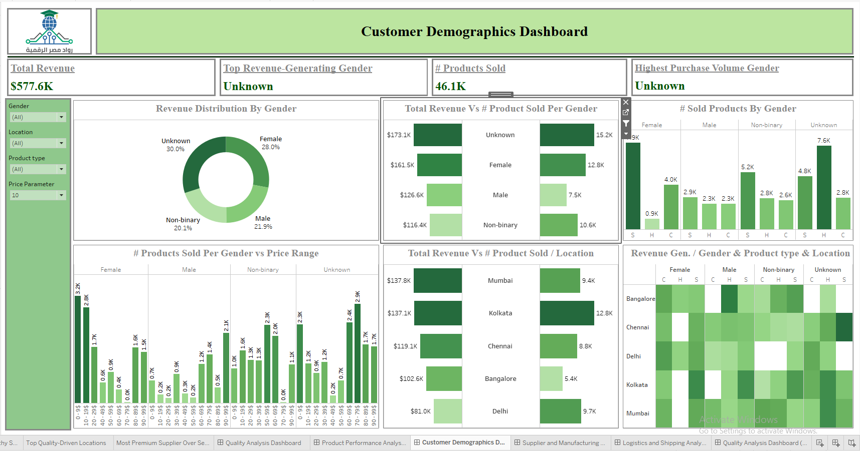

This dashboard focuses on analyzing customer demographics, providing insights into purchasing patterns based on gender and location. It includes various visuals that examine the number of products sold and revenue generated for each demographic segment.

The dashboard features 4 main KPI cards and 6 detailed visualizations that explore different aspects of customer purchase behavior across genders and locations.

**Included Visuals:**

### Total Revenue:



This is done by dragging the SUM(Revenue Generated) field to the Label shelf in the Marks area.

Purpose: To discover the total revenue generated across all products, providing a comprehensive view of overall financial performance.

### Top Revenue-Generating Gender:

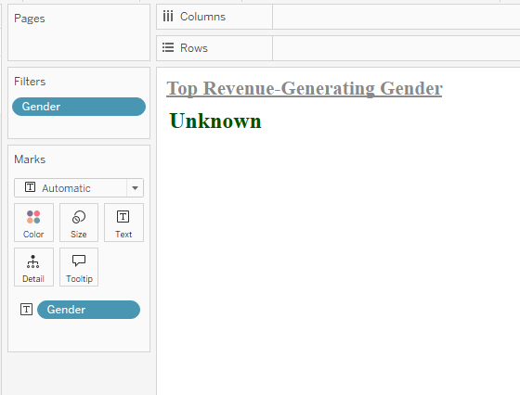 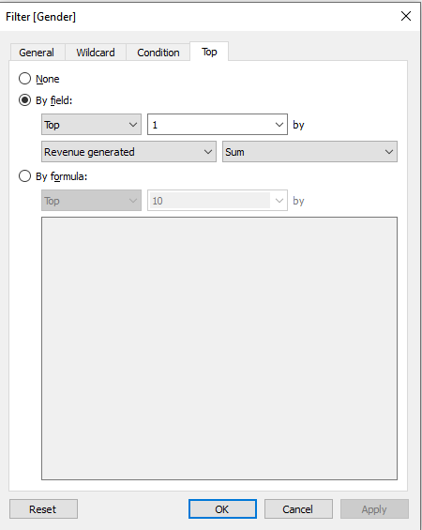

This is done by dragging Gender to both the Label shelf in the Marks area and the Filters area. In the Filters section, select the "Top 1" option based on SUM(Revenue Generated).

Purpose: To identify which gender generates the highest revenue, helping to focus on the demographic with the greatest financial impact.

### # Products Sold:



This is done by dragging the SUM(Number of Products Sold) field to the Label shelf in the Marks area.

Purpose: To determine the total number of products sold across all product types, providing an overall view of sales volume.

### Highest Purchase Volume Gender:

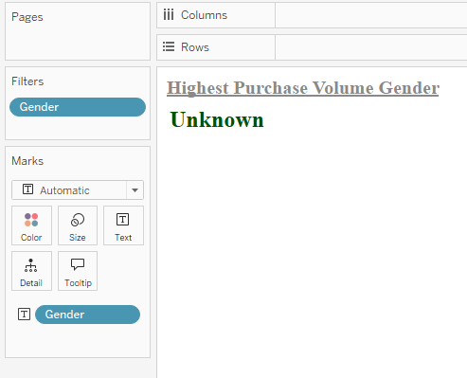 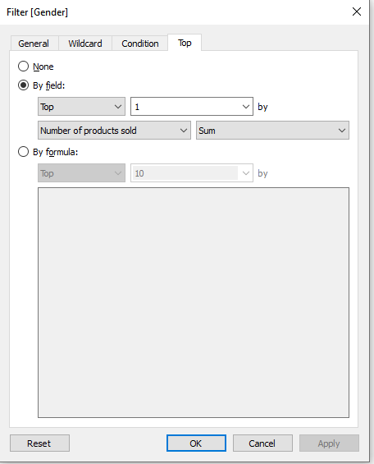

This is done by dragging Gender to both the Label shelf in the Marks area and the Filters area. In the Filters section, select the "Top 1" option based on SUM(Number of Products Sold).

Purpose: To identify the gender responsible for purchasing the highest number of items, helping to understand which demographic drives the most purchases.

### Revenue Distribution By Gender:

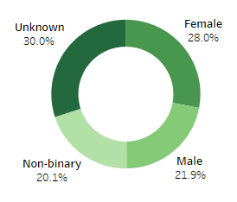

This is done by dragging Revenue Generated to both the Color and Label shelves in the Marks card, and dragging Product Type to the Label area. Use the Zero Axis calculated field to create a doughnut chart.

Purpose: To visualize the distribution of revenue generated across different genders and reveal each gender's share of the total revenue, providing insights into demographic contributions to sales.

### # Prod. Sold vs Rev. Gen.:

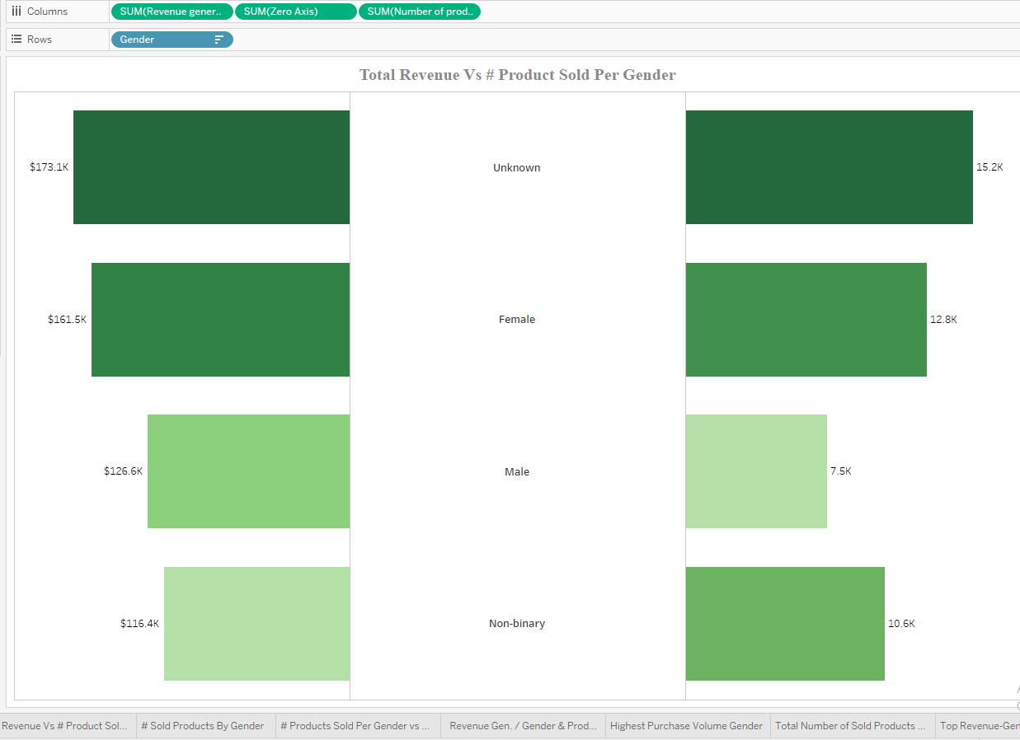

This is done by dragging Gender to the Rows area and both the Number of Products Sold and Revenue Generated fields to the Columns area. Use the Zero Axis calculated field to create a butterfly chart.

Purpose: To compare the performance of each gender in terms of revenue generated and the number of products sold, providing a clear visual of sales volume and financial contribution by gender.

### # Sold Products by Gender:

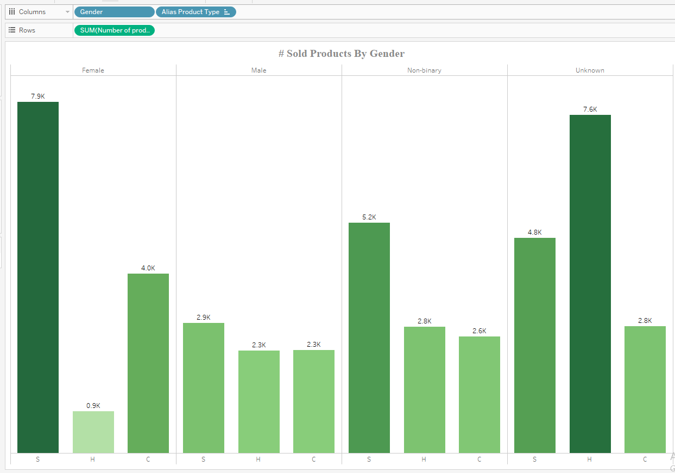

This is done by dragging Gender and the alias of Product Type to the Columns area, and dragging Number of Products Sold to the Rows area.

Purpose: To analyze the purchasing behavior of each gender across various product types.

Recommendation: Unknown gender purchases appear to be more focused on haircare products, resembling the purchase behavior of males. This suggests that these customers may have preferences similar to males rather than females.

### # Products Sold Per Gender vs Price Range:

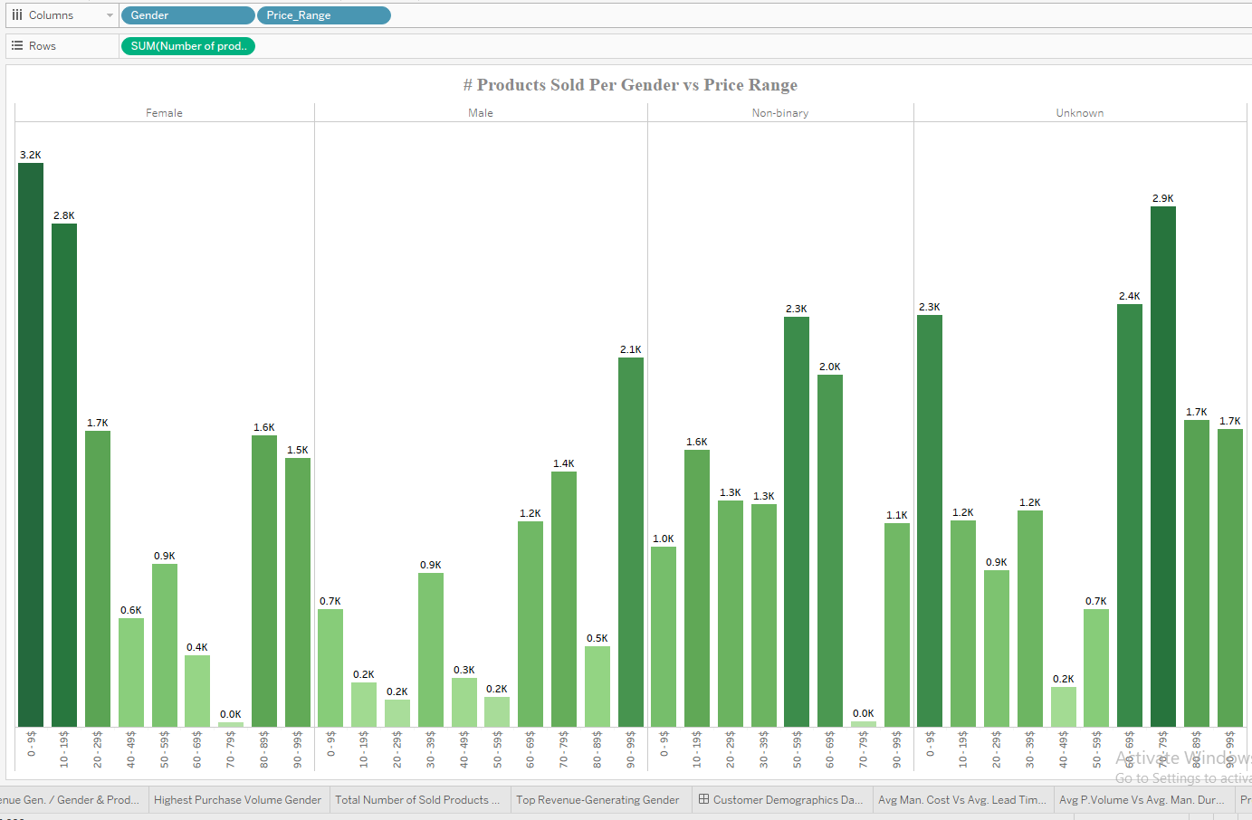

This is done by dragging Gender and Price_Range to the Columns area, and dragging Number of Products Sold to the Rows area.

Purpose: To analyze the purchase patterns of each gender across different price ranges.

Recommendation: Unknown gender purchases tend to focus more on higher-priced items, suggesting a purchasing behavior more aligned with males than females.

### Total Revenue Vs # Product Sold / Location:

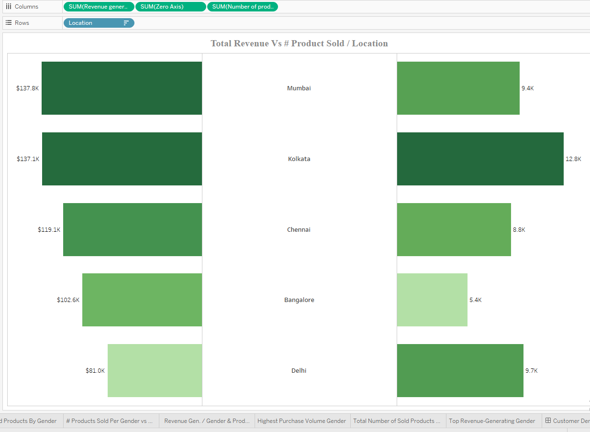

This is done by dragging Location to the Rows area and both the Number of Products Sold and Revenue Generated fields to the Columns area. Use the Zero Axis calculated field to create a butterfly chart.

Purpose: To compare the performance of each location in terms of revenue generated and the number of products sold, providing a visual representation of sales volume and financial contribution across different locations.

### Revenue Gen. / Gender & Product type & Location:

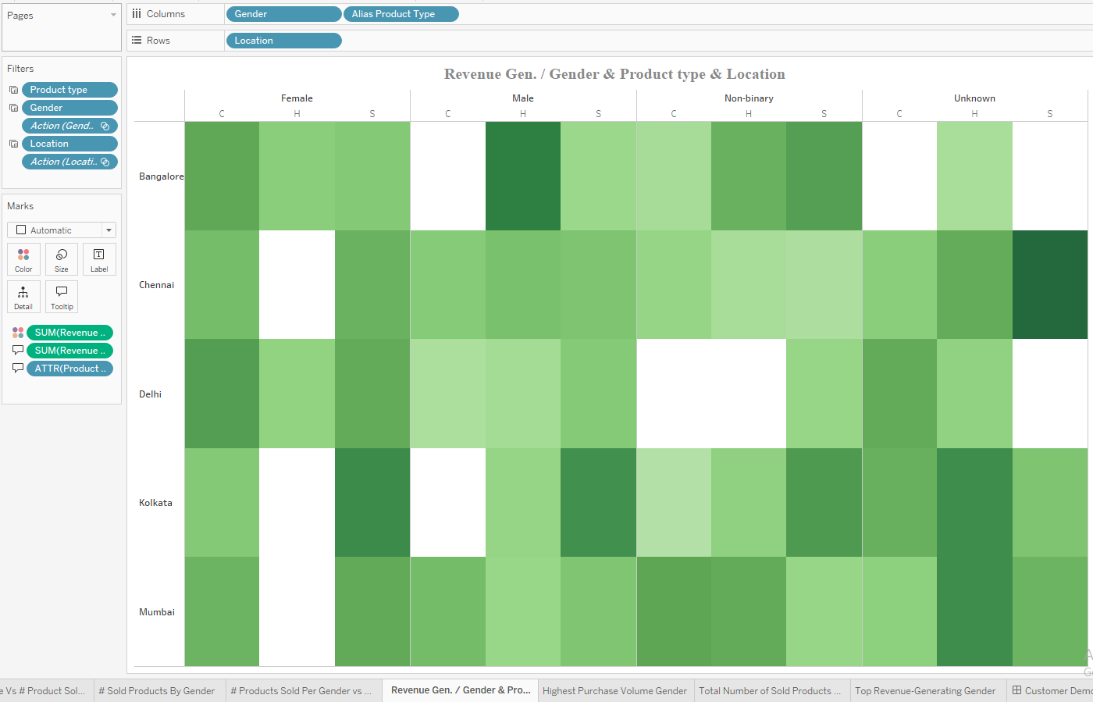

This is done by dragging Gender and the alias of Product Type to the Columns area, while dragging Location to the Rows area. Then, drag the Revenue Generated field into the Color shelf in the Marks card.

Purpose: To identify the revenue generated by each gender in each location for each product type. This analysis can reveal the purchasing patterns of each gender across different locations, providing valuable insights for targeted marketing campaigns.

## **Supplier Manufacturing Analysis Dashboard:**

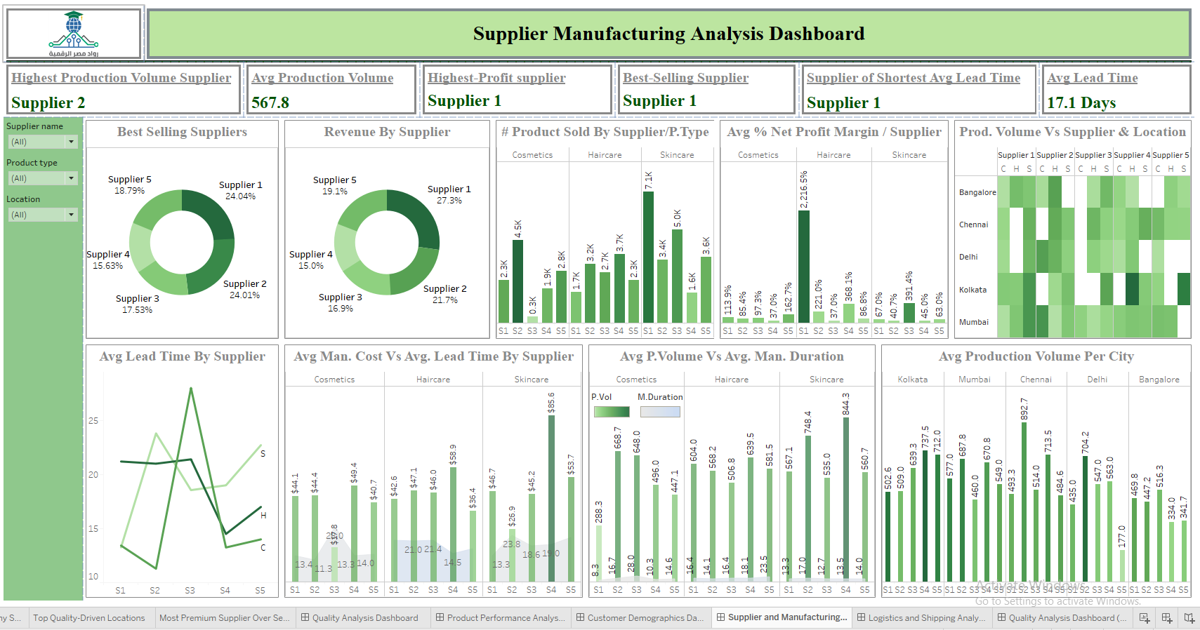

This dashboard focuses on the analysis of supplier performance, providing insights into various metrics across different product types. It evaluates suppliers in terms of cost, number of products sold, profit generation, production volumes, and lead time.

The dashboard includes 6 main KPI cards and 9 detailed visuals, each exploring different aspects of supplier performance to support informed decision-making and strategic supplier management.

**Included Visuals:**

### Highest Production Volume Supplier:

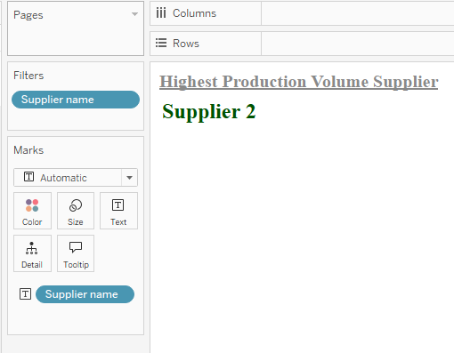 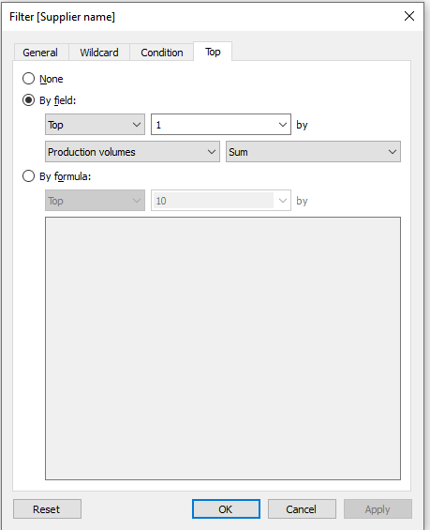

This is done by dragging Supplier Name to both the Label shelf in the Marks area and the Filters area. In the Filters section, select the "Top 1" option based on SUM(Production Volumes).

Purpose: To identify the supplier with the highest production volumes across all product types and locations, helping to highlight the top-performing supplier in terms of output.

### Avg Production Volume:

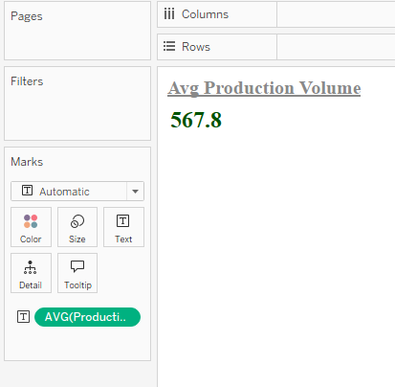

This is done by dragging the Average Production Volumes field to the Label shelf in the Marks area.

Purpose: To discover the average production volumes across all suppliers for all product types, providing insights into typical production levels within the supplier network.

### Highest-Profit supplier:

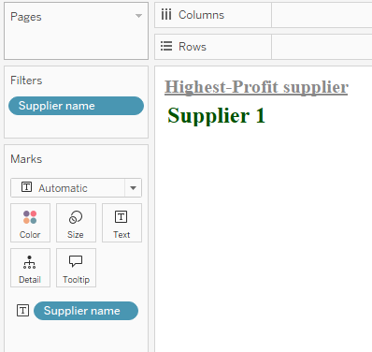 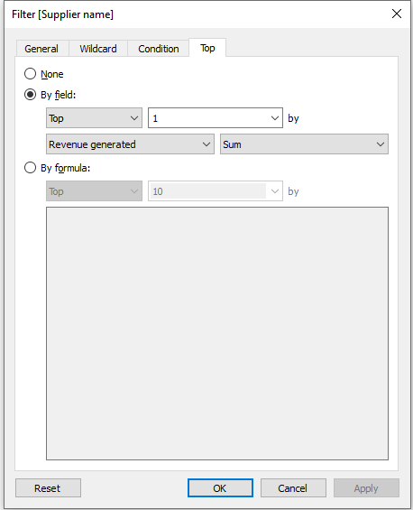

This is done by dragging Supplier Name to both the Label shelf in the Marks area and the Filters area. In the Filters section, select the "Top 1" option based on SUM(Revenue Generated).

Purpose: To identify the supplier responsible for generating the highest revenue across all product types.

Recommendation: Consider making this supplier a preferred partner and enhancing the relationship to further maximize revenue potential.

### Best-Selling Supplier:

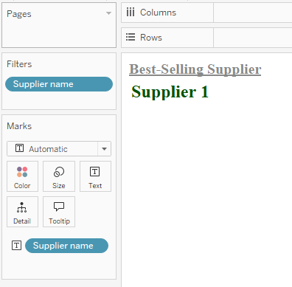 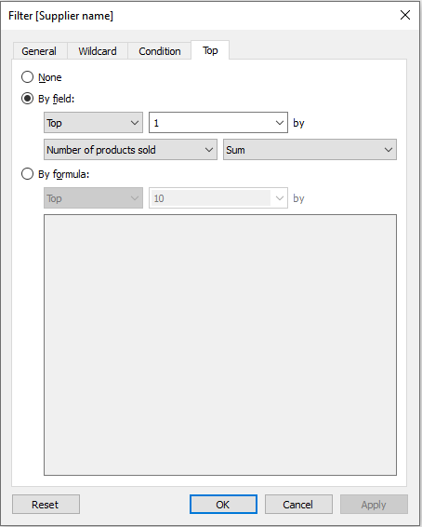

This is done by dragging Supplier Name to both the Label shelf in the Marks area and the Filters area. In the Filters section, select the "Top 1" option based on SUM(Number of Products Sold).

Purpose: To identify the supplier responsible for the highest number of products sold, indicating that the products from this supplier are the most popular compared to those from other suppliers.

### Supplier of Shortest Avg Lead Time:

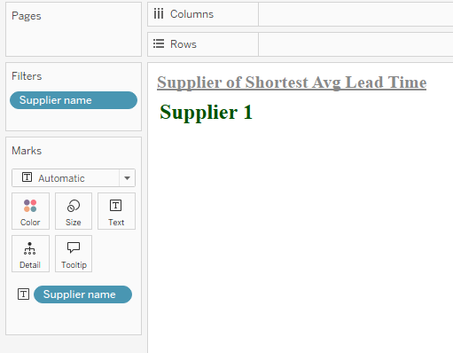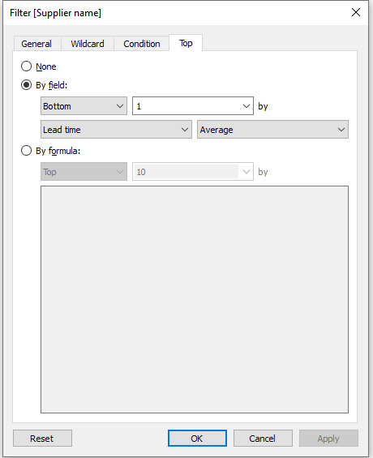

This is done by dragging Supplier Name to the Label shelf in the Marks area and selecting the "Bottom 1" option based on Average Lead Time.

Purpose: To identify the supplier with the shortest lead time across all suppliers, helping to streamline operations and reduce wait times.

### Avg Lead Time:

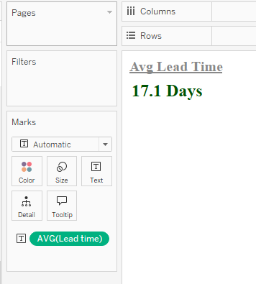

This is done by dragging the Average Lead Time field to the Label shelf in the Marks area.

Purpose: To discover the average lead time across all suppliers for all product types, providing insights into typical supplier delivery times

### Best Selling Suppliers:

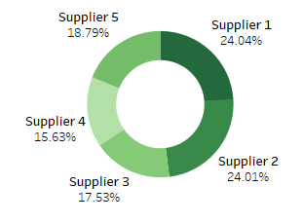

This is done by dragging the Number of Products Sold field to both the Color and Label shelves in the Marks card, and dragging Supplier Name to the Label area. Use the Zero Axis calculated field to create a doughnut chart.

Purpose: To discover the distribution of market share across different suppliers for all product types, providing a visual representation of each supplier’s contribution to total sales.

### Revenue by Supplier:

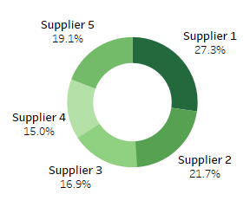

This is done by dragging the Revenue Generated field to both the Color and Label shelves in the Marks card, and dragging Supplier Name to the Label area. Use the Zero Axis calculated field to create a doughnut chart.

Purpose: To discover the distribution of revenue generated across different suppliers, revealing the share of each supplier in the total revenue, and highlighting which suppliers contribute most to overall sales.

### # Product Sold By Supplier/P.Type:

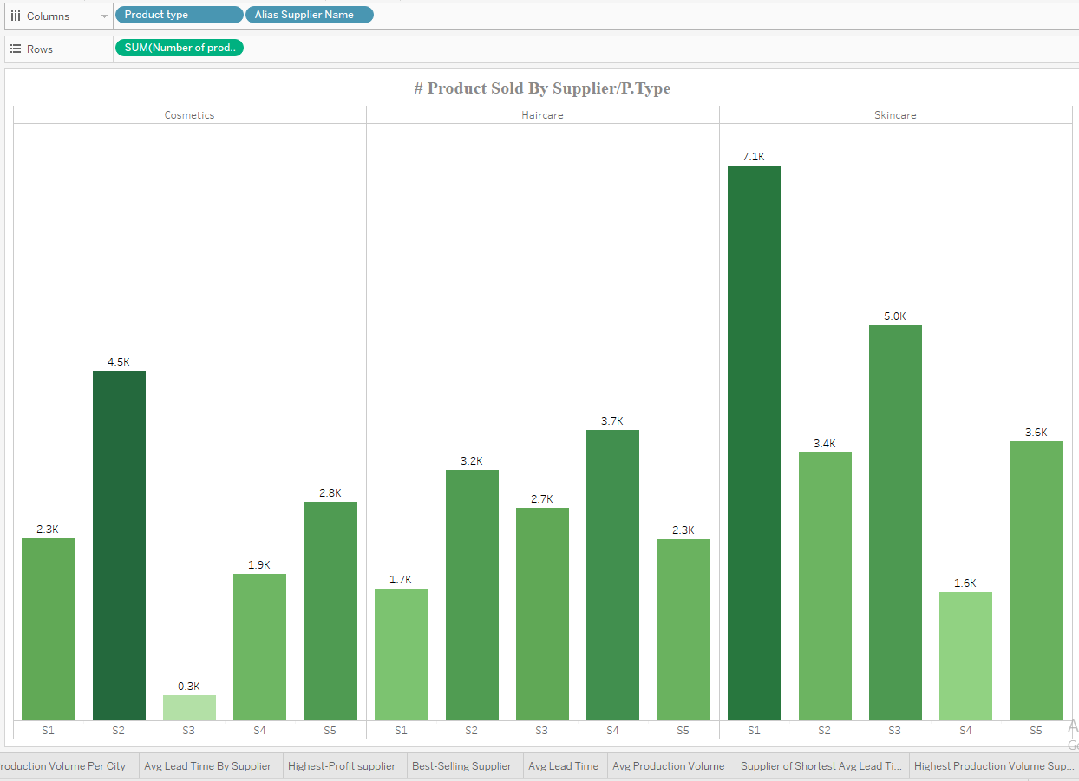

This is done by dragging Product Type and the alias Supplier Name to the Columns area, while dragging Number of Products Sold to the Rows area.

Purpose: To identify the most popular supplier for each product type, providing insights into supplier performance across different product categories.

### Avg % Net Profit Margin / Supplier:

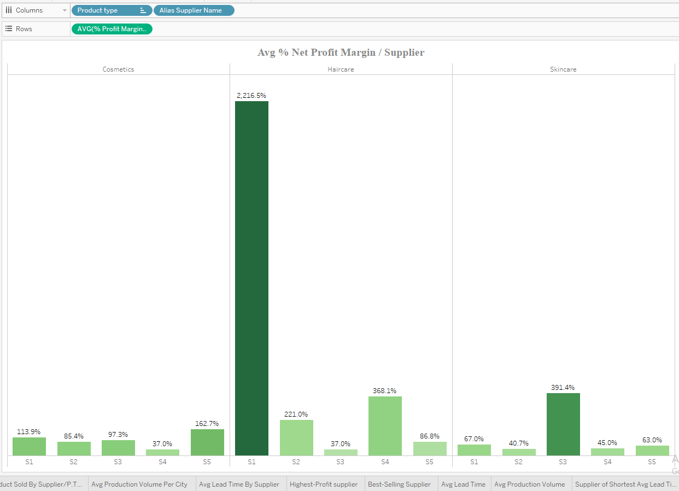

This is done by dragging Product Type and the alias Supplier Name to the Columns area, while dragging the Average % Profit Margin / Piece to the Rows area.

Purpose: To discover which supplier offers products with the highest profit margin across different product types, helping to identify suppliers that contribute more to profitability.

### Prod. Volume Vs Supplier & Location:

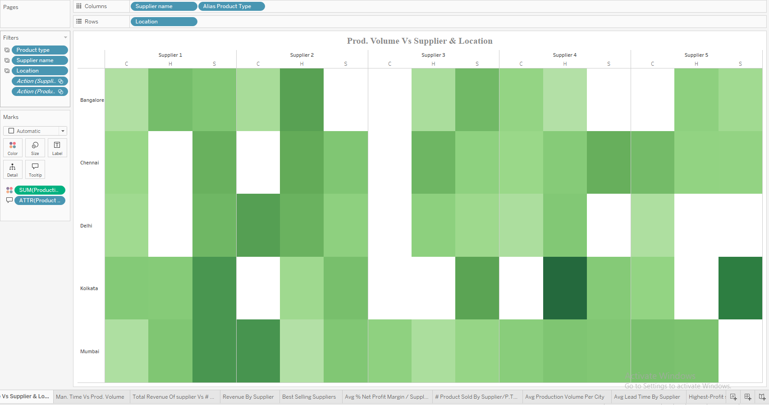

This is done by dragging Supplier Name and the alias Product Type to the Columns area, while dragging Location to the Rows area. Then, drag the Production Volume field into the Color shelf in the Marks card.

Purpose: To identify the production volume of each supplier in each location for each product type, providing insights into the geographical distribution and production scale of each supplier.

### Avg Lead Time by Supplier:

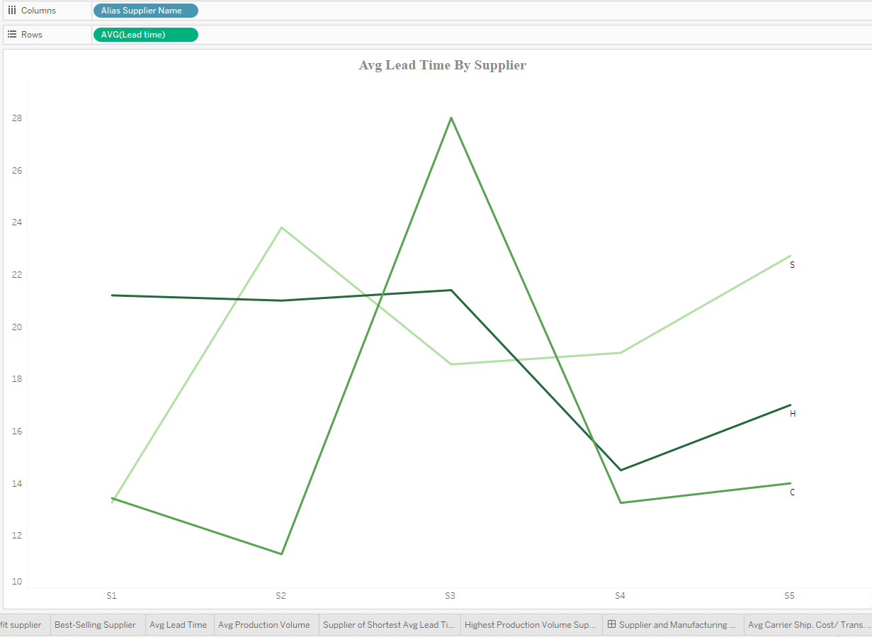

This is done by dragging the alias Supplier Name to the Columns area, while dragging the Average Lead Time to the Rows. Then, drag Product Type to the Color shelf and the alias Product Type to the Label shelf in the Marks card.

Purpose: To identify the lead time of suppliers across each product type, enabling the determination of which supplier is the best choice for each product type based on their lead time performance.

### A screenshot of a graph AI-generated content may be incorrect. Avg Man. Cost Vs Avg. Lead Time By Supplier:

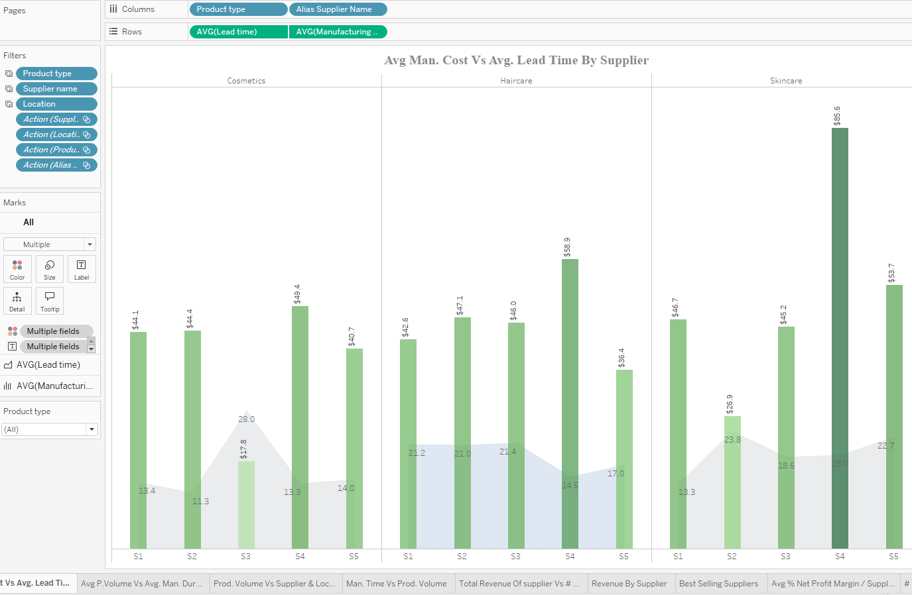

This is done by dragging the alias Supplier Name and Product Type to the Columns area, while dragging both the Average Lead Time and Average Manufacturing Cost to the Rows. Use a dual synchronized axis for both charts. The Average Manufacturing Cost chart is represented by a bar chart with green bars, while the Average Lead Time chart is represented by a gray area chart.

Purpose: To compare the relationship between Average Manufacturing Costs and Average Lead Time for each supplier across different product types, helping to assess how cost and production time correlate for each supplier.

### A screenshot of a graph AI-generated content may be incorrect.A screenshot of a graph AI-generated content may be incorrect. Avg P.Volume Vs Avg. Man. Duration:

This is done by dragging the alias Supplier Name and Product Type to the Columns area, while dragging both the Average Production Volume and Average Manufacturing Duration to the Rows. Use a dual synchronized axis for both charts. The Average Production Volume chart is represented by a bar chart with green bars, while the Average Manufacturing Duration is represented by a gray area chart.

Purpose: To examine the relationship between Production Volume and Manufacturing Duration for each supplier across different product types, helping to understand how production speed correlates with the quantity of items produced.

### Avg Production Volume per City:

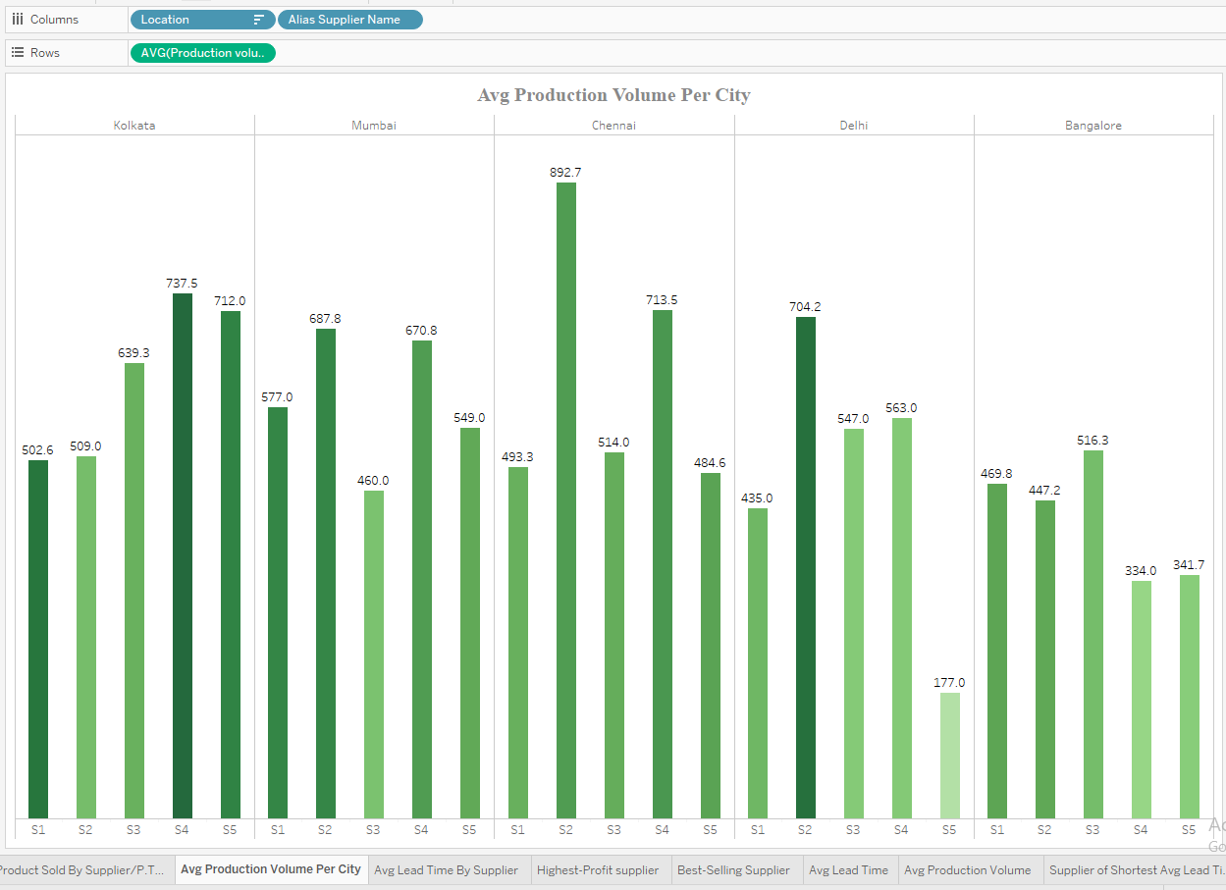

This is done by dragging Location and the alias Supplier Name to the Columns area, while dragging the Average Production Volumes to the Rows.

Purpose: To discover the distribution of production volumes for each supplier within each location across all product types, providing insights into how production is spread across different regions and suppliers.

## **Logistics and Shipping Analysis Dashboard:**

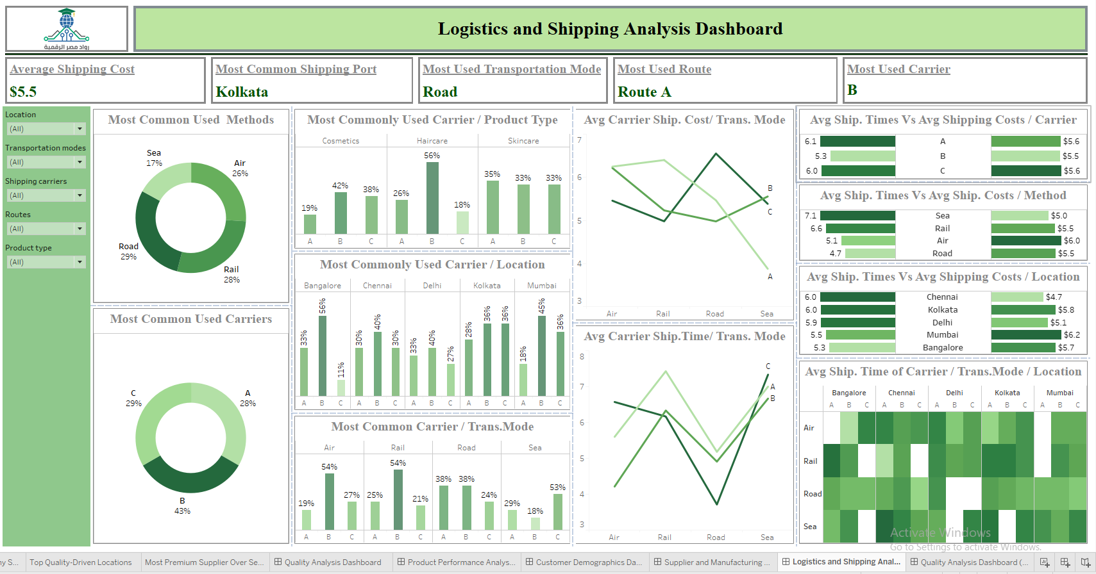

This dashboard focuses on the analysis of logistics and shipping, offering insights into various shipping methods and carriers across different locations.

It includes 5 main KPI cards and 11 detailed visuals that compare shipping methods and carriers based on key metrics such as shipping times and costs.

These visualizations help evaluate the efficiency and cost-effectiveness of different logistics options, assisting in optimizing shipping strategies.

**Included Visuals:**

This is done by dragging the Average Shipping Cost field to the Label shelf in the Marks area.

Purpose: To discover the average shipping cost across all shipping carriers and shipping methods, providing insights into overall shipping expenses.

This is done by dragging Location to the Label shelf in the Marks area and to the Filters area. In the Filters section, select the "Top 1" option based on the Count of supply_chain_data.csv.

Purpose: To identify the most common shipping port across all locations, helping to focus on key hubs for logistics operations.

1. Most Used Transportation Mode:  
     
    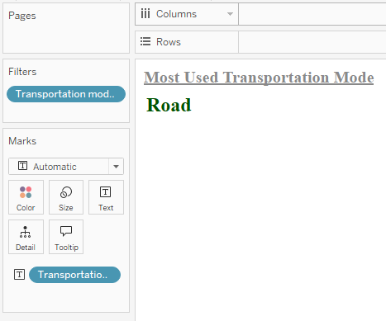 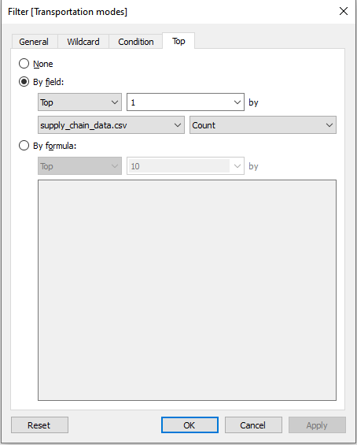

This is done by dragging Transportation Mode to the Label shelf in the Marks area and to the Filters area. In the Filters section, select the "Top 1" option based on the Count of supply_chain_data.csv.

Purpose: To identify the most common transportation mode used, providing insights into the preferred logistics method for shipments.

1. Most Used Route:  
     
    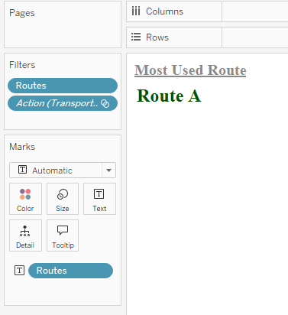 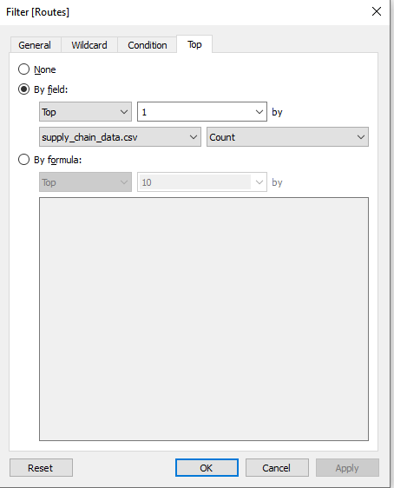

This is done by dragging Routes to the Label shelf in the Marks area and to the Filters area. In the Filters section, select the "Top 1" option based on the Count of supply_chain_data.csv.

Purpose: To identify the most common route used, helping to optimize logistics and focus on the most frequently traveled routes for shipping.

1. Most Used Carrier:  
     
   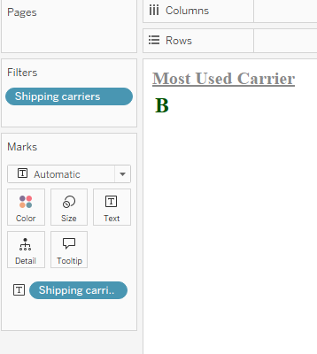 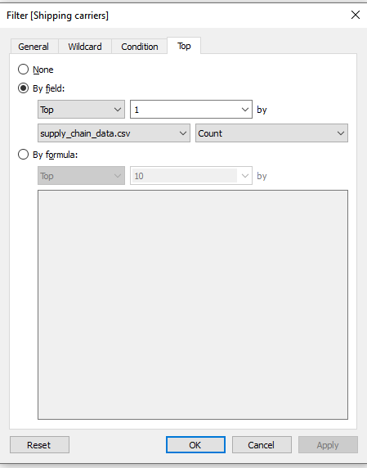

This is done by dragging Shipping Carriers to the Label shelf in the Marks area and to the Filters area. In the Filters section, select the "Top 1" option based on the Count of supply_chain_data.csv.

Purpose: To identify the most used shipping carrier, helping to highlight the carrier with the highest frequency in the shipping data.

### Most Common Used Methods:

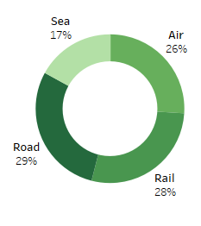

This is done by dragging Transportation Mode to both the Color and Label shelves in the Marks card. Then, drag % Count of supply_chain_data.csv to the Label shelf, using the Zero Axis calculated field to create a doughnut chart.

Purpose: To discover the most used shipping methods by visualizing their distribution and understanding their share in the total shipping data.

### Most Common Used Methods:

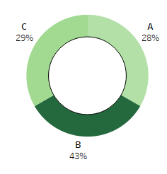

This is done by dragging Shipping Carriers to both the Color and Label shelves in the Marks card. Then, drag % Count of supply_chain_data.csv to the Label shelf, using the Zero Axis calculated field to create a doughnut chart.

Purpose: To discover the most used shipping carrier by visualizing their distribution and understanding their share in the total shipping data.

### Most Commonly Used Carrier / Product Type:

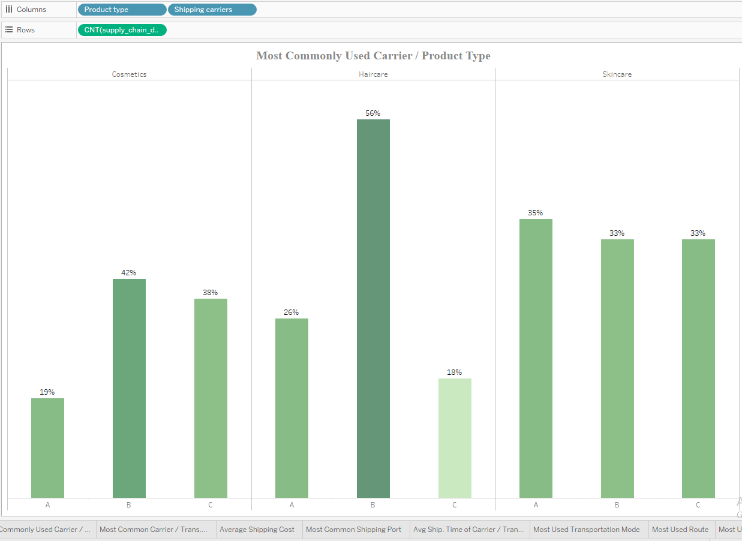

This is done by dragging Product Type and Shipping Carriers to the Columns area, while dragging % Count of supply_chain_data.csv to the Rows.

Purpose: To discover the share of the shipping carriers in shipping various product types, helping to analyze how different carriers handle the distribution of different product categories.

### Most Commonly Used Carrier / Location:

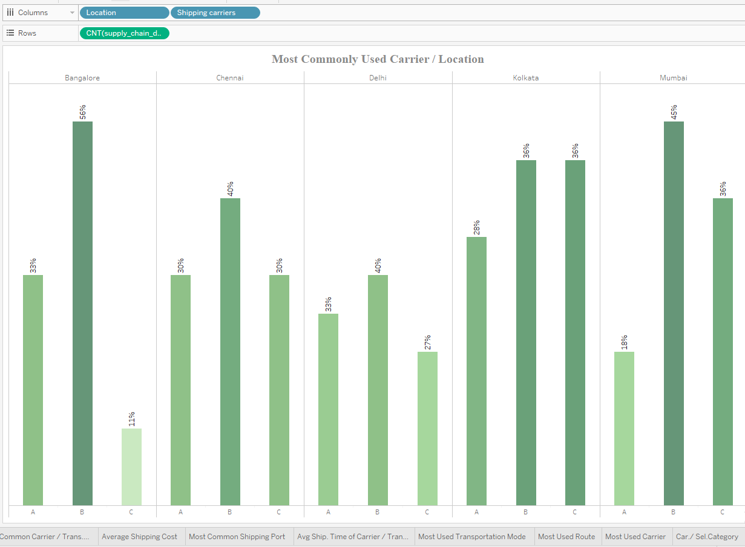

This is done by dragging Location and Shipping Carriers to the Columns area, while dragging % Count of supply_chain_data.csv to the Rows.

Purpose: To discover the share of shipping carriers within various locations, helping to analyze how different carriers are distributed across different regions.

### Most Commonly Used Carrier / Trans.Mode:

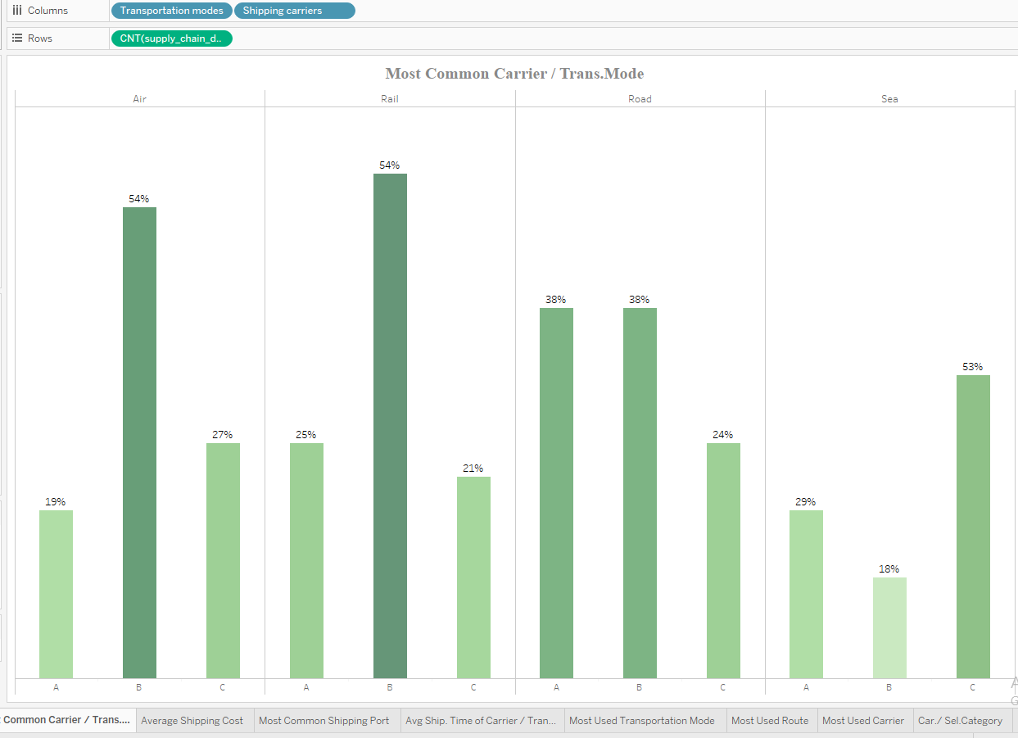

This is done by dragging Transportation Mode and Shipping Carriers to the Columns area, while dragging % Count of supply_chain_data.csv to the Rows.

Purpose: To discover the share of shipping carriers within each transportation mode, helping to analyze how different carriers perform across various transportation methods.

### Avg Carrier Ship. Cost/ Trans. Mode:

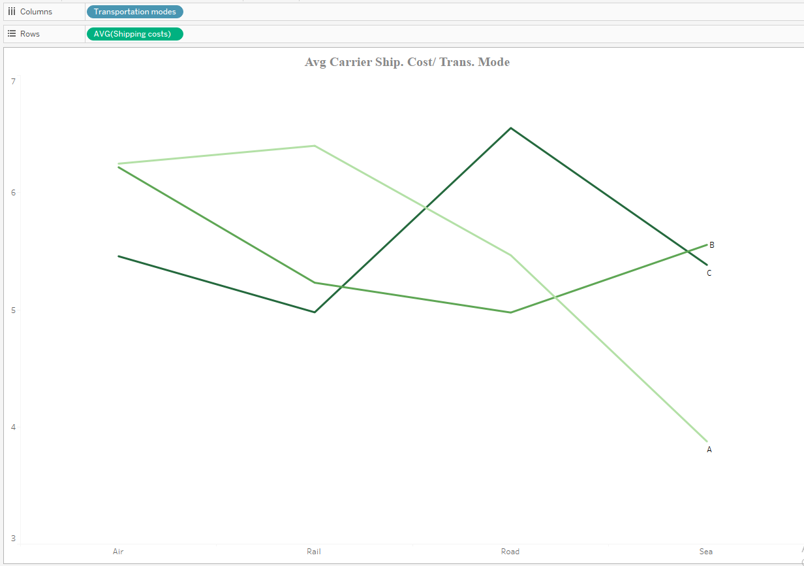

This is done by dragging Transportation Mode to the Columns area, while dragging the Average Shipping Costs to the Rows. Then, drag Shipping Carrier to the Color shelf and the Alias Shipping Carrier to the Label shelf in the Marks card.

Purpose: To identify the average shipping costs of each shipping carrier per transportation mode, helping to evaluate cost efficiency across different carriers and shipping methods.

### Avg Carrier Ship.Time/ Trans. Mode:

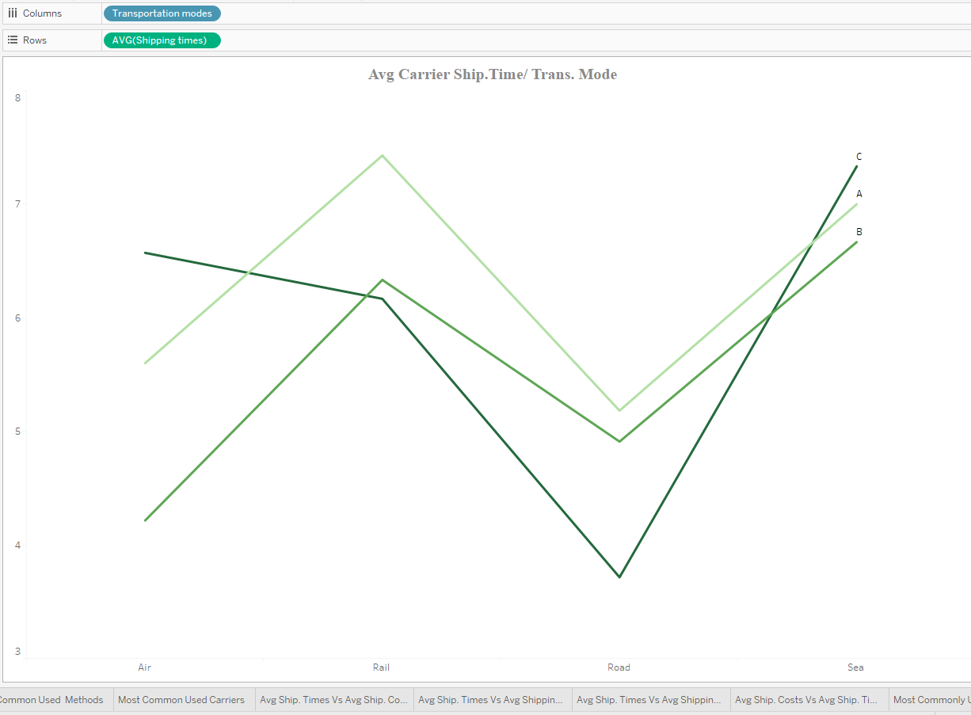

This is done by dragging Transportation Mode to the Columns area, while dragging the Average Shipping Times to the Rows. Then, drag Shipping Carrier to the Color shelf and the Alias Shipping Carrier to the Label shelf in the Marks card.

Purpose: To identify the average shipping times of each shipping carrier by transportation mode, helping to assess the efficiency of carriers in terms of delivery speed across different transportation methods.

### Avg Ship. Times Vs Avg Shipping Costs / Carrier:

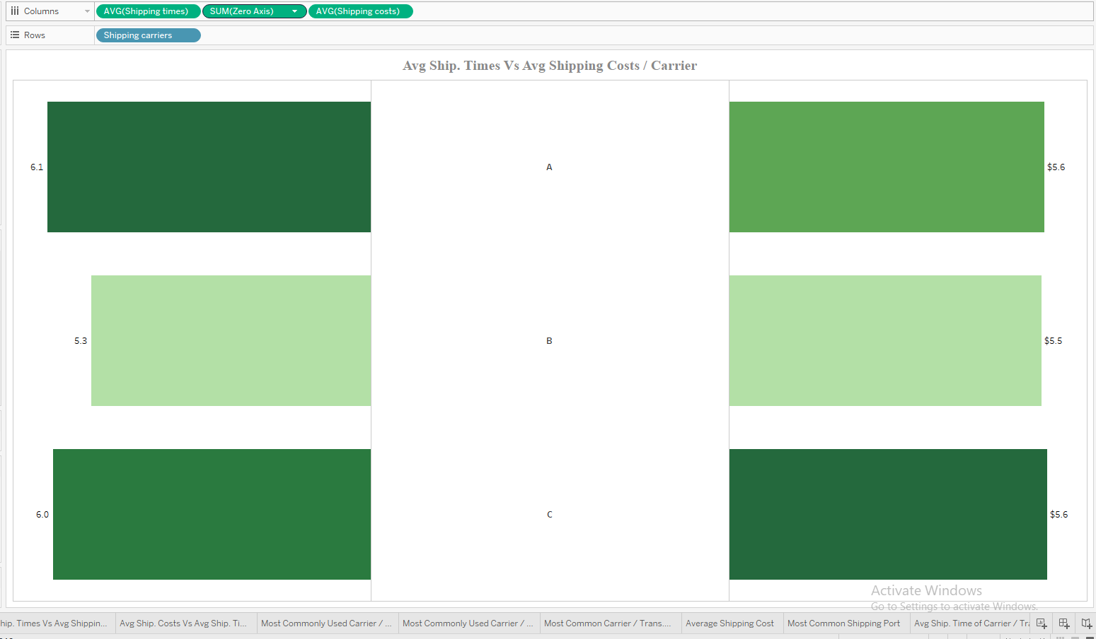

This is done by dragging Shipping Carriers to the Rows area, while dragging both the Average Shipping Times and Average Shipping Costs to the Columns area. Use a Zero Axis calculated field to create a butterfly chart.

Purpose: To compare the performance of shipping carriers in terms of shipping times and shipping costs, helping to evaluate the efficiency and cost-effectiveness of different carriers.

### Avg Ship. Times Vs Avg Ship. Costs / Method:

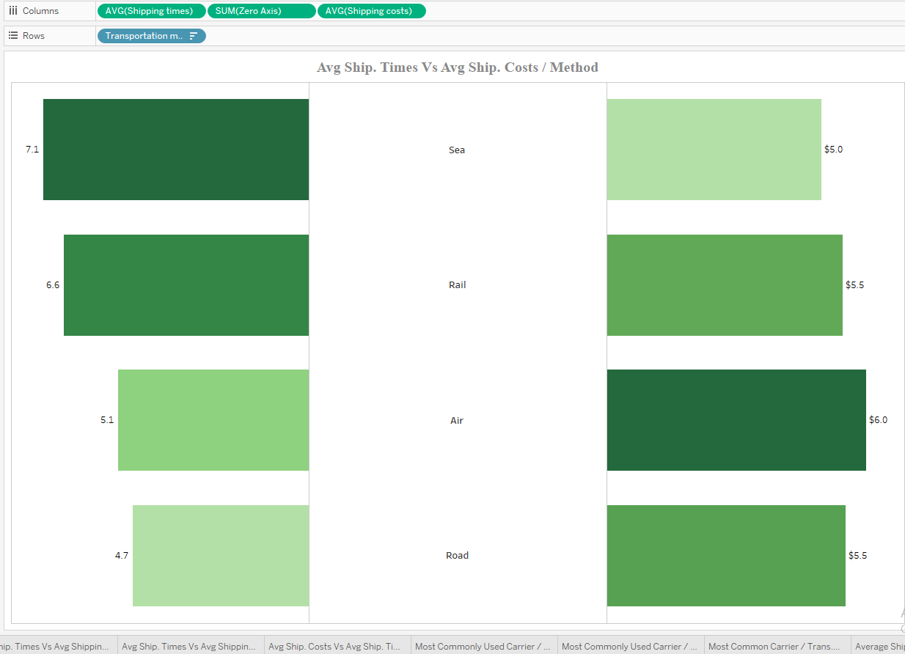

This is done by dragging Transportation Mode to the Rows area, while dragging both the Average Shipping Times and Average Shipping Costs to the Columns area. Use a Zero Axis calculated field to create a butterfly chart.

Purpose: To compare the performance of transportation modes in terms of shipping times and shipping costs, helping to assess which transportation methods are most efficient and cost-effective.

### Avg Ship. Times Vs Avg Shipping Costs / Location:

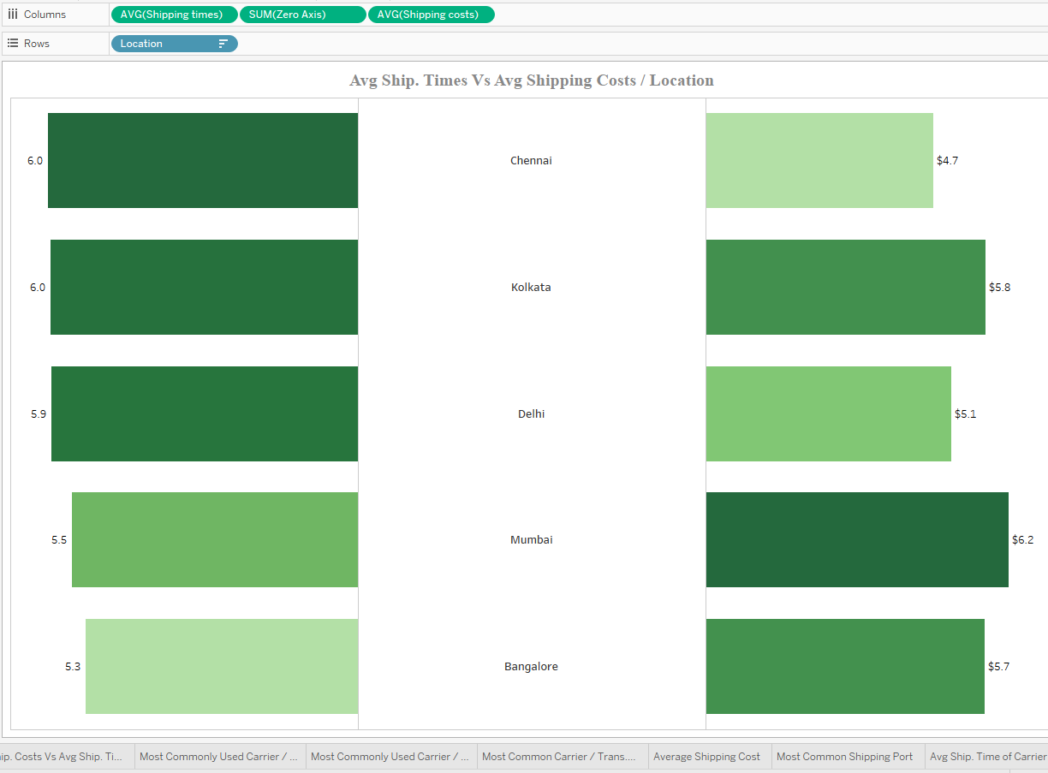

This is done by dragging Location to the Rows area, while dragging both the Average Shipping Times and Average Shipping Costs to the Columns area. Use a Zero Axis calculated field to create a butterfly chart.

Purpose: To compare shipping costs and shipping times within each location, helping to assess the efficiency and cost-effectiveness of shipments across different regions.

### Avg Ship. Time of Carrier / Trans.Mode / Location:

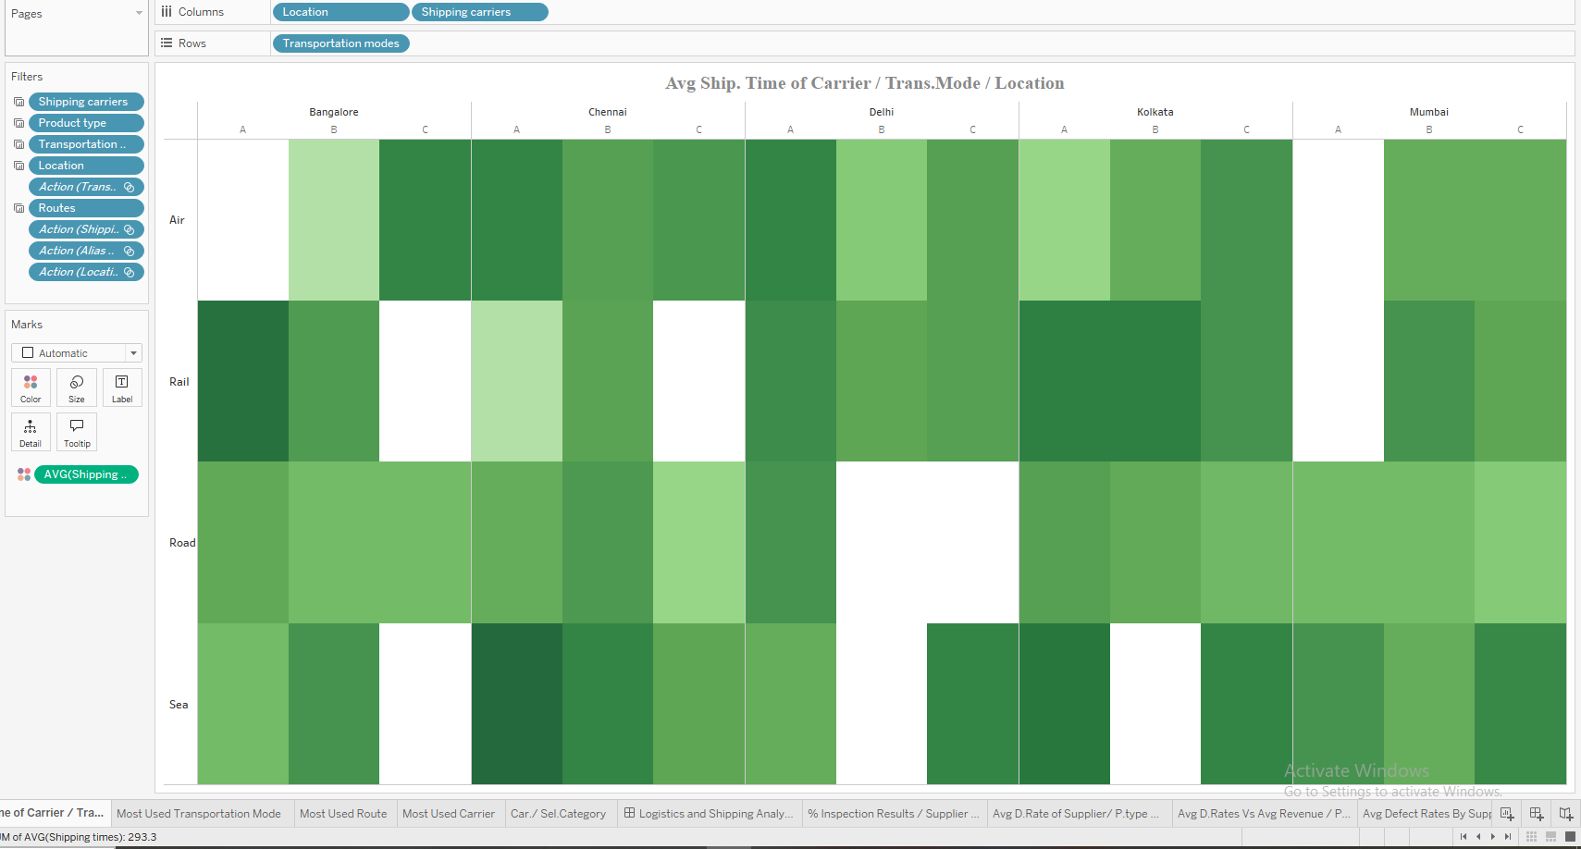

This is done by dragging Location and Shipping Carrier to the Columns area, while dragging Transportation Mode to the Rows. Then, drag the Average shipping Times field to the Color shelf in the Marks card.

Purpose: To identify the average shipping times for each shipping carrier within different locations and transportation modes, helping to analyze how shipping times vary based on carrier and location.

## **Quality Analysis Dashboard:**

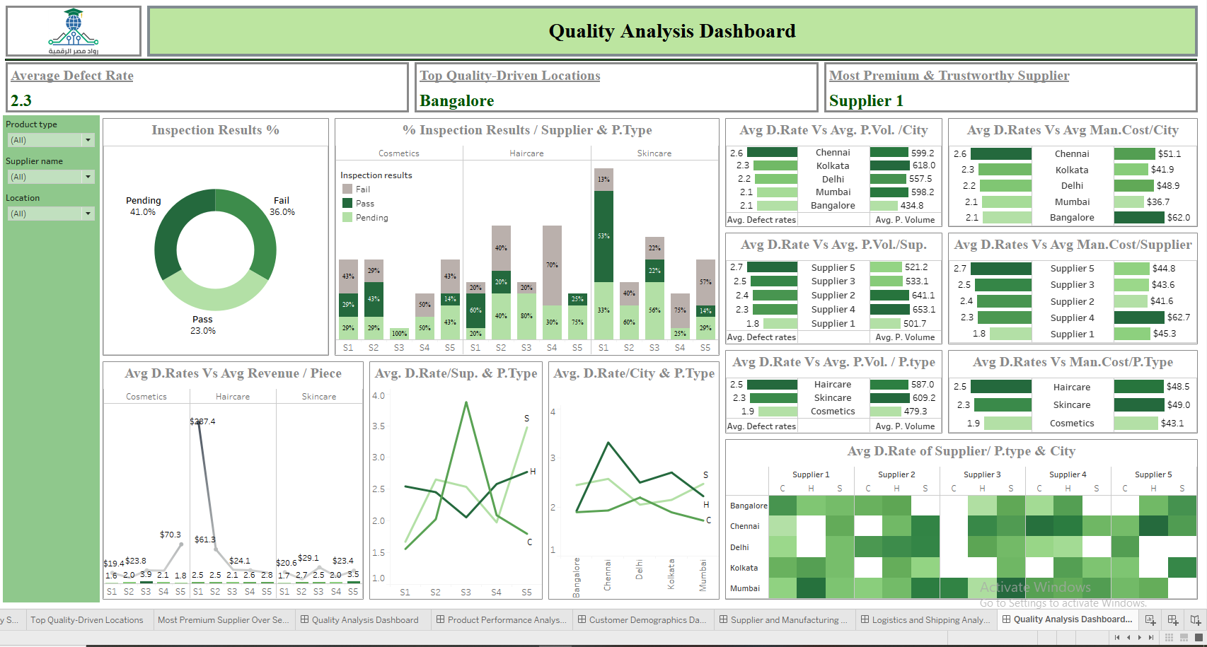

This dashboard focuses on Quality Analysis, providing in-depth insights into quality control across different product types, suppliers, and locations. It includes 3 main cards and 12 visual components that explore various quality metrics, including defect rates and their comparisons across suppliers, locations, and product types.

Purpose: To evaluate the overall quality performance, identify trends and areas for improvement, and make informed decisions based on defect rates and other quality control measures. The visuals highlight key quality aspects, allowing comparisons across multiple variables to ensure continuous improvement and optimal quality standards.

**Included Visuals:**

1. Average defect rates:  
     
   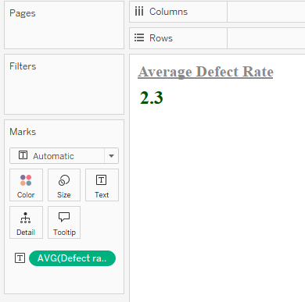

This is done by dragging the Average Shipping Cost to the Label shelf in the Marks area.

Purpose: To discover the average defect cost across all suppliers for all product types, providing insights into the financial impact of defects on the overall product quality and supplier performance.

### Top Quality-Driven Locations:

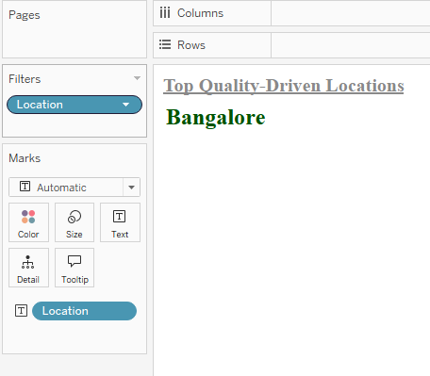 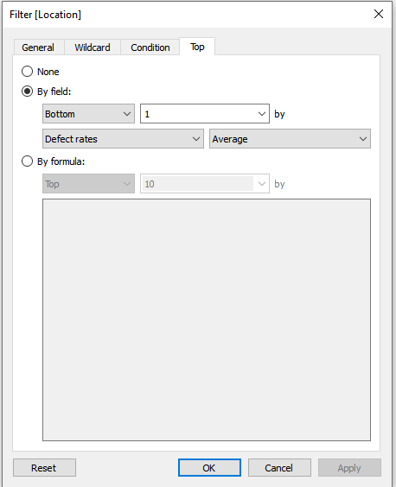

This is done by dragging Location to the Label shelf in the Marks area and to the Filters area, then selecting the Bottom 1 option in terms of Average Defect Rates.

Purpose: To discover the location with the lowest average defect rates across all product types and suppliers, highlighting areas with the best quality control and top-quality products.

### Most Premium & Trustworthy Supplier:

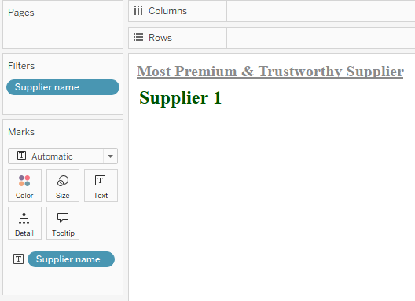 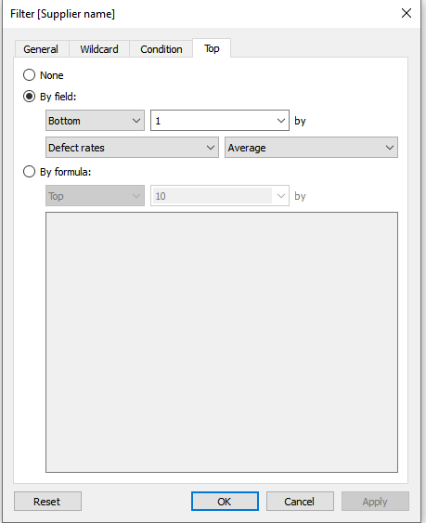

This is done by dragging the Supplier Name to the Label shelf in the Marks area and to the Filters area, then selecting the Bottom 1 option in terms of Average Defect Rates.

Purpose: To discover the supplier with the lowest average defect rates across all product types and locations, identifying them as a premium quality supplier with consistent high-quality standards.

### Inspection Results %:

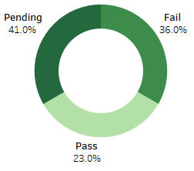

This is done by dragging Inspection Results to the Label shelf in the Marks card and dragging % Count of supply_chain_data.csv to both the Color and Label shelves. Additionally, use a Zero Axis calculated field to create a doughnut chart.

Purpose: To discover the distribution of inspection results across all items, with a focus on identifying items with a high failure percentage. Items with high failure rates should be further investigated to understand the root causes of defects.

### % Inspection Results / Supplier & P.Type:

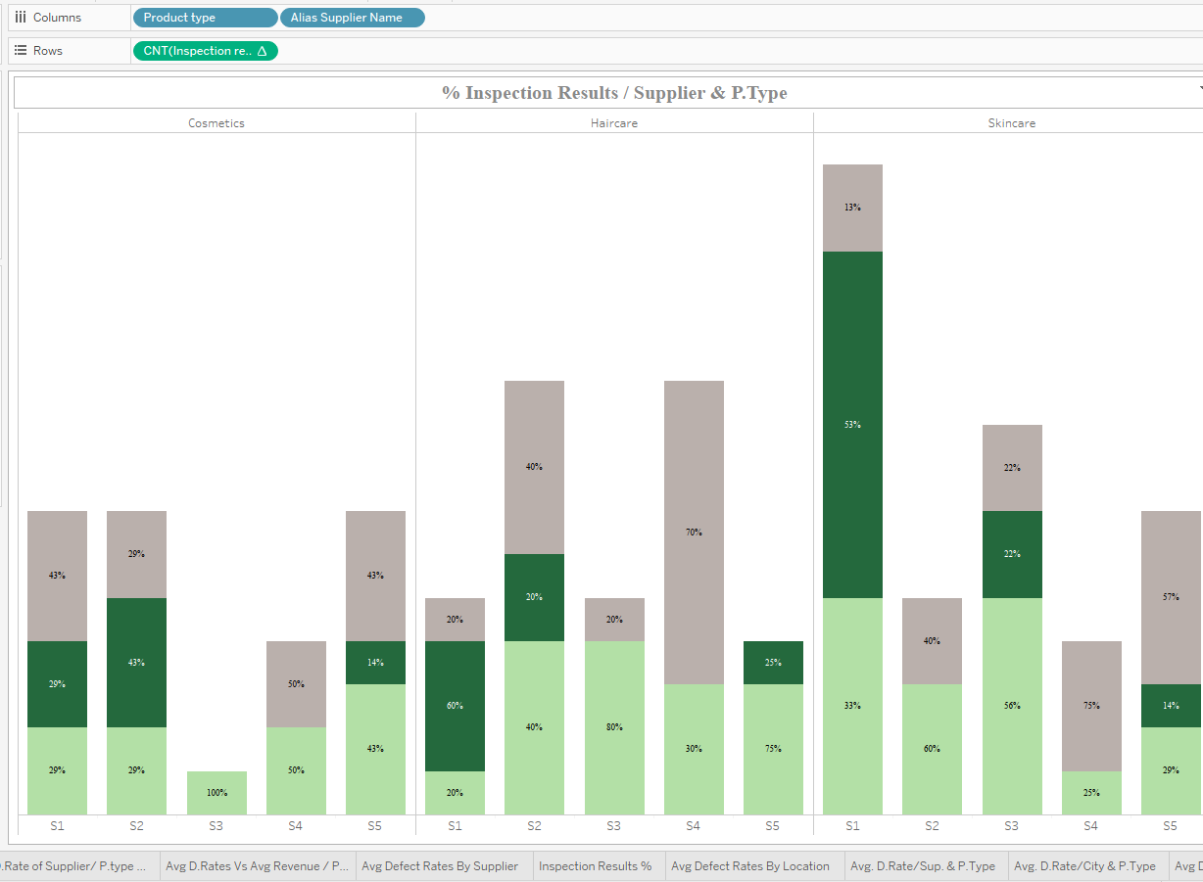

This can be easily achieved by dragging Product Type and Alias Supplier Name into the Columns shelf, and placing the % Count from supply_chain_data.csv into the Rows shelf. Then, select the Stacked Bar chart from the Show Me panel.

Purpose: To visualize the percentage distribution of inspection results for each product type across different suppliers.

### Avg D.Rates Vs Avg Revenue / Piece:

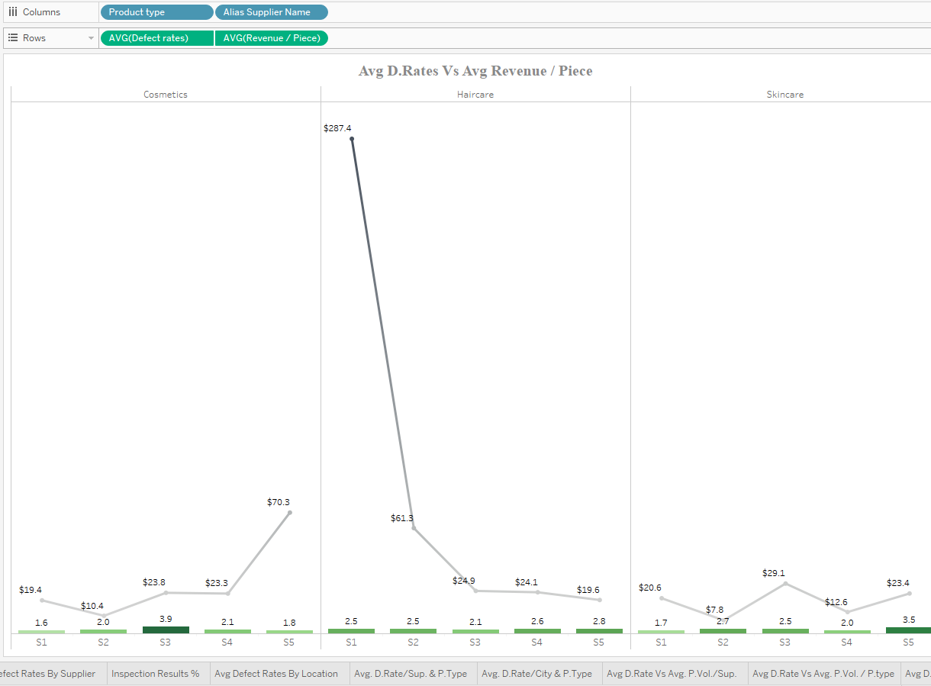

To create this visualization, drag Alias Supplier Name and Product Type to the Columns shelf. Then, drag both Average Defect Rate and Average Revenue per Piece to the Rows shelf. Use a dual-axis chart and synchronize the axes for accurate comparison. Set the Average Defect Rate to display as a green bar chart, and the Average Revenue per Piece as a gray line chart.

Purpose: To compare the relationship between average defect rates and average revenue per piece for each supplier across different product types.

### Avg. D.Rate/Sup. & P.Type:

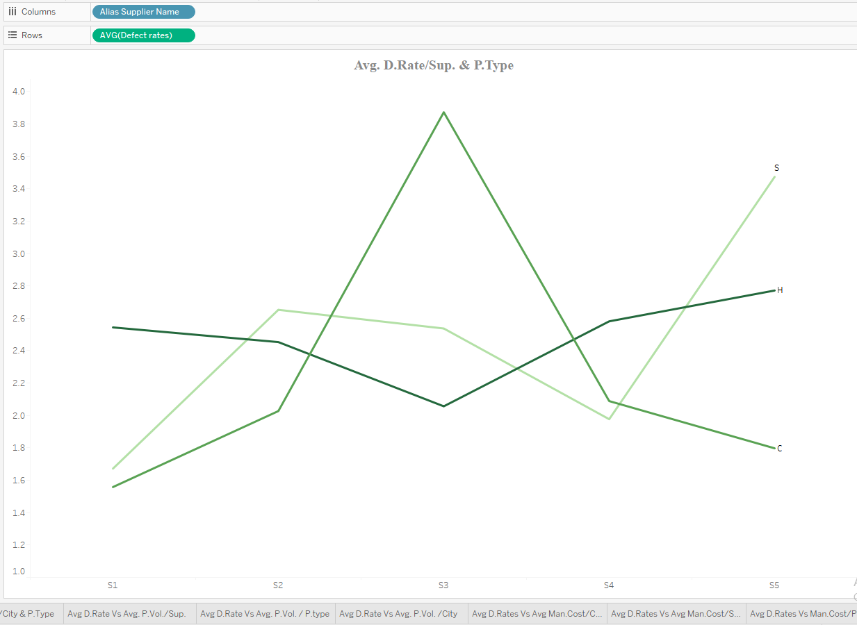

To build this visualization, drag Alias Supplier Name to the Columns shelf and Average Defect Rate to the Rows shelf. Then, drag Product Type to the Color shelf and Alias Product Type to the Label on the Marks card.

Purpose: To identify and compare the average defect rates of each supplier across different product types.

### Avg. D.Rate/City & P.Type:

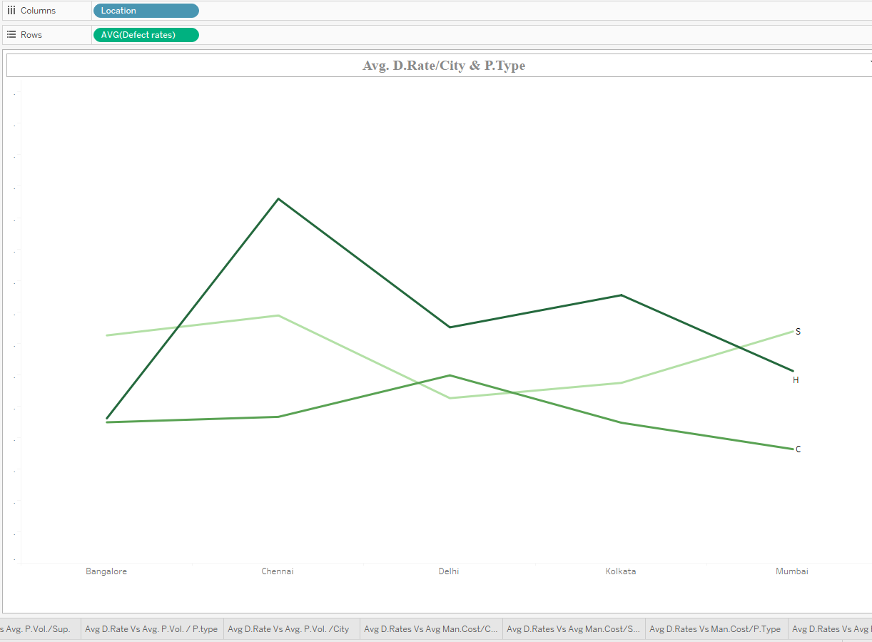

To create this visualization, drag Location to the Columns shelf and Average Defect Rate to the Rows shelf. Then, drag Product Type to the Color shelf and Alias Product Type to the Label on the Marks card.

Purpose: To identify and compare the average defect rates across locations for each product type.

### Avg D.Rate Vs Avg. P.Vol. /City:

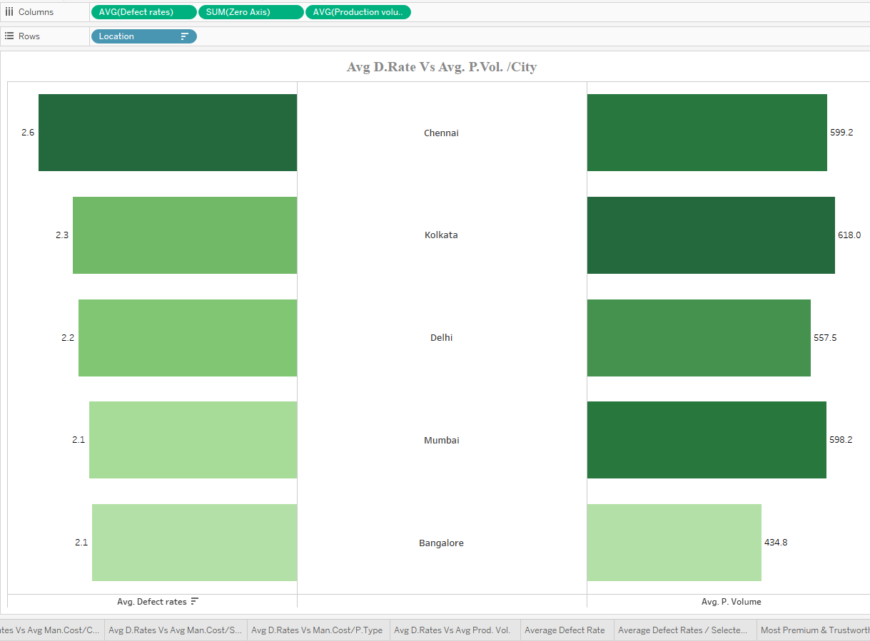

To create this butterfly chart, drag Location to the Rows shelf, and place both Average Defect Rate and Average Production Volume into the Columns shelf. Use a Zero Axis calculated field to align both measures around a central axis, enabling a mirrored (butterfly-style) comparison.

Purpose: To compare average defect rates against corresponding production volumes across locations, providing insight into potential quality issues relative to production scale.

### Avg D.Rates Vs Avg Man.Cost/City:

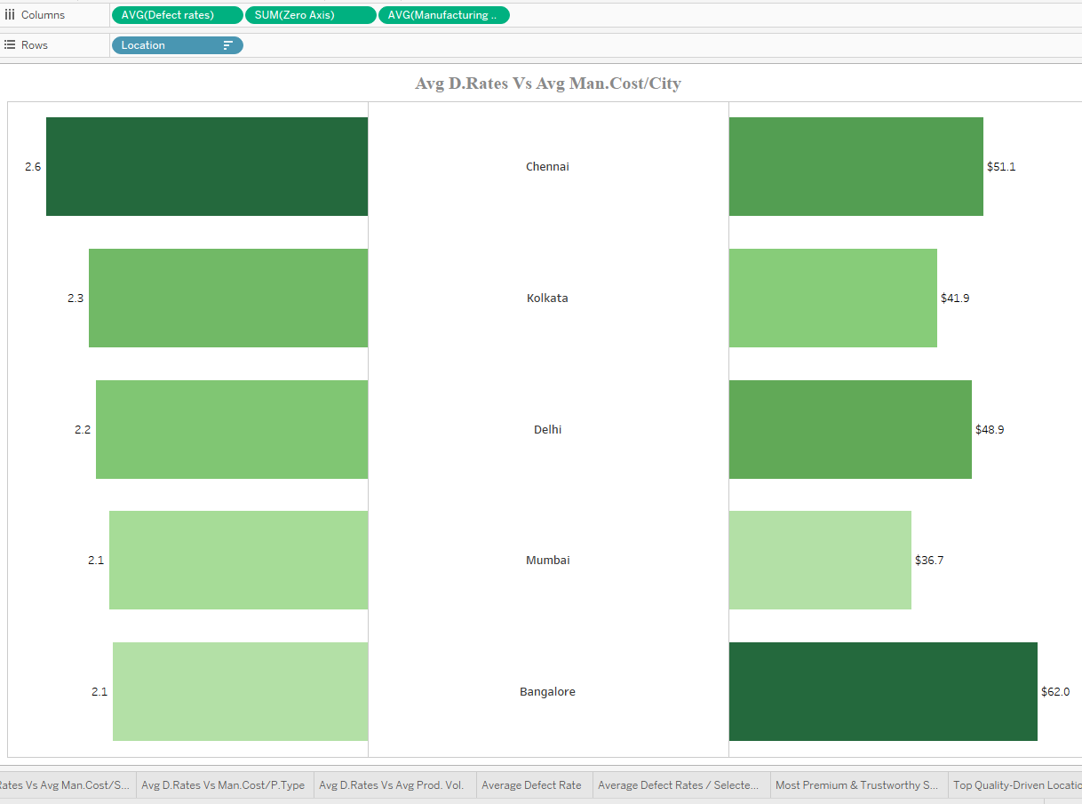

To create this butterfly chart, drag Location to the Rows shelf, and add both Average Defect Rate and Average Manufacturing Cost to the Columns shelf. Use a Zero Axis calculated field to center the measures, enabling a mirrored layout for clear visual comparison.

Purpose: To compare the average defect rates with the corresponding manufacturing costs across different locations, helping identify potential trade-offs between cost efficiency and product quality.

### Avg D.Rate Vs Avg. P.Vol./Sup.:

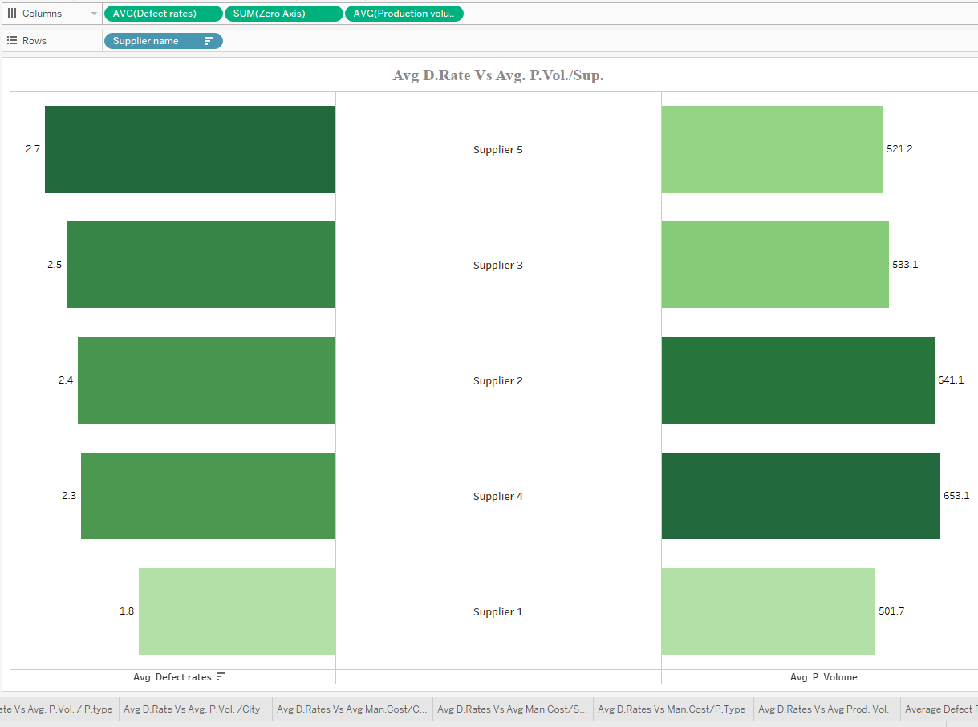

To build this butterfly chart, drag Supplier Name to the Rows shelf, and place both Average Defect Rate and Average Production Volume into the Columns shelf. Use a Zero Axis calculated field to center the two measures, allowing for a mirrored visual comparison.

Purpose: To compare average defect rates against corresponding production volumes for each supplier, highlighting potential relationships between production scale and quality performance.

### Avg D.Rates Vs Avg Man.Cost/Supplier:

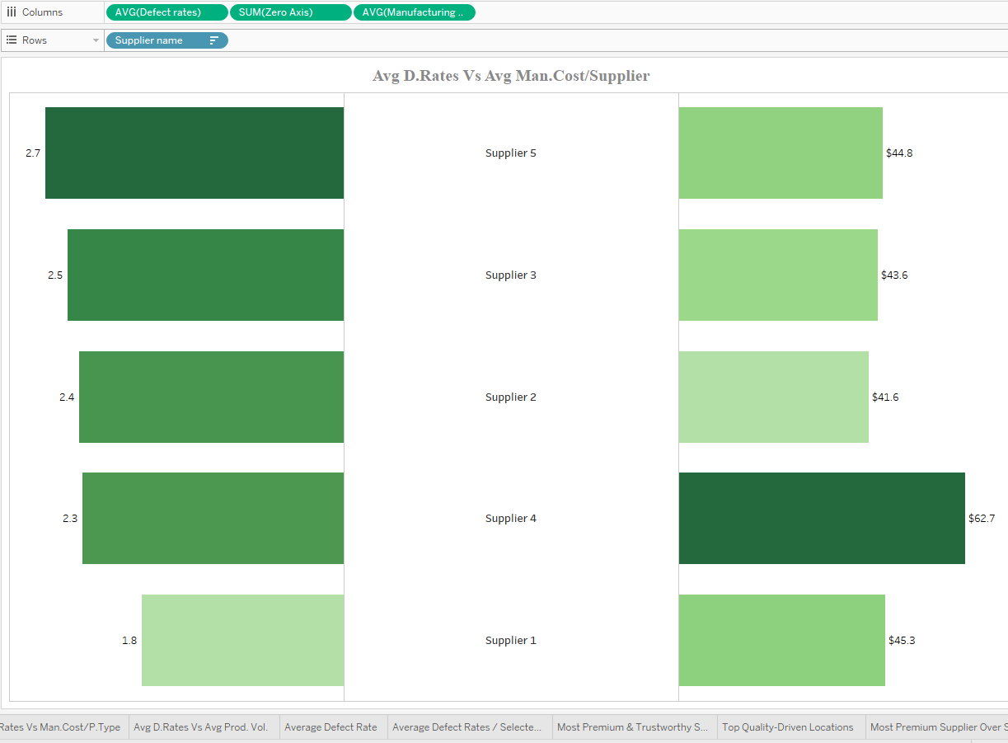

To create this butterfly chart, drag Supplier Name to the Rows shelf, and add both Average Defect Rate and Average Manufacturing Cost to the Columns shelf. Incorporate a Zero Axis calculated field to align both measures around a central axis for a mirrored layout.

Purpose: To compare average defect rates with manufacturing costs for each supplier, enabling analysis of the relationship between production cost and product quality.

### Avg D.Rate Vs Avg. P.Vol. / P.type:

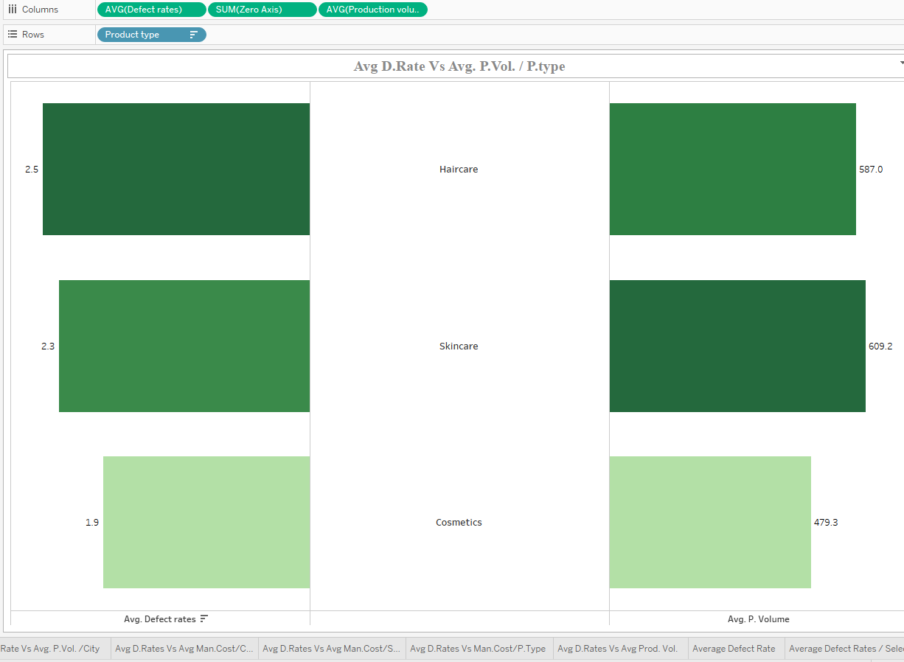

To build this butterfly chart, drag Product Type to the Rows shelf, and place both Average Defect Rate and Average Production Volume into the Columns shelf. Use a Zero Axis calculated field to center the measures, creating a mirrored visual layout.

Purpose: To compare the average defect rates with the corresponding production volumes for each product type, allowing for insights into quality and production scale relationships.

### Avg D.Rates Vs Man.Cost/P.Type:

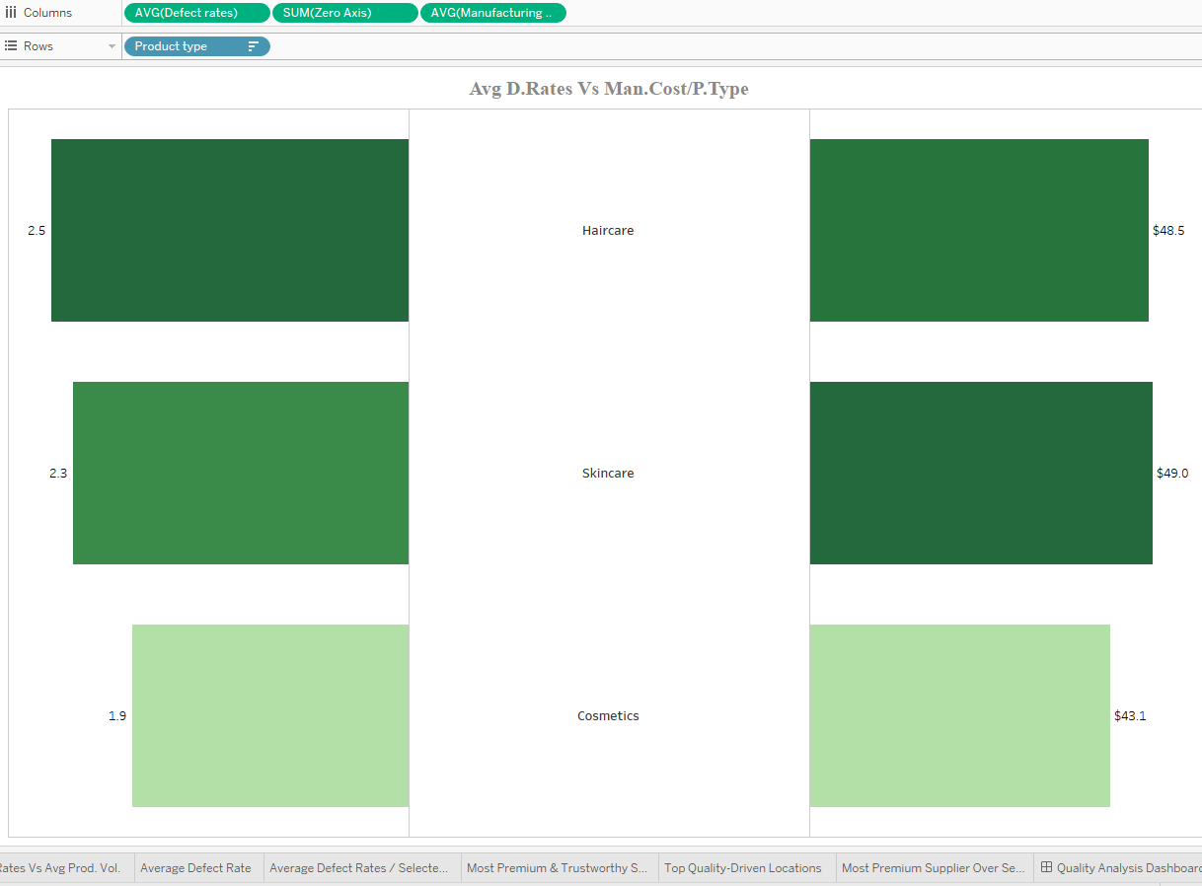

To create this butterfly chart, drag Product Type to the Rows shelf, and place both Average Defect Rate and Average Manufacturing Cost into the Columns shelf. Use a Zero Axis calculated field to center both measures, creating a mirrored visualization.

Purpose: To compare the average defect rates with the manufacturing costs for each product type, highlighting the relationship between product quality and production expenses.

### Avg D.Rate of Supplier/ P.type & City:

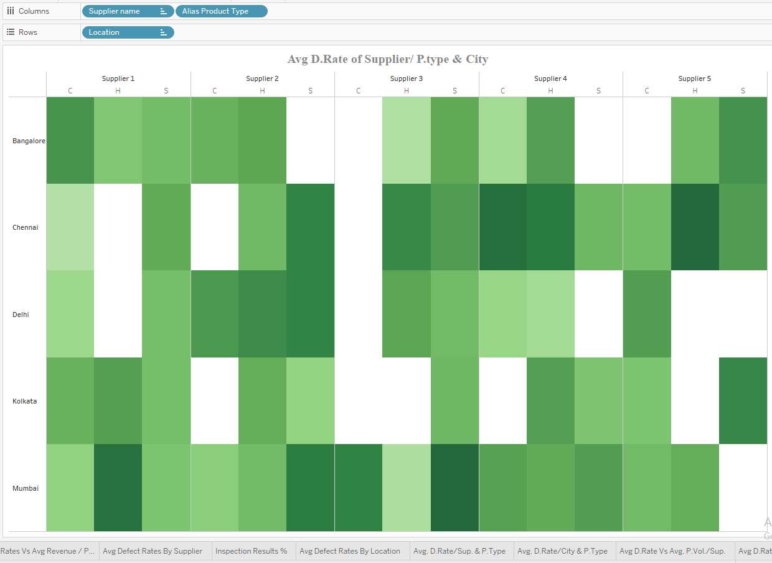

To create this visualization, drag Supplier Name and Alias Product Type to the Columns shelf, then drag the Location field to the Rows shelf. Place the Average Defect Rate field into the Color shelf on the Marks card.

Purpose: To identify the average defect rates for each supplier in each location, broken down by product type.

# **Phase 4: Insights and Recommendation**

## Product Performance Analysis Dashboard:

### Chart 1: Revenue Dominance

* Skincare is the clear revenue leader, significantly outperforming Haircare and Cosmetics, which contribute similar, substantial portions.

### Chart 2: Average Revenue / Category

* Cosmetics yield the highest average revenue per sale, followed by Skincare, with Haircare generating the least per transaction.

### Chart 3: Products Sold vs Price Range

* Sales are concentrated at the lowest ($0-9) and highest ($90-99) price points, with a secondary peak in the $60-69 range and a notable dip in mid-range sales.

### Chart 4: Products Sold vs Availability

* Inventory levels do not show a direct correlation with sales performance. High or low stock doesn't guarantee high or low sales.

### Chart 5: Top 10 SKU Stock-to-Sales / Order Quantity

* + SKU2: High stock, high demand.
  + SKU5: Balanced stock and demand.
  + SKU70: Overstocked relative to low demand.
  + SKU56: High demand with limited stock.
  + Low stock-to-sales SKUs (e.g., SKU97, SKU48) also have low demand.
  + Some good sellers (e.g., SKU3, SKU33, SKU6, SKU17) have tight stock levels.

### Chart 6: Bottom 10 SKU Stock-to-Sales / Order Quantity

* Most bottom-performing SKUs sell through their limited stock quickly. Demand varies, with some having very low orders and others maintaining relatively higher sales despite scarcity.

### Chart 7: Top 5 % Revenue vs. % Sold SKU

* SKU2, SKU31, SKU38, and SKU90 are high-value products, generating disproportionately high revenue compared to their sales volume. SKU51's revenue contribution aligns with its sales share. SKU31 and SKU51 have particularly high value per unit.

### Chart 8: Bottom 5 % Revenue vs. % Sold SKU

* The bottom 5 SKUs are low-value products, contributing minimal revenue despite a higher percentage of total units sold. SKU78 is a high-volume, low-value item.

### Chart 9: Top 5 % Selling vs. % Revenue

* SKU9, SKU10, SKU36, and SKU37 are high-volume, lower-value products. SKU94 is a higher-value product among the top sellers.

### Chart 10: Bottom 5 % Selling vs. % Revenue

* The bottom 5 selling SKUs are low-volume, high-value products, generating a surprisingly large portion of revenue despite minimal sales.

## Customer Demographic Dashboard:

### Chart 1: Revenue Distribution by Gender

* Unidentified customers are the top revenue source (30%), followed by females (28%), males (21.9%), and non-binary individuals (20.1%).

### Chart 2: Total Revenue vs. Products Sold per Gender

* While 'Unknown' customers generate the highest revenue and purchase a significant number of products, females buy the most products and contribute the second-highest revenue. Males have the lowest purchase volume and revenue. Non-binary customers buy a moderate amount but generate the least revenue.

### Chart 3: Gender vs. Product Type vs. Location for Revenue Generation

* Skincare consistently drives strong revenue across most genders and locations. Cosmetics are also a key revenue generator, particularly for females and the 'Unknown' gender. Haircare generally underperforms compared to Skincare and Cosmetics across segments.

### Chart 4: Number of Products Sold per Gender Across Different Price Ranges

* Females and 'Unknown' customers favor the cheapest and most expensive items. Males prefer mid to higher price points. Non-binary customers show varied preferences with lower engagement in the highest range.

### Chart 5: Quantity of Sold Products by Gender for Different Categories

* Skincare is the top-selling category for all specified genders. Females are the highest overall purchasers, with strong interest in Skincare and Cosmetics. 'Unknown' customers surprisingly lead in Haircare purchases.

## Supplier and Manufacturing Analysis

### Chart 1: Top-Selling Suppliers by Percentage

* Suppliers 1 and 2 are the dominant players, each commanding 24% of sales, followed by Supplier 5 (18.8%), Supplier 3 (17.5%), and Supplier 4 (15.6%).

### Chart 2: Revenue by Supplier

* Supplier 1 generates the highest revenue (27.3%), followed by Supplier 2 (21.7%) and Supplier 5 (19.1%). Supplier 4 contributes the least revenue among the top 5 (15.0%).

### Chart 3: Average Number of Products Sold by Supplier and Product Type

* Supplier 2 leads in average sales for Cosmetics and Skincare. Supplier 5 excels in Haircare sales. Category performance varies significantly by supplier.

### Chart 4: Average Percentage Net Profit Margin per Supplier for Different Product Types

* Profit margins are highly variable across suppliers and product types. Supplier 1 shows an exceptional Haircare margin (outlier). Excluding this, Supplier 5 leads in Cosmetics, Supplier 4 in Haircare, and Supplier 3 in Skincare.

### Chart 5: Product Volume vs. Supplier and Location

* Supplier 1 has high Cosmetics and Skincare volume in multiple cities. Supplier 5 shows strong Skincare volume in several locations and Haircare in Kolkata. Supplier 2 has a strong Skincare presence in Chennai and Cosmetics in Mumbai. Supplier 3 generally has lower volume.

### Chart 6: Average Lead Time (in days) by Supplier for Different Product Types

* Cosmetics have the fastest lead times across suppliers. Skincare lead times are the most variable, with Supplier 3 being significantly slower. Haircare lead times are generally consistent and moderate.

### Chart 7: Average Manufacturing Cost vs. Average Lead Time by Supplier for Different Product Types

* Higher manufacturing costs don't consistently guarantee shorter lead times. For Cosmetics and possibly Skincare, lower costs appear linked to longer lead times for some suppliers.

### Chart 8: Average Production Volume per City for Different Suppliers

* Chennai and Kolkata have the highest overall production volume, with Supplier 3 leading in Chennai and Suppliers 4 & 5 in Kolkata. Bangalore has the lowest overall production. Supplier production is concentrated in specific cities.

### Chart 9: Manufacturing Time vs. Production Volume

* There's no clear relationship between manufacturing time and production volume. Short or long manufacturing times don't reliably predict high or low production volumes.

## Logistics and Shipping Analysis Dashboard

### Chart 1: Most Commonly Used Shipping Methods

* Road (29%) and Rail (28%) are the primary shipping methods, followed by Air (26%), with Sea (17%) being the least utilized.

### Chart 2: Most Commonly Used Carriers

* Carrier B (43%) is the preferred choice, followed by Carrier C (29%), and Carrier A (28%).

### Chart 3: Most Commonly Used Carrier per Product Type

* Carrier B is favored for Cosmetics and especially Haircare. Skincare utilizes all three carriers with similar frequency.

### Chart 4: Most Commonly Used Carrier per Location

* Carrier B is the most frequent choice across all locations. Carrier C often ranks second, while Carrier A is generally the least used.

### Chart 5: Most Commonly Used Carrier by Transportation Mode

* Carrier B is dominant for Air and Rail. Road utilizes Carriers B and A equally. Sea primarily relies on Carrier C.

### Chart 6: Average Carrier Shipping Cost by Transportation Mode

* Shipping costs vary by carrier and mode. Carrier B is pricier for Road and Sea, Carrier A for Rail, and Carrier C for Air.

### Chart 7: Average Carrier Shipping Time by Transportation Mode

* Carrier B generally offers the fastest shipping for Air, Rail, and Road. Carrier A is quickest for Sea.

### Chart 8: Average Shipping Times vs. Average Shipping Costs per Carrier

* Carrier B provides the best balance of speed and cost. Carrier A is the slowest, while Carrier C offers moderate speed at a similar cost to A.

### Chart 9: Average Shipping Times vs. Average Shipping Costs per Transportation Method

* Road is fastest but not cheapest. Air is fast but most expensive. Rail is slower and cost-effective. Sea is slowest and cheapest.

### Chart 10: Average Shipping Times vs. Average Shipping Costs per Location

* Bangalore has the fastest shipping. Mumbai is the most expensive. Chennai is cheapest but slowest. Kolkata has long shipping times and higher costs than Chennai.

### Chart 11: Average Shipping Time of Each Carrier by Transportation Mode and Location

* Air is generally fastest, with Carrier B often leading. Rail can be very slow in some cases. Road is consistently quick, often with Carrier B. Sea is slowest but varies by carrier and city.

Here are the rephrased insights for the Quality Analysis Dashboard:

## Quality Analysis Dashboard

### Chart 1: Inspection Results

* A significant portion of inspections are pending (41%), with over a third failing (36%) and less than a quarter passing (23%).

### Chart 2: Average Defect Rates vs. Average Production Volume

* No clear correlation exists between average defect rates and production volume. Defect frequency appears independent of production scale.

### Chart 3: Percentage of Inspection Results by Supplier and Product Category

* Inspection outcomes are highly variable by supplier and product. Supplier 3 shows strong pass rates (potentially low volume), while Supplier 2 has high failure rates in Cosmetics. Pending inspections are notable for some suppliers and categories.

### Chart 4: Average Defect Rates vs. Average Revenue per Piece by Supplier and Product Category

* Higher priced items don't necessarily have more defects. Supplier 1's high-revenue Haircare stands out. Some suppliers achieve high revenue with low defects in Cosmetics and Skincare.

### Chart 5: Average Defect Rates by Supplier and Product Type

* Defect rates vary significantly by supplier and product. Supplier 5 generally has higher defects in Haircare and Skincare, while Supplier 3 has high defects in Cosmetics but low in Haircare. Supplier 1 tends to have lower defect rates overall.

### Chart 6: Average Defect Rates by Location and Product Type

* Chennai has a specific issue with high Haircare defects. Cosmetics generally have low defects across all locations. Skincare defect rates are moderate with a slight increase in Delhi.

### Chart 7: Average Defect Rates vs. Average Manufacturing Cost by Location

* Mumbai achieves low defects with the lowest costs. Bangalore has the lowest defects but highest costs. Chennai has the worst combination: high defects and high costs.

### Chart 8: Average Defect Rates vs. Average Manufacturing Cost by Supplier

* Supplier 1 offers the best quality at a reasonable cost. Supplier 4 has the highest cost without the best quality. Supplier 5 has the worst quality at a moderate cost.

### Chart 9: Average Defect Rates vs. Average Manufacturing Cost by Product Type

* Cosmetics are cheapest and have fewest defects. Skincare is most expensive with moderate defects. Haircare has most defects at a moderate cost.

### Chart 10: Average Defect Rate by Supplier, Product Type, and Location

* High defect hotspots include Supplier 2's Haircare in Chennai and Supplier 5's Skincare in Kolkata. Supplier 3 generally shows good quality. Chennai struggles with Skincare quality across suppliers. Cosmetics generally have lower defects. Specific high-defect combinations exist.